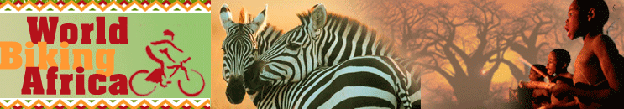

update 1. pre-departure
6 June 2006 - Location: Obernai, France
Fundraising efforts are off to a promising start: $1,730 raised so far. Many thanks to all the generous individuals who have donated to CAMFED through our charity page.
Bicycles are ready to go, but we're still trying to figure out how to stuff tent, stove, cookware, spare parts, computer, cameras and clothing into 8 saddle bags. The weatherman predicts sunshine and pleasant temperatures for our departure on Wednesday--let's just hope he's right.
World Biking Africa was featured in the French regional newspaper the Dernières Nouvelles d'Alsace: read the article (in French) here.
10 May 2006 - Location: Darmstadt, Germany
Update by Amaya - Less than a month till departure and I can already feel the butterflies batting around in my belly (or maybe that's just a minor stomach upset from the raw chocolate chip cookie dough I devoured last evening).
Eric has recently discovered the joys of e-bay and can be found most evenings glued to the monitor tracking down deals on everything from Canon cameras to Shimano spokes. Needless to say we're not making much progress towards chalking up the 1000 kilometers necessary to break in the Brooks saddles--they're about as comfortable as a 3rd class bench on an Indian train.
After much consideration, we have chosen CAMFED for our charity fundraising efforts. Its focus is on increasing girls' access to education in some of the poorest rural areas of Africa. CAMFED currently reached over 70,000 girls per year and is a partner in Tony Blair's "Make Poverty History" campaign as well as the chair of the United Nation's" Initiative for Girls’ Education". If you would like to help eradicate poverty by educating girls, please consider making an online donation to CAMFED.
10 April 2006 - Location: Darmstadt, Germany
Update by Amaya - Things seem to be coming together at last. We had long debated whether to pursue sponsors in order to defray some of the costs of the trip. From other cyclists' reports, we knew that Ortlieb wouldn't be beating down the door begging us to use their 'free' products in exchange for a plug on our web site. It seems finding sponsors is hard work and requires countless hours selling your project to disinterested managers of sporting goods companies. So imagine our surprise when the friendly Bikemax manager almost immediately agreed to a generous discount after I had asked only half jokingly if he wouldn't like to support us. Thanks to this good fortune, we'll be seeing Africa from the saddle of the Koga Miyata World Traveller. This is a bike specifically designed for tours such as ours. It's made to withstand all the wear and tear of rough roads and it's also the bicycle used by legendary cyclist Tilmann Waldthaler.
The range of outdoor gear available nowadays is mind-boggling! Vigilance is a must if you want to make it through the checkout without setting yourself back several hundred (or thousand!) euros. The slick salesman at Decathlon in Strasbourg had almost convinced me of the merits of the cool max seamless moisture wicking cycling socks with the €16.50 price tag. Fortunately I came to my senses, put things into perspective and realized that the price of those hi-tech socks would be the equivalent to a week's wages in some African countries. Sweaty feet certainly won't kill me.
20 March 2006 - Location: Darmstadt, Germany
Update by Amaya - 10 weeks to go and something tells me we should be further along in the preparations. Felt especially despondent as I checked out Granny on a Bike's site--she's set to depart in 2007 and already has her send off party planned. I try to console myself by remembering that I thrive under pressure.
Some progress on the bicycle selection front. Looks like we'll be going with a sturdy German bike from Fahrradmanufaktur--the T400! Tough decision as I wanted to go with a model from a competitor with the sweet sounding name "Montana". A missed publicity opportunity for my home state. The voice of reason (otherwise known as Eric) seems to have won this battle.
The shopping list is long: tent, spd cycling shoes, panniers, sunglasses, clothing, water purifier, cookware, laptop, camera and a thousand other "necessities". In any case, I'm not allowing myself to slip into crisis mode yet as I know we'll be able to pick up any forgotten items along the way as we travel through Europe.
Finances are in order and Eric's brother has kindly offered to make space for our belongings in his garage. Thanks Fabrice!
update 2. new rhythms: life on the road
15 June 2006 Le Puy en Velay, Auvergne, France
Kilometers: 763 - falls: Eric 4, Amaya 1
number of times on-lookers have remarked "vous êtes bien chargés!" ( you're really loaded): 27
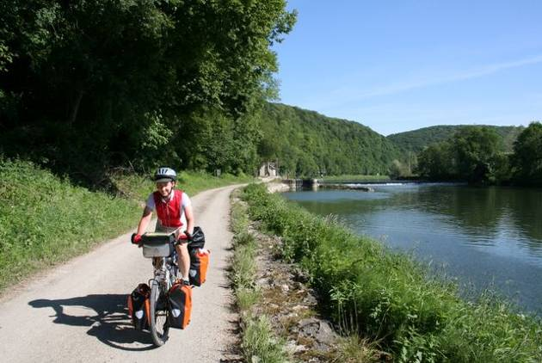
After cycling what will certainly be counted amongst the 8 hottest days of the year, we arrived in Le Puy, the starting point of the pilgrimage route leading to Santiago de Compostelle. Mother Nature decided that the onset of summer would coincide with our departure and we've had scorching afternoons ever since.
On Day One we cruised along both banks of the Rhine, allowing us one final chance to bid farewell to Germany and treat ourselves to a delicious Spaghetti Eis (ice cream specialty that resembles a bowl of spaghetti, but with a strawberry rather than tomato sauce ). We knocked off just over a hundred kilometers without undue effort and were pleasantly surprised to see that hauling 30 kilos of equipment on the back of a bicycle is as demanding as we had imagined.
Curious individuals often ask why we didn't choose a tandem for our trip. The answer is simple: we both like our independence and Amaya has no desire to spend 18 months staring at Eric's backside. But cycling separately can pose problems--especially at a crossroads. More than once we've been obliged to flag down passers-by and question them as to whether they've seen a similarly outfitted cyclist, and if so in which direction was he/she headed. So we developed 'the whistle system' which numerous villages in Franche Comté are now well-acquainted with.
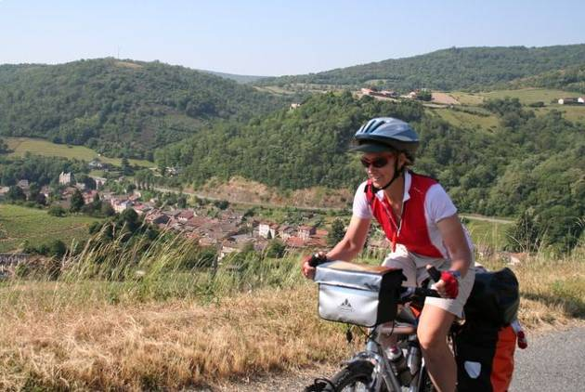
Bike paths and gentle riding quickly disappeared and within a couple of days we found ourselves tackling the imposing hills of the Jura and the Beaujolais region of Burgundy. A long, steep climb brought us to St Cyr Le Châtou, where we arrived just in time to gorge ourselves on the leftovers of Sunday's fête du village. Fresh cheese and pasta salad were kindly offered when the mayor took pity on us after having announced that we certainly wouldn't find a grocery store open within several hours' ride. The food had been intended for local livestock who had to content themselves with stale baguettes instead, which was all that was left after our passage. Lesson learned: Monday is a day of rest for rural shopkeepers in the heart of the French countryside.
Campsites are a rarity along the back roads of the Beaujolais. We had resigned ourselves to a night of wild camping when Gérard appeared: our savior. The sun was already low in the sky and we had already three hilly passes behind us as we slowly made our way up yet another hill and... There was Gérard attending to his vineyard. An avid cyclist himself, he enthusiastically welcomed us to camp under his cherry trees, offered Amaya a much-needed hot shower and Eric a taste of his Beaujolais nouveau. Hot coffee, homemade jam and a baguette awaited us the next morning to fortify us for the never-ending hills that awaited us. Now that's hospitality!
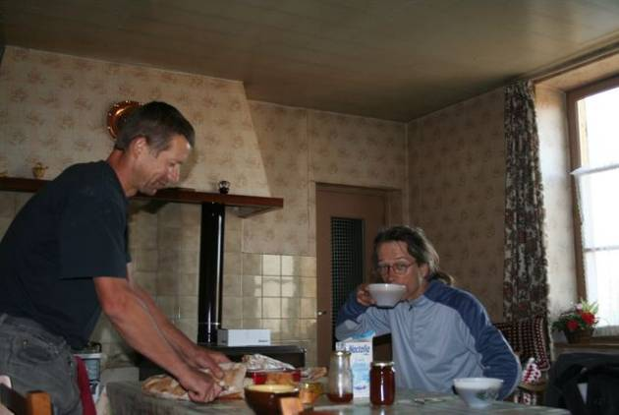We hope you will be as pleased as we were to learn that St Bônnet le château is not only a well-preserved medieval village (which can only be reached by arduous, winding roads) but also the world capital of pétanque (boules). For us it offered a foretaste of the Pyrenees. While mapping out the following day's ride we realized with much dismay that yet more climbs were in store for us. A quick consultation with some retired locals lead to an alternative route consisting of an easy descent to the Loire valley and a pleasant ride following the meandering river of the same name.
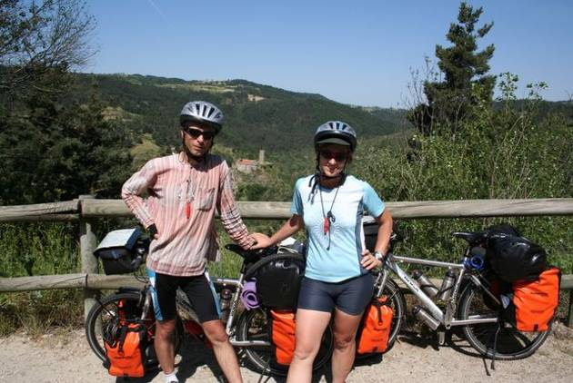
We are now enjoying a well-deserved rest day, playing tourist and seeing the sites of Le Puy. Tomorrow bright and early we'll set of on the via podensis leading to the St Jean pied de Port, another crossroads to Santiago de Compostelle at the foot of the Pyrenees.
update 3. - santiago and the road to the end of the world
21 July, 2006 Location: Sines, Portugal
Le Puy, France to Tui, Spain
Total kilometers cycled: 3,519
Maximum distance in one day: 144 km
Most frequently asked question: "Why are you torturing yourselves like this?"
Best question: "Where's the engine?"
You may be asking yourselves why we haven't reached Africa yet. Instead of taking the direct route, avoiding hordes of European holiday-makers and crowded campsites as reasonable people would, we decided to take the long route, do some sightseeing along the way and find out what it's like to be a tourist at the height of the holiday season (not recommended!). We also thought that roads on the Atlantic coast would be flatter and the air cooler. In fact, the coast is very hilly, temperatures have been above 35 C most of the time and when the air was cooler we had to reckon with strong headwinds.
Encounter with 'traveling folks'
We left Le Puy after a well deserved rest day and reached the busy "camping municipal" of St Almans sur Batignoles, where the fête du village was winding down and a band of gypsies was the only group of campers in sight. We were welcomed to the campground by the inebriated mayor, who couldn't be bothered to collect the fees anymore. A few hours later a retired Belgian couple turned up and accosted Amaya (with her blonde hair she obviously wasn't part of the gypsy crowd). Gypsies don't enjoy the best of reputations in Europe and the Belgians had bolted the door of their camper and were dreading nightfall. Being the politically-correct individual that she is, Amaya attempted to reassure the frightened couple: "They look like fine upstanding citizens to me." and "I'm sure they won't try to rob you in your sleep."etc. In fact they were a quiet bunch (apart from a minor brawl that broke out) and in the end we were disappointed that they didn't do anything even remotely gypsy-like such as offer to tell our fortunes or sing and dance around a roaring campfire.
In sharp contrast to the farmlands and villages we had passed earlier, the plateau of Aubrac offered austere, windswept landscapes, limestone rock formations and highland pastures. A leg-breaking climb brought us up to the pass at 1,340 meters and then we were rewarded with 24 kilometers of downhill cruising. Such remote and desolate areas often give rise to myths and legends and Aubrac is no exception. As all good French schoolchildren know, La bête du Gévaudan, a beast half hyena, half lion terrorized the region in the 18th century and was responsible for the disappearances and deaths of numerous individuals.
Most beautiful Villages in France
In the Midi Pyrenees, we cycled through the area that must have the highest concentration of villages voted "plus beaux villages de France". Some beautiful villages indeed, though some have long lost their "authenticity" (Conques is one of them), with most of the traditional houses turned into shops and restaurants frequented by free-spending tourists. Some villages still hold on to their spirit and charm and you have the feeling of being transported back to another era, when social life revolved around the corner café and people chatted with their neighbors instead of strangers in an on-line chat room.
Bicycle race
One fine Sunday afternoon our itinerary overlapped with that of an amateur bicycle race and we were constantly overtaken on the uphill climbs, which might have been disheartening if each cyclist hadn't had a word of encouragement and admiration as they passed. As we finally approached the top an exceptionally long climb, we were greeted with applause and invited to partake in refreshments. Cycling remains a predominately male pastime in France with only 18 of the 215 competitors being female. This figure is increasing each year we are told. Eric had a nice chat with on of the old-timers who was ful of advice and tips for us.
The five additional cycling days required to reach St Jean Pied de Port and the Spanish border became more and more strenuous, with never-ending leg-breaking ups and downs, passing through the Armagnac and Gascogne regions with another high concentration of "plus beaux villages" de France. One campsite manager told us about a couple of cyclists from the Alps who had found this terrain the hardest since they left home. This remark didn't help soothe our muscle-aches, but it was good for our morale.
Modern day Pilgrims
St Jean Pied de Port greeted us with rain and cold and we pitched the tent as it poured. Once all set up, we didn't dare venture out and huddled in our shelter and gobbled down muesli to calm the hunger as the rain fell heavier and heavier.
Finally, as the storm receded we trotted down to the village, paid our two-euro registration fee, picked up a conche (shell) and officially became pilgrims on our way to Santiago to Compestela in Galicia. During the Middle Ages pilgrims from throughout Europe steadily made their way to this holy city and the route is brimming with history, legends and art. Since the mid 1980s there has been renewed interest in the 'Camino de Santiago' and today thousands of people make the more than 800 kilometer journey on foot, by bicycle or on horseback.
Crossing the Pyrenees to reach Pamplona was easier than we had anticipated in spite of a downpour and near zero visibility at the summit due to foggy conditions (sorry no breathtaking photos!). We cycled through the city gates--the very same through which the bulls pass during the famous San Fermín festival-- and wandered through the cobblestone streets of the old town admiring the Gothic architecture and taking in the ambiance of Navarra.
In our new role of pilgrims, life was much easier in some respects. Firstly, to find our way we merely had to follow the ubiquitous large yellow arrows indicating the Camino. Secondly, we were entitled to stay at inexpensive pilgrims hostels. These hostels may be cheap ( 4 euros per person) but one has to cope with snorers, early risers (5 AM seems to be popular with German walkers) and plastic bag freaks who pack and repack their sacks in the wee hours when reasonable people only want to catch a bit more shut-eye.
Those big, yellow arrows also led us into some trouble. Following them out of Pamplona brought us to a dry, barren stretch of land and the formidable Alto del Perdón. Well, we had to push the bikes most of the way up the ascent as the terrain consisted of man-sized holes, annoying rocks and loose gravel. We soon discovered that doing the Camino on a fully-loaded bicycle meant finding alternative routes at times. During the 11 days we spent on the Camino we encountered diverse landscapes--vineyards and farmlands , the small peaks of the Oca mountains, the plains of León, the wheat fields of the Meseta (flatlands) and finally the lush countryside of Galicia--and diverse individuals--many who were on a spiritual search, perhaps inspired by Paolo Coelho's bestsellers, others who desired a physical challenge and also various history and art buffs.
On the downside, there are also large sections of the Camino which follow the national highway and are thus noisy and nerve wracking. For a cyclist this isn't so bad as the kilometers go by rather quickly, but for the majority of the pilgrims, who are on foot, this means countless hours spent under the ruthless sun listening to the whoosh of trucks speeding by.
This is when the MP3 player comes in handy.
Renewed interest in the Camino de Santiago has also turned the route into a bit of a commercial circus, with Pepsi, Coca-Cola and Nestle all vying for the pilgrims' euros. Vending machines tempting thirsty trekkers are located at strategic points along the way, just before the village water fountains offering up refreshing (and free!) water.
The highlight of the pilgrimage was receiving (for the 'suggested donation' of 2 euros) the Compestela, an official certificate issued by the Pilgrims Bureau in Santiago accrediting the completion of the pilgrimage. We'll be sure to have it framed to hang up with other prestigious documents and awards to impress colleagues and friends.
The End of the Earth
Purists believe that pilgrimage actually ends in Fisterra--the end of the earth. The Spanish tourist authorities insisted that this is the most western point of continental Europe although many French are fooled into believing that this point is in western Bretagne. Well they fooled us too as we later found out. Portugal holds this point at Cabo da Roca. Not
knowing this at the time, we made the detour to
Fisterra. "It's not even a hundred kilometers and it'll be flat," assured Eric. He couldn't have been more wrong. An arduous six hours of cycling and a roller coaster ride through narrow winding ways finally brought us to the pilgrims hostel some 15 kilometers before the lighthouse marking the supposed most westerly point. This little side trip cost us 3 days and liters of sweat!
Being in a pilgrimage kind of mood, we decided to continue on the "Camino Portugues", but in the opposite direction. It was obviously not as easy to find the yellow arrows heading the wrong way and the locals were befuddled when we headed away from Santiago. "But this is not the Camino, " they insisted with a baffled look and sigh of exasperation. So we ended up riding the windy and winding Atlantic coastal roads instead. With a sense of accomplishment we finally reached the Portuguese border on the 10th of July.
We expect to be on the ferry to Africa in early August, so we've still got a few more weeks of European holiday-making ahead of us. Many thanks again to all of you for your support of our fundraising efforts for CAMFED and your encouraging emails--do keep in touch!
All the best--Amaya and Eric
update 4. - cruising down the coast
7 August, 2006
Tui, Portugal to Chefchaouen, Morocco
Total distance cycled: 4,484 KM/2,802 miles
Number of flat tires: Eric 1 Amaya 0
Maximum distance in one day: 178 km /111 miles
Most frequently asked question in the Rif mountains: "Wanna buy some kif?"
Highest recorded temperature: 41 degrees (106 Fahrenheit) in Seville at 5 pm.
After almost two months of traipsing through Europe, we have at last arrived in Africa and are set to begin the second leg of our journey under the scorching Moroccan sun. Chefchaouen with its bustling market, laid-back cafés and picturesque campsite overlooking the town has got a hold on us and, as many travelers before us, we'll surely end up spending far longer than planned here. 'No' our reluctance to move on has nothing to do with the widely-available Kif (marijuana) that is so freely indulged in here. With his long hair, Eric is a constant target for casual dealers and one determined gentleman even tried hard to convince Amaya of Kif's ability to improve cycling performance and diminish the ill-effects of the heat--well, we'll never know if those claims have any substance.
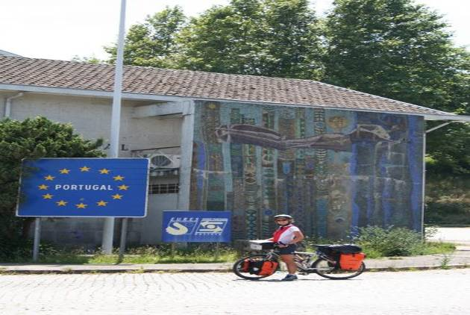Chefchaouen grew to fame in the 70s as hippies flocked there to chill-out and partake in the illicit drugs. The town has cleaned up its image and nowadays it attracts middle-class French families, young European backpackers and the occasional Moroccan tourist thrown in for good measure.
But we're getting ahead of ourselves. In early July we crossed the Portuguese border and then headed straight to the Atlantic coast and, for the following two weeks, never strayed more than 15 kilometers from the ocean and its refreshing breeze. The first thing that struck us about the land of Fado and Fatima was the ubiquitous cobblestones. They're lovely in pedestrian zones, but the bumpty-bump quickly becomes tiresome when you're cycling over them for kilometers on end. For some odd reason (financial perhaps) paved roads haven't caught on in some parts of the country and cyclists are doomed to either risk life and limb on the highways or suffer a bone-jarring ride on the backroads. We chose the later.
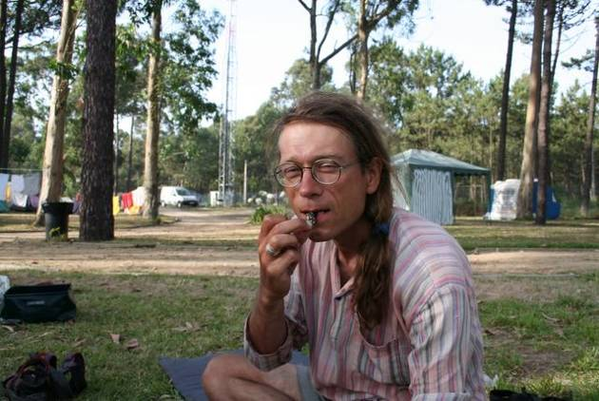
We found the Portuguese to be very hospitable people and even more so in the less-touristic north. On our first evening a couple in the adjoining campsite timidly approached us with a dish of steaming shellfish. The woman had surely seen us eying her enviously as she prepared her husband's catch (we were preparing yet another plate of spaghetti) and had taken pity on us. Although we're still not quite sure what we devoured (something strongly resembling chickens' feet that had a taste similar to mussels) the kindness was touching and we immediately felt at home in Portugal.
Neither of us are really beach people. Amaya can't stand the feel of pesky sand between her toes and blaring music, screaming kids and the sight of the lobster-red beer-bellies of Northern Europeans and scantily-clad women of a certain age are things we can easily give a miss. But cycling the coast can be wonderful. The views are often breathtaking and the strong gusts of wind invigorating. Large bands of the coast are eerily desert-like, with the sand encroaching on the towns. Off the beaten path, roads can be rough but the tranquility and beauty of the remoter areas are more than just compensation for the discomfort and extra effort required.
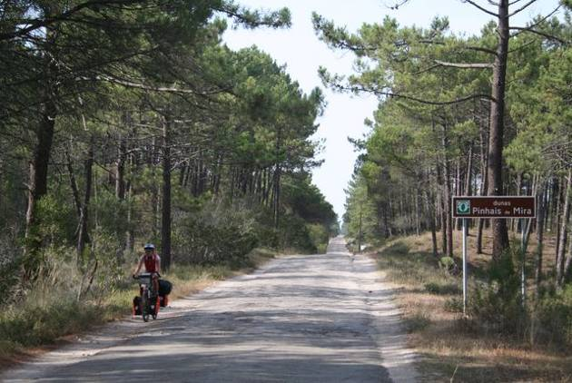
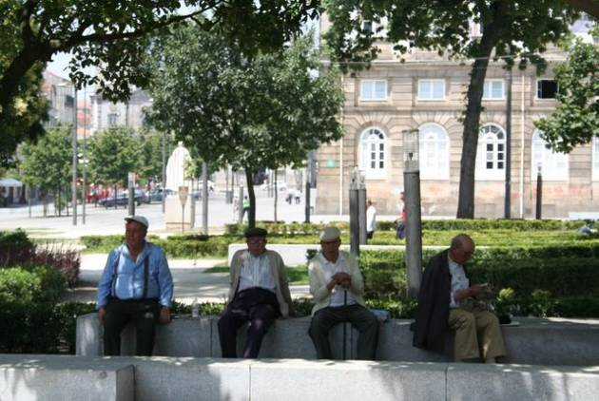
Traditions are still strong in the North and the pace of life much less hectic than in the tourist-infested Algarve region south of Lisbon. Small corner shops selling everything from grocery-items to hardware abound, elderly folk gather in the parks to pass the time over a game of chess and women take the time to chat as they do their daily shopping. Kids are curious and always keen to strike up a conversation with strangers. This, however, often proved difficult as our Portuguese is limited to 'Bom Dia' and 'Obrigado'. Fortunately French is fairly wide-spoken throughout the country and our Spanish and French were a great help in understanding the Portuguese, even if not much help in actually speaking the language.
The World Heritage Sites of Sintra, perched high up on a hill amongst a sea of pine and eucalyptus trees, and Porto with its labyrinth of narrow lanes and slightly sleazy feel that port towns often have don't disappoint. Although we must say a tour of Porto on bicycle is far from ideal. Not only are there uneven cobblestones poking out from the streets, but the endless ups and downs of the city means you spend more time pushing than pedaling. Porto's colorful, narrow buildings seem to be stacked on top of each other, many proudly flying Portuguese flags, sprouting satellite dishes and the freshly washed clothes out to dry in the sea breeze add a touch of color. Sintra has a far more genteel air, with its beautiful park, wide boulevards and tree-lined squares.
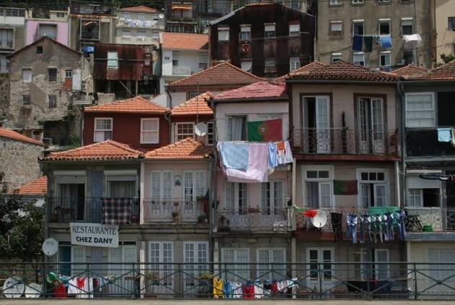
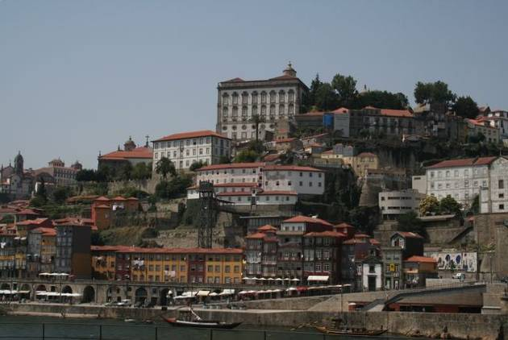
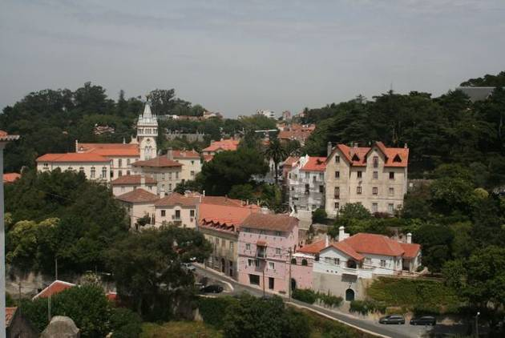
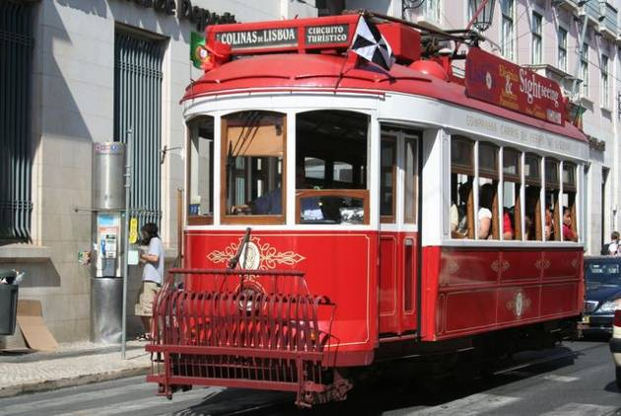
A trip to Portugal wouldn't have been complete without a visit to its capital. Saying that getting to Lisbon was a nerve-wracking experience would be an understatement. Apart from the motorways (forbidden for cyclists, horses and those on foot) the only road leading to Lisbon was the four-lane coastal expressway with non-stop traffic and kamikaze drivers. Fear makes the adrenalin kick in, and we did the 35 kilometer stretch to the city limits in just under an hour. We let out a sigh of relief a tad to soon, as we quickly realized that the campground, although only a few hundreds meters away, lay on the other side of an intricate network of overpasses and highways, all clearly marked as forbidden to cyclists. Not that we would have considered bringing our lives to an early end by taking on the rush-hour traffic. Hot and tired after a long day of cycling, Amaya shed a few tears by the roadside and briefly considered heading for the airport, but Eric's careful reasoning finally won her over (but what will all of those people who are following our web site think? We haven't even made it to Africa yet!). In the end, we were forced to make a long loop around the city to reach the campground and just as we arrived, the clouds burst and we were treated to a tropical-like storm.
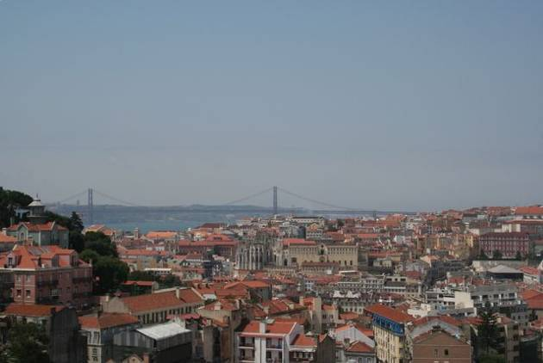
Lisbon is a city on the move, with cranes dotting the skyline and new buildings going up all the time. It's also a San Francisco wannabe with its cable cars and replica of the Golden Gate bridge. Heading south out of Lisbon proved to be far less stressful than entering from the north, and by 9AM the morning of our departure, we were on a ferry heading across the river Tejo (you guessed it, the Golden Gate replica is forbidden for cyclists) and on to less heavily populated areas.
We entered another national park with an almost deserted highway, lonely beaches and sand dunes on either side of us. More pleasant and peaceful riding along the coast until we hit the Algarve region, Portugal's answer to Spain's Costa del Sol or France's Côte d'Azur. A couple of hundred kilometers lined with upscale hotels, golf courses, restaurants serving up international cuisine and shops catering to the huge expat-crowd, mostly comprised of Brits wanting to escape their rainy island. Also a popular locale for the backpacker crowd in search of a cheap spot to party and soak up some rays. We felt distinctly out of place at the rubbish-strewn campsite, surrounded by 20-somethings in various states of drunkenness, and after a sleepless night (we hadn't noticed the outdoor disco next door), we broke camp early and headed further south towards Spain.
Our first stop back in Spain was the eerie Parque Natural de Donana. Rich in bird life, lagoons and salt fields the area was a sharp contrast to the frenzy of the Algarve. Our route then took us to the hot, dusty and sparsely populated Spanish interior. A long campsite-free stretch meant that we put in our longest day yet, 177 KM, on the ride to Seville. Not much to see along the way, and most of the towns we passed were deserted between 2PM and 5PM as their inhabitants had holed up in their homes to escape the suffocating heat.
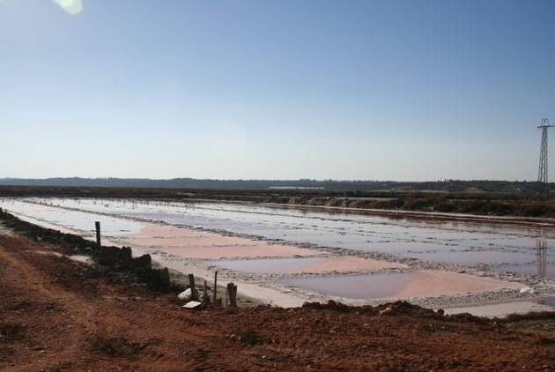
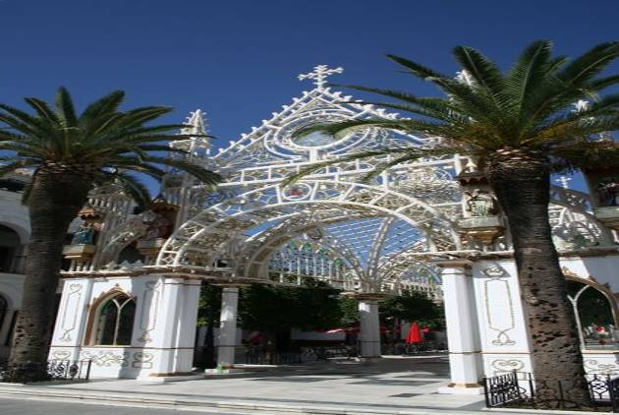
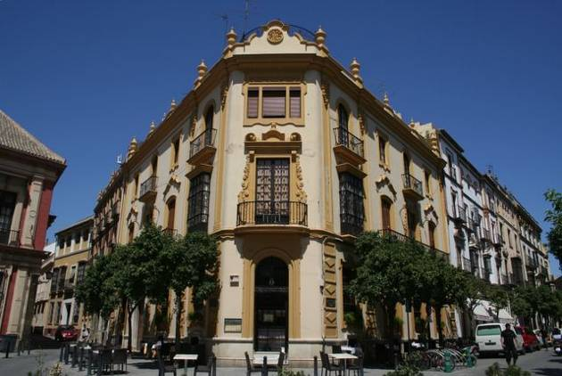
Temperatures in the 40s (100s Fahrenheit) meant our visit to Seville was little more than a series of attempts to get from one shady spot to another as quickly as possible. After a few hours we had to admit that sightseeing in such weather loses its appeal and we enthusiastically headed back to the campground and plunged into the refreshing pool.
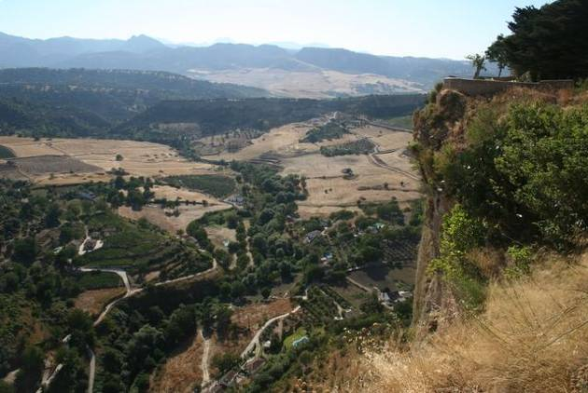
Wanting to avoid the oppressive heat, we forced ourselves out of our comfortable cocoon before sunrise the next morning and were quickly on the road headed out of Seville. After 144 kilometers of flatlands and wheat fields, which gradually gave way to rolling hills and vineyards and culminated in a steep climb of hairpin curves, we arrived exhausted and thirsty in spectacularly-situated Ronda. The city is built high atop a mountain and is surrounded on all sides by steep cliffs which give away to the fertile valley below and is an amazing place to explore.
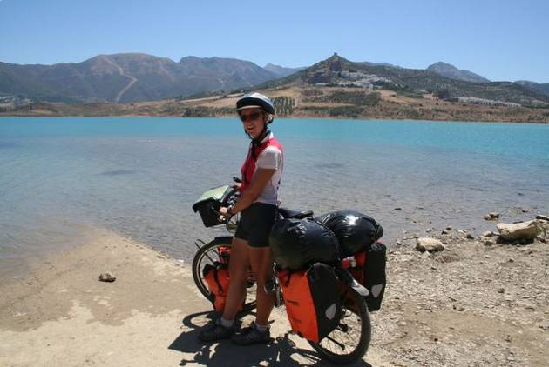
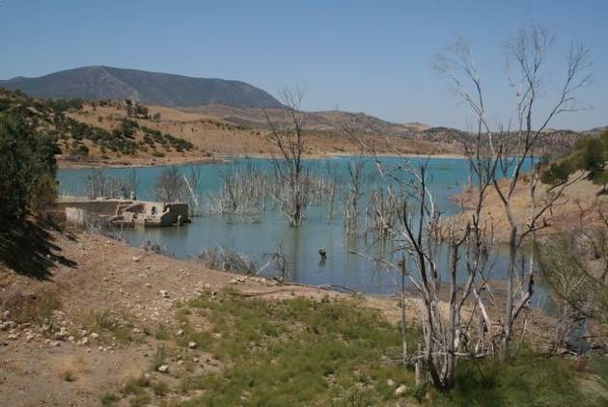
Having been assured by several individuals that the road out of Ronda was all downhill to the coast, we lounged around the town till noon, expecting an easy day cycling. As you can imagine, the 17 kilometer climb out of Ronda up to Alijar pass came as quite a surprise to us. Thankfully, the scenery was lovely , but we're still asking ourselves how all those people could have been so mistaken about the terrain.
Our final stop before hopping on the ferry bound for Africa was Gibraltar and a meal at the Punjab Palace. Now, what could be more British than an Indian curry house? After having filled our stomachs with generous portions of Palak Paneer and Veg Curry ( a nice change from pasta) we took a stroll about town, admired the English architecture and were rebuked by the orderly Bobbies who didn't take kindly to cycling in the pedestrian zone.
During the last month we also had the chance to catch up with two former colleagues of Eric's from Eumetsat. Joe and his wife Brid warmly welcomed us at their holiday home south of Nazare on a lovely stretch of the Atlantic coast. We gorged ourselves on delicious Portuguese pastries and fresh fish and enjoyed cooling off in the pool. In Marbella, we stopped off for a visit with Matt and Pino and had a chance to meet new additions to the family, Lance and Andrea. Matt in particular seems to have taken to life on the laid-back Costa del Sol, and it's no wonder with the beach just minutes from their home and the nearby mountains providing endless hiking opportunities.
Confusion reigned in Algeciras as we sought to board the ferry for the Spanish enclave of Ceuta. August is holiday month in France and it seemed all of its inhabitants of Moroccan origin had decided to return to the Maghreb to spend their vacation with relatives. The boat was jam-packed and we felt quite conspicuous in our cycling gear. The normally quiet border crossing into Morocco was sheer mayhem, with vehicles backed-up for kilometers and pushing and shoving on all sides. After a two-hour wait, we were awarded the coveted entry stamps and triumphantly cycled down Morocco's Mediterranean coast to discover the land and its people.
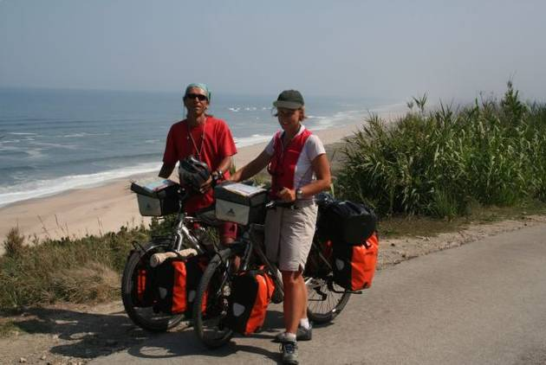
update 5. - heat, heights and hospitality
5 September, 2006
Chefchaouen, Morocco to Tafraoute, Morocco
We loved...
- indulging in delicious 'French' pastries for a fraction of their price in the Hexagon
- the warm welcome and laid back hospitality of the Moroccans
- the few drops of refreshing rain that fell while we crossed the barren plains
- the numerous cheers, thumbs up signs and shouts of encouragement we received along the route
We loathed...
- being chased after by the Moroccan branch of the 'one pen brigade'
- the extreme heat and resulting thirst that even a liter of coca-cola wouldn't quench
- the inconsiderate and infantile backpackers who prevented us from getting a good night's rest
- the maniac bus drivers who refused to give up even an inch of the road to lowly cyclists
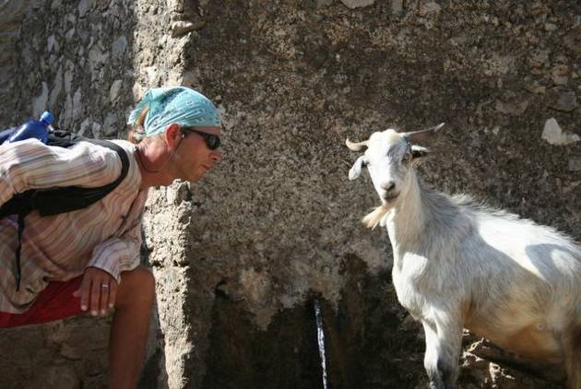
We're actually thankful to have made it to Chefchaouen all in one piece. On the final kilometer of a steep climb up to the city, a jam-packed bus came barreling down the road at top speed and was taken by surprise by a broken down delivery truck blocking the route behind a sharp bend in the road. The driver slammed on the brakes, went into a long skid and came to a sharp stop just meters in front of two very shaken-up cyclists. Out of nowhere the truck driver appeared (perhaps he had been dozing in the cab), sauntered over to where we were recovering from the fright and remarked calmly 'Les gens sont fous.' Indeed, there are a lot of crazy people in the world.
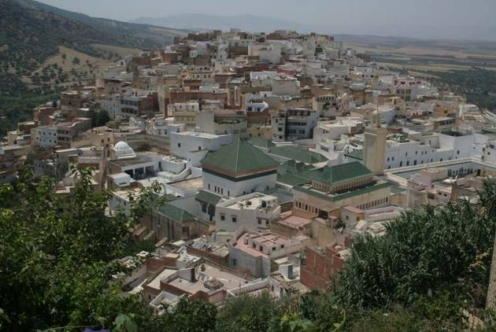
As we dined on Chefchaouen's main square late one sunny afternoon, our impression of Morocco was hardly that of an exotic land full of intrigue and mystery. We were surrounded by other European vacationers in an area where restaurant menus were available in four different languages and one could hardly make it 10 meters down the street without an invitation to have a look in a shop stocked with Berber handicrafts or handmade carpets juste pour le plaisir les yeux, as we so often heard. Nonetheless we spent almost an entire week lazing about in Chefchaouen. One day when we had had enough of browsing the markets and people watching, we decided to head up into the mountains of the Rif Mountains National Park, the entry of which was just a stone's throw from our campsite. Uncertain as to which path to follow as the road came to a fork, we flagged down a man on a donkey and asked for directions. In addition to Arabic and a Berber dialect, the gentleman spoke Spanish, which is in fact quite common in northern Morocco given that the area was under Spain's rather than France's influence. Off to the left, he explained with pride, there were plantas grandes. Hmmmm. Big plants. No need to ask which kind of big plants he was referring to since the Rif region was well-known for its cultivation of marijuana.
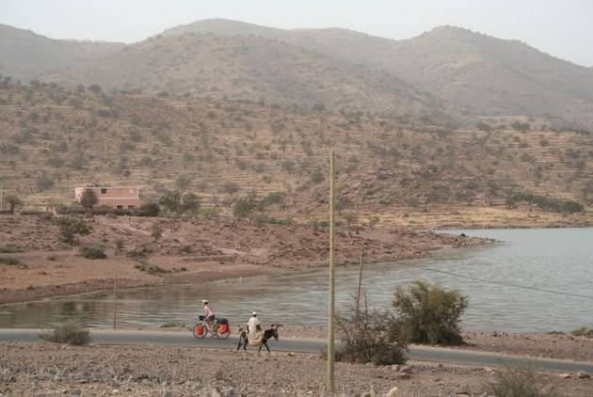
Not wanting to get mixed up with any dodgy individuals who might have been involved with those plantas grandes, we chose to take a right instead. The path took us up to an altitude of more than 2000 meters and along the way we spotted some pretty impressive looking five-leaved plants as well. Sore muscles the following day were proof enough for us that cycling and hiking work different parts of the body. Needing to 'recover' was, however, a good excuse to be lazy for another day and postpone facing the heat of the plains.
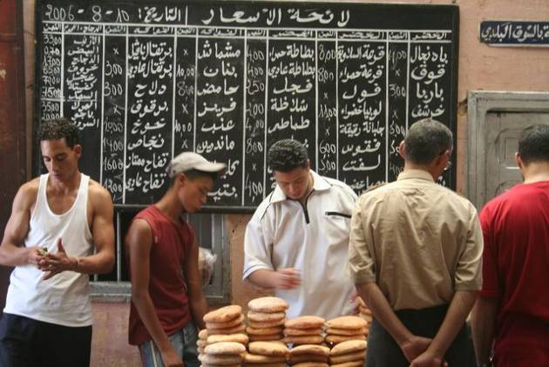
Our next destination was the imperial city of Meknès, famous for its well-preserved medina dating back to the 10th century. Leaving Chefchaoun, after just a few hours of cycling through wooded areas, we were once again down on the flatlands and, with temperatures in the 40s and trees harder to find than public restrooms in Spain, cycling was tough. We carried on until late into the afternoon and suddenly realized that we were in the middle of NOWHERE. We had just passed through the last town of any size indicated on our Marco Polo map and it had no hotels or even a simple room to rent above a café. Not knowing what to do, we sought the assisance of a helpful police officer who suggested we camp at the service station just down the road. This immediately conjured up images of a lone pump on a dusty plot of land surrounded by stray dogs and debris. You can imagine what a pleasant surprise we had upon arriving at the sparkling new Afriquia Service Center with its lush lawn, chic café and functioning toilets. We were given a spot on the roof to pitch the tent, from which we had a bird's eye view of the spectacle below. Afriquia was obviously THE place to be on a Friday night. As soon as the sun went down, cars starting pulling in, not to fill up with gas, but to enjoy a high-priced cup of coffee on the Paris-style terrace overlooking the pumps.
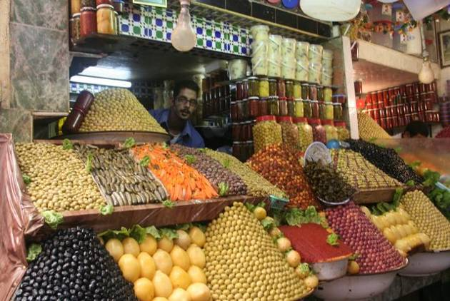
This provided a good bit of entertainment until we snuggled up in the tent and were lulled to sleep by the Arabic pop music being blasted out of the meter-high speakers, only to be woken up a little later to the sounds of the muezzin calling the faithful to worship in Afriquia's own in-station mosque.
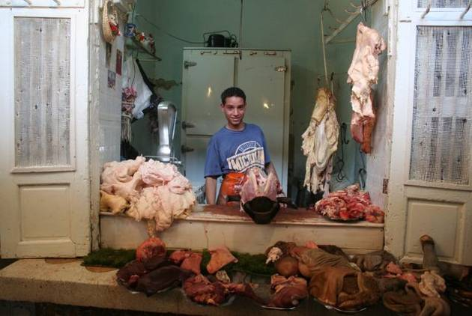
Our travel guide ranks Volubilis and its Roman ruins (yes, ROMAN!) as one of the highlights of a trip to Morocco. Blame it on the unrelenting sun, but we missed the 'amazing mosaics and truly Triumphal Arch'. When we reached the junction where the site was signposted as being just three kilometers away, we took a quick look at each other and continued on towards the campground. The lure of a patch of shade and a bit of respite from the UV rays had won out over culture, history and personal edification.
In the souks of Meknès we found the exotic Morocco we had been in search of. Food markets brimming with artistically arranged olives, dates, almonds and colorful fruits stacked up in precarious pyramids. Butchers hacking away at all sorts of animal parts from the head to the hooves. Bearded men in flowing robes hawking 'antique' carpets and flimsy souvenirs to unsuspecting tourists. Best of all, amid all the hustle and bustle, stumbling upon a quiet shaded courtyard with a simple café serving up a mean mint tea and offering a cool place to rest tired feet.
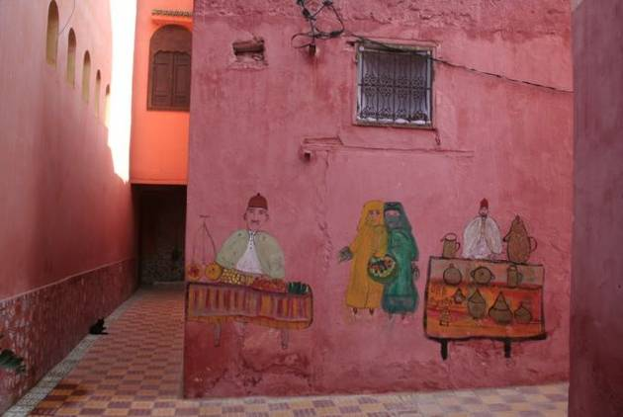
Still in search of cooler temperatures, we headed back up into the mountains to Azrou, a quiet Berber town surrounded by the cedar forests of the Middle Atlas. Again, almost a week went by before we could face the furnace that awaited us back down on the plains. We had gotten more than enough rest in Chefchaouen, so we spent the time cycling around the area, up to Morocco's premier ski resort, Mischliffen, to Ifrane, or little Switzerland as the locals like to think of it, and we spent a day trying to find all the lakes on the Lake circuit. We certainly would have been more successful if the signposting wasn't just in Arabic at some key crossroads.
As we made plans to move on, Hassan, the hospitable owner of the Azrou campsite, warned us about the scenic route we planned to take leading to the waterfall Oum-er-Rbia.
I sent a pair of Dutch cyclists up that way not long ago. The left before dawn, but were back by 9AM. They couldn't take the hills.
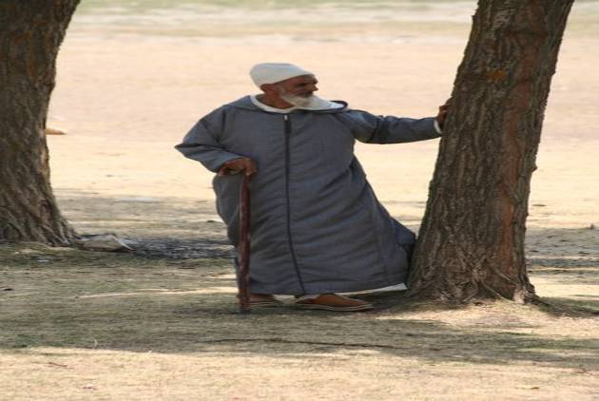
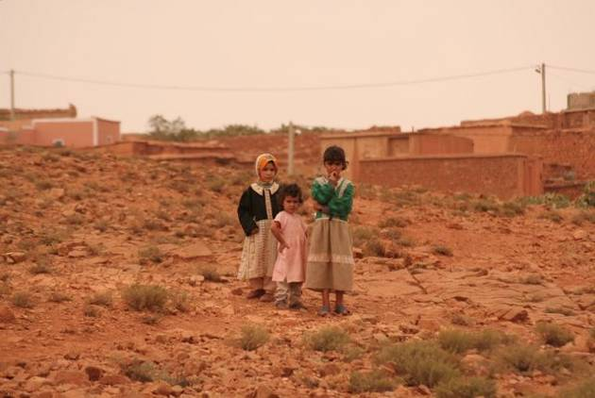
We decided to give it a try anyway, and found out that the hills weren't half as bad as the kids lining the route. Up until that point we had only been greeted by big waves and enthusiastic bonjours--never any begging. That day the kids were out in droves to hassle the tourists. We reckon they were fed up with their requests for bombons, pens and money all being ignored by the passing motorists, and had decided to take out their frustrations out on us. Gangs of pre-adolescent boys darted out in front of the bikes to block the road and even a few girls couldn't resist a tug on the back of the cycles. It was all very tiring and a pity to see what a negative impact tourism has had on the local population.
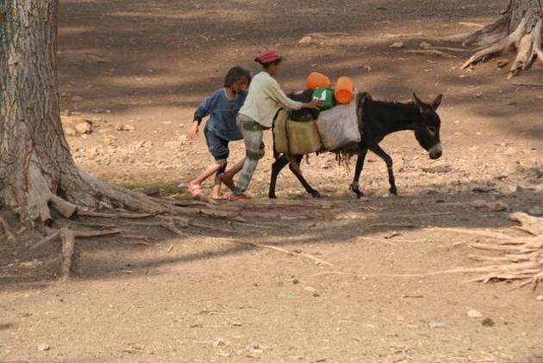
Next came more cycling through the gentle hills of the Middle Atlas south of Khenifra with some spectacular scenery along the way. One afternoon we spotted a patch of grass (very rare commodity in these dry parts) with a bit of shade (even rarer) along the highway and decided it would be the perfect spot for a picnic. Just as we were getting settled down to a fine meal of olives, Laughing Cow cheese and a crusty baguette, the owner of the property turned up. Not in the least bit bothered by our presence, he insisted on bringing down a table and chairs and even served us a pot of tea after the meal. After having refilled our water bottles with refreshingly cool water from his well, we were sent off with some delicious figs and wishes of bon courage.
A brief stint back down on the plains near Beni-Mellal led us back up into the mountains as we decided that the rigors of the hills were preferable to roasting on the flatlands. A steep climb that wound round and round the mountainside and then whoosh down the other side in a flash with fantastic views of the crystal- clear waters of the lake below. We spent the night at the derelict campsite below the Bin-el Ouidane dam and (unsurprisingly) had the place to ourselves. The campground was in ruin and surely the toilets hadn't received even a yearly scrub down. Fortunately, the peaceful lake made up for the lack of creature comforts and cleanliness and, in any case, we had little choice, as our weary legs needed a rest before the climb back up out of the mountains.
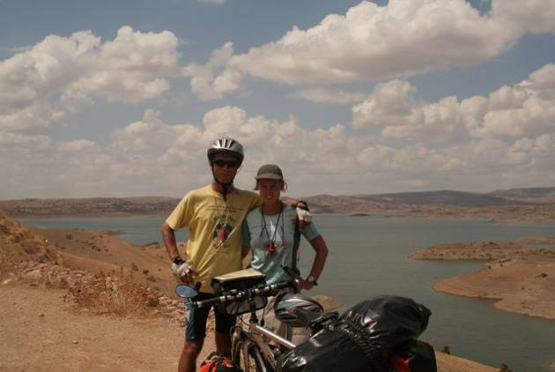
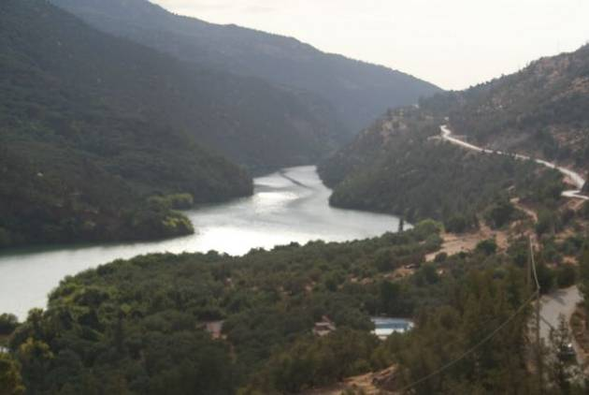
The next morning as we pulled up to the tiny shop perched on the top of the mountainside, hoping to fill up on sugary cakes and fizzy drinks, Mustapha, the guardian of the local school, invited us to have tea with his family. A short walk over the rocky terrain as he shooed the goats away and cleared a path for the bicycles, brought us to his simple three-room home where he lived with his wife and five children. As we sat around sipping mint tea and munching on almonds, Mustapha spoke of the low wages and high cost of living in Morocco, and his hopes of obtaining a passport and visa in order to travel to Spain and work in the agriculture sector. This was in fact fairly common in his village and several of the teachers at his school had already made the trip and come back with substantial savings (by Moroccan standards). We enjoyed getting to know the family, but eventually decided it was time we were on our way, so we wished him luck with his endeavors, thanked him for his kind hospitality and then enjoyed the easy ride down to Azilal and on to Demnate.
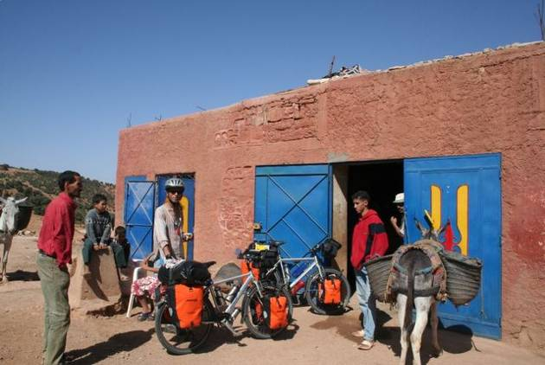
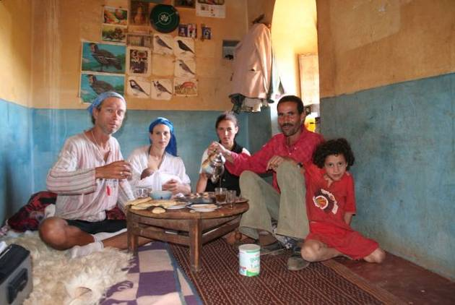
A nasty stomach bug meant Amaya spent the entire following day huddled up in bed hoping to get back enough strength to pedal the remaining 100 km to Marrakesh. Being of hardy Nordic stock, she was up at 5am the next day and raced on through the heat to Morocco's most touristic city. And tourists there were. We checked into what seemed to be a quiet hotel near the medina with 15 simple rooms around a tiled courtyard. What we didn't know was that there were at least 40 boisterous backpackers camping out on the roof. No amount of polite requests, threats or begging could get them to quiet down, so we were rather bleary-eyed as we rode out past the Palmeraie two days later on our way to conquer the Tizi-n-Test pass.
Lack of sleep meant fatigue set in quickly and after just 50 km we reached Asni and decided to call it a day. There was a youth hostel of sorts, but the dark prison-like rooms were so uninviting that we decided to pitch the tent in the shady garden instead. The mountains were bathed in a soft light early the next morning as we set off for what promised to be a grueling day of cycling, with almost 100 km separating us from the pass at 2,100 meters. We were in the High Atlas now and the mountains were stunning. Spectacularly rugged and sparsely vegetated with tiny Berber villages perched precariously in the oddest of places. The lower valleys we crossed were lush with apples, almonds and apricots nourished by intricate irrigation systems that channel water from high up in the mountains. As we neared the top, the road spiraled around the mountain and with each oncoming vehicle we were greeted with cheers. Amaya seemed to receive more than her fair share with the 'Allez, madame!''s outnumbering those for monsieur. Camping at the pass sounded romantic, but with the wind howling all night we could only hope not to be swept down into the valley below.
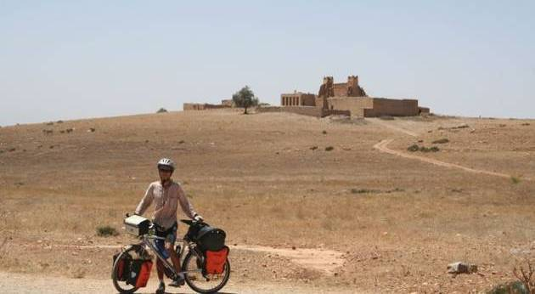
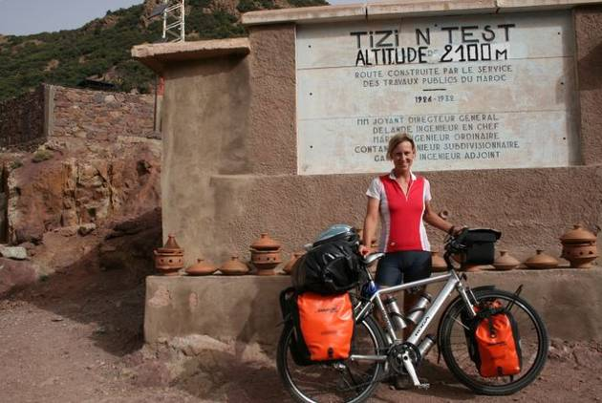
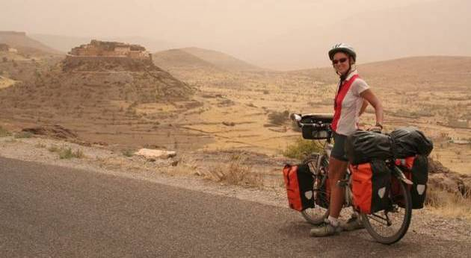
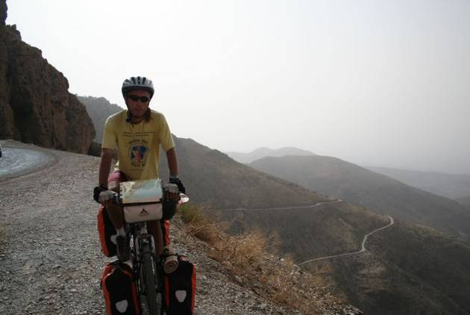
The next morning, a short ride through the fertile Souss Valley past olive groves and orange orchards brought us to the pleasant mud-walled city of Taroudant, which provided the perfect resting spot. We took a room with a terrace overlooking the main square and enjoyed watching the endless stream of bicycles, motorcycles, donkey carts and horse-drawn carriages criss-cross the town. The markets were less of a hassle than Fès or Marrakesh and we could admire the fine craftsmanship of the jewelery, pottery and baskets without any overly-anxious salesmen breathing down our necks.
Well-rested, we were ready to tackle the arid Anti Atlas, the last mountain range before the long and lonely ride through the Sahara. Our plan to take what appeared to be a direct route to Tafraroute following a minor road over the mountains was squelched when the local police officers insisted that we use the brand-new expressway. This was the route for tourists, they insisted, and our security couldn't be assured if we chose to set off in another direction. What dangers awaited us we'll never know as the policeman made it quite clear that the road in question was off limits to itinerant cyclists. Perhaps they were only concerned about us getting lost, which in fact we did, not long after turning off the expressway. The road forked and in the absence of any road signs we chose to go left. The road got narrower and bumpier as the kilometers passed and it looked as if we were headed straight for a steep mountainside. All of a sudden a bearded and turbaned gentleman in a beat-up old Mercedes pulled up and inquired as to where we could possibly be headed. To Tafraroute, of course! With a sigh and chuckle he directed us back to the main route and we were again headed in the right direction.
We were impressed by the lunar landscapes as we traversed the barren mountains, and the effort to cross the Tizi Mlil pass at 1662 meters was duly rewarded as we caught sight of our first palm groves on the descent into Tafraoute. This was a little taste of the tropics that await us some 1000 kilometers further south. The village is in a dramatic setting amongst huge boulders with the Anti Atlas as a backdrop. Naturally, we had to stay an extra day to explore the area and psych ourselves up for the demanding days in the desert which lie ahead.
A quick glance at the map and one might be tempted to think that the coastal road south is a scenic one. In fact, the highway passes through endless stony, inhospitable and very un-picturesque desert known as hamada. Our chief concerns will be obtaining water, since the region is sparsely populated with settlements often over 100 km apart, and combating the boredom of the monotonous landscape. Time to load some new tunes on to the MP3 player and practice some in-the-saddle meditation!
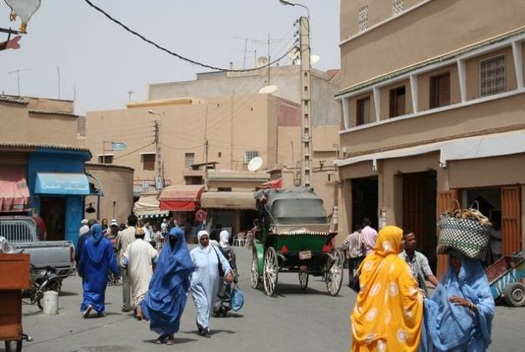
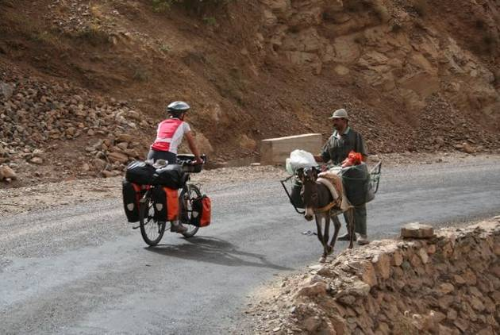
update 6. sahara crossing: 2000 kilometers of solitude, sufferings and surprises
18 September, 2006
Guilmine, Western Sahara to Nouakchott, Mauritania
Total kilometers cycled: 8,126
days cycling through the desert: 14
longest day: 198 kilometers
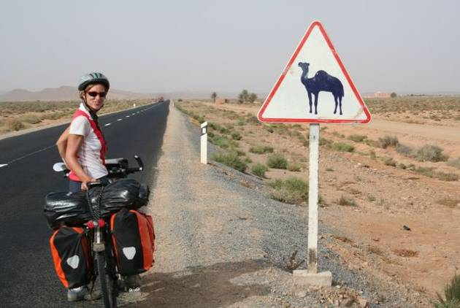
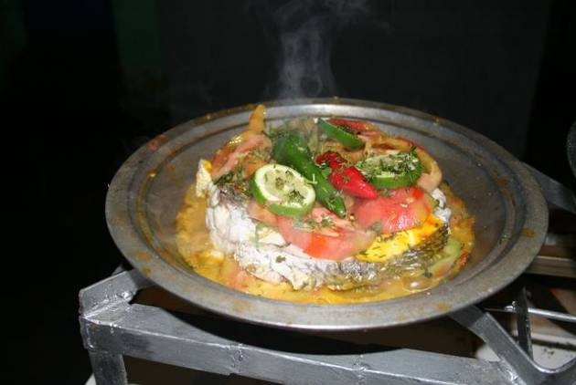
When we first began investigating the possibility of crossing the Sahara, we read tales of military escorts and convoys making their way through disputed Western Sahara and of 500 kilometers of muddy coastal piste through Mauritania, passable only at low tide in a sturdy 4x4 with the aid of an experienced local guide who might navigate at night, using the constellations as a guide. Nowadays, with the Moroccan military tightly controlling Western Sahara and the highway connecting Nouadhibou and Nouakchott finally finished, traversing the desert is a fairly routine affair. Nevertheless, we had our reservations. The region is sparsely populated with settlements (and sources of water) often more than 150 kilometers apart, the desolate landscape offers little shelter from the scorching sun and gusts of wind are known to sweep sand across the highway cutting visibility to near zero and wreaking havoc on contact lenses wearers. There was a certain temptation to hitch a ride on a truck headed south and be done with the desert in a matter of hours rather than days.
'But, yes, we're glad we spent 96 hours, 4 minutes and 29 seconds suffering in the saddle just to reach the Mauritanian capital.'
'Would we do it again?'
'Only for a very large sum of money or several thousand camels.'
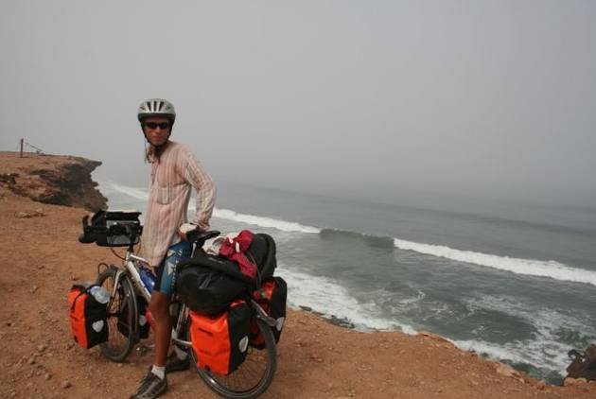
Our first desert surprise came in the form of cloudy and foggy weather which made riding comfortably cool. Cool, that is, in comparison with the 40+ temperatures we had endured in the Moroccan interior. The road out of Tan Tan followed the coast closely and we often hopped off the bikes to peer over the edge of steep cliffs that dropped quite spectacularly into the breakers of the Atlantic. The tang of the sea was invigorating and with the kilometers passing by quickly thanks to smooth, flat roads and a gentle tailwind, morale was high. But at some point, boredom set in and it seemed the counter turned ever slower and slower. Time to think up new distractions such as determining the most popular brand of mineral water by analyzing the empty bottles which littered the roadside (Sidi Ali is clearly more popular than Ciel). Brushing up on little-used elementary school math was also time well spent. Something like 'If Amaya continues to cycle at 27 KM per hour and her destination is 87 kilometers away, what time will she arrive? ' And the old standby, fantasizing about food 'If I could shop at a well-stocked supermarket what would I buy?
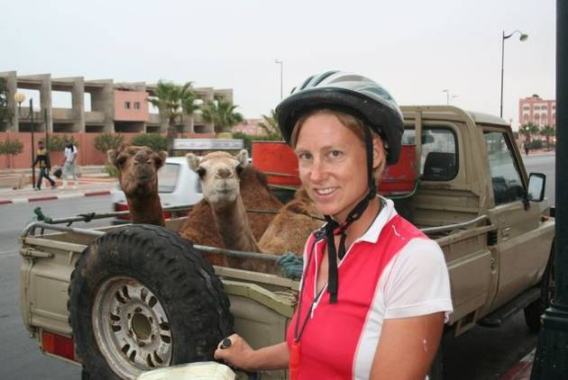
After Tan Tan came the one-road town of Akhfenir where we had our first taste of the delicious fresh seafood available throughout the region. Then it was on to sleepy Tarfaya whose only claim to fame is having been one of Antoine de Saint-Exupéry's stopovers when he was a pilot for the Aéropostale in the 1920's. It was hard to imagine the author of The Little Prince finding inspiration in such a place. Apart from the paved main street with its brightly-lit restaurants and exceptionally good bakery, the town was a sandy conglomeration of half-finished concrete structures and dilapidated buildings from the colonial period. There were barefoot and bare-bottomed toddlers tossing a ball about in the dust, oblivious to the dangers of the passing donkey carts and noxious fumes being sputtered out by the patched-up vehicles which raced by kicking up a storm of sand in their wake. We were directed to the town's one hotel, which surely welcomed far more sailors than foreign tourists.
Warm croissants got us off to a good start the next morning and by noon we were in Western Sahara's main city, Laayoune. The ongoing conflict in the region means there is a strong United Nations and Moroccan military presence in the town. Several police checks before entering the city (they seemed most interested in our professions), loads of Toyota Land rovers speeding past with UN emblazoned on the side and expats hanging around the internet cafés. As Eric was checking in at the main post office to see if a package he was expecting had arrived (it hadn't) he got into a heated debate about Saharan politics with a fellow client. Later that afternoon we ran into the gentleman again just outside our hotel and, as we were chatting, a police van pulled up. After a brief exchange of words, the officers whisked the man away despite Eric's assurances that everything was in order. Maybe all those UN Observers should spend more time checking out what's going on in the streets and less time observing what's happening in the city's posh hotels.
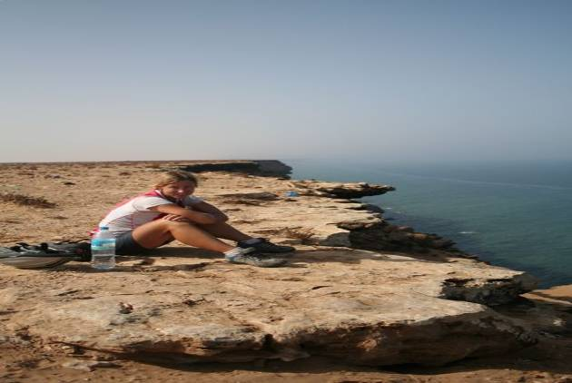
On our way out of town the next morning we caught sight of our first camels, albeit in the back of a pick-up truck. During our ride through Western Sahara we passed several villages, obviously newly-constructed with street lamps, and tidy-looking lanes, the buildings painted in soft pastel hues, but never a person in sight. These phantom villages, plopped down in the middle of the desert, really baffled us. One evening as we were stocking up on supplies for the following day (canned tuna fish, processed cheese and the like), we met the caretaker of one such village who cleared up the matter for us. The Moroccan government had constructed the villages for an expected influx of Saharan refugees returning from camps in Algeria. The refugees haven't returned and entire villages, complete with schools and mosques, lie empty.
Down the coast and through the desert we continued, stopping three days later in Dakhla for a rest before the final stretch into Mauritania. There were lots of vehicles with European license plates heading in our direction, but these were not your typical tourists. Cars are a lucrative business in these parts and a late model Mercedes can command a good price in West Africa. We met many French people who made a living this way, driving down through Europe and Morocco several times a year and then selling their auto in Mauritania or Senegal and then flying back home. Supplemental income, we were told, could be made by hawking a few bottles of wine on the side or other hard-to-come-by items such as perfume or even deodorant.
Four kilometers of heavily mined No Man's Land separate Mauritania from Morocco. We were advised to stay on the rough dirt track and shoot straight for the huts housing customs on the other side. Off to the left was a large group of cars--those without the proper papers (ie stolen) were haggled over here and then brought into the country after a little palm greasing. With a fair amount of pushing through the deep sand we made it to the Mauritanian side and were greeted by two exceedingly friendly immigration officers who immediately filled our numerous bottles with much needed water. While we were waiting for our personal details to be recorded in a very official-looking ledger we met Fabrice, who was traveling in the other direction, back to France with his new Senegalese wife. She had been turned back at the border just a few months ago due to a new law requiring citizens of Senegal (and many other sub-Saharan countries) to enter Europe by air only. This in an attempt to stem the tide of immigrants seeking a better life further north. For Fabrice and his bride it just meant a lot of hassles and dealings with officialdom in order to receive authorization for her to enter Europe by land.
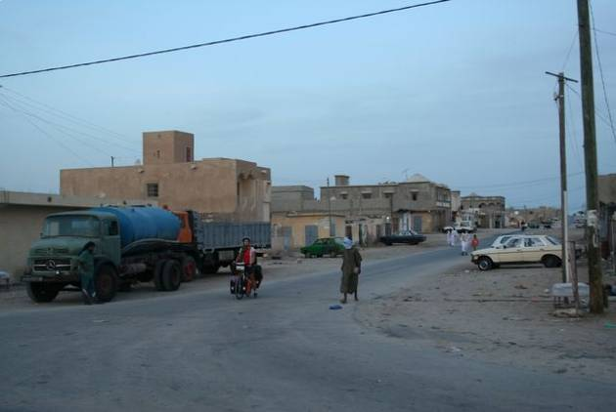
We thought traveling through some of Asia and Latin America's poorest and most chaotic cities (Calcutta and Tegucigalpa, Honduras come to mind) would have prepared us for anything full-on Africa had to offer. Not so. Nouadhibou, Mauritania's second city and economic capital, came as a shock. The city is depressingly run-down and the town center, with goats doing the only garbage pick up, ranks just above a shantytown. Everyone on the road seemed to be in a hurry with drivers impatiently tooting the horns of their patchwork Mercedes and vehicles veering on to the sandy shoulder of the road to pass each other. Quite a scary place to be cycling. Rusting ships litter the harbor and abandoned warehouses and plants dot the outskirts of town.
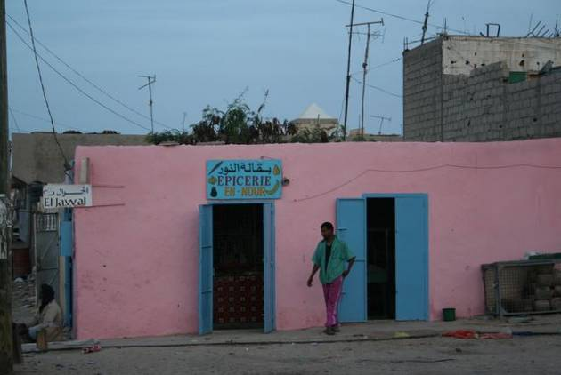
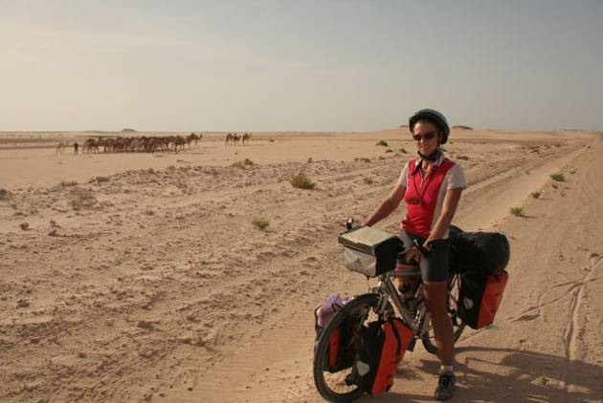
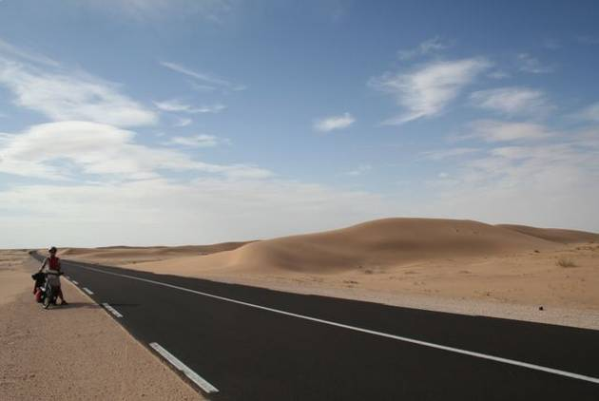
It was Africa overload for us and we took refuge in a quiet auberge run by Senegalese immigrants Momo and Fanta and didn't venture out until the following afternoon when we went looking for lunch. At the restaurant recommended in the guidebook, we were told to take a stroll through town and come back in an hour or so (it was 12:30 at the time) when the daily meal would be ready. Taking a stroll through Nouadhibou (to see the sights???) was the last thing on earth we wanted to do. Sensing our hesitation, one of the employees offered to lead us to his sister's restaurant just around the corner. It was a little hole in the wall, but spotlessly clean and cheerfully decorated and the simple meal of spicy rice and fish was delicious. When we went to pay, however, we realized that we had 'invited' our guide to dine with us and that 'sister' was used in the loosest of senses.
As we left town the next morning the smell of fresh bread overpowered that of rotting rubbish and in the soft light the town took on a calmer aura. Maybe it wasn't such a bad place after all.
It was back to the dramatic desert for 470 more kilometers through Mauritania. September is the rainy season further south and this effects weather in the Sahara as well. For us, it meant a strong headwind that hampered progress and put a damper on the fun. Fortunately our extra efforts were compensated with fantastic scenery.
We had been relying heavily on Luke and Anna's (www.africabybike.org) detailed account of their overland crossing for information on the availability of food, water and accommodation. The Mauritania section mentioned several auberges (guesthouses) and lots of restaurants along the way. We briefly envisioned hot showers, soft mattresses and hearty meals. The 'auberges' in question were nothing more than canvas tents with mats on the ground to keep out the sand and a few pillows for comfort. All that was required to open a 'restaurant' was to get a sign made and stick it in front of a tent and wait for customers to show up. Then the proprietor could worry about rustling up something to eat for the hungry clients. We regretted not stocking up better on provisions, as all that could be found along the way was overpriced canned food and not even a loaf of bread or egg could be had.
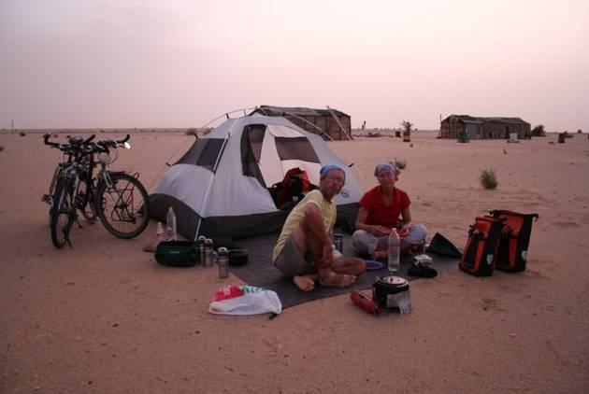
Our first night was spent camping chez Ahmed, who used to make a living guiding foreigners on the treacherous piste between Nouadhibou and Nouakchott and whose source of income had dried up with the completion of the highway. Being an industrious young man, he decided to use his navigational skills (the best GPS lies in the head, he says) to transport 'unlicensed vehicles' to the capital via the off-road track, thus avoiding customs officials and police roadblocks. Apparently he makes quite a good living this way, earning the equivalent of 500 euros for each vehicle brought to Nouakchott.
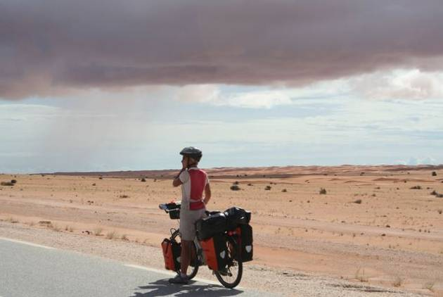
Cheir, an astute businessman masquerading as a simple camel herder, and his family welcomed us the next night. Since the completion of the highway, life had changed a dramatically for the family. They had moved four kilometers inland from the old piste and opened up a shop and a small restaurant beside the new highway which supplemented Cheir's income from selling camel's milk. He had been able to set aside 13,000 euros and was looking for a business partner in Europe. !3,000 euros seemed like quite a large amount for a country with a GDP of just 345 dollars per inhabitant, but when one charges seven times the going price for a meal (as we found out when it came time to pay up) profits must add up quickly. But he was an affable man and the camel's milk he offered us for our corn flakes was tasty, so we quickly forgave him for the price gouging. Before heading off to bed, Cheir warned us that their might be rain. We dismissed this as pure wishful thinking on his part, despite the tell-tale sign of a covered sky. Around midnight we were awoken by gusts of wind sweeping sand into the tent (minus the rain fly, of course) and within minutes we were in the midst of a torrential rain. In a flurry we fumbled to attach the fly and avoid flooding the tent. We were mildly successful, but sand and rain is a disastrous combination and all our possessions were covered in a thick layer of grime.
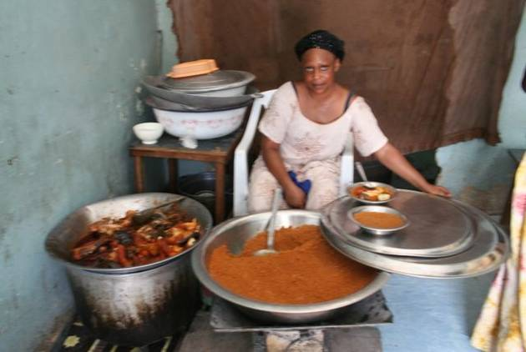
Continued headwinds and stormy weather meant our planned 3-day ride to Nouakchott turned into four. We treated ourselves to a stay in one of the 'Auberges' on the final evening as the damp and smelly tent hardly sounded inviting after a tough day battling the winds. Luck was with us for the last 100 kilometers. The wind had changed and we rolled effortlessly into the capital in time for spicy rice and fish for lunch. The goats were out at work cleaning the town, but they weren't doing a very good job with the plastic bottles which were accumulating in large mounds by the side of the road. Nouakchott won't make it into the top 1,000 tourist destinations in the near future, but it is a step above Nouadhibou in terms of cleanliness and calm. It' not an easy country to survive in. 50% of the population lives under the poverty line, the economy is vulnerable to fluctuations in the price of iron ore, overfishing has depleted stocks and given the very limited industry and arable land, almost all products and many foodstuffs are imported. But based on purely anecdotal evidence, the parallel economy is thriving. Mauritanians are go-getters with a keen sense of business and a desire to improve their situation. And things are looking up these days. The new government --under pressure from the IMF- has opted for economic liberalization and oil has been discovered offshore.
Mauritania, unlike Morocco which is so European in many respects, feels like Africa. It moves to a special beat and there's a feeling of hope in the air despite the overwhelming poverty. It's painfully clear to us that there are many facets to the continent and we've only just begun to scratch the surface.
The worst of the lonely desert is behind us now. Just 200 kilometers and we'll be in the fertile region surrounding the Senegal River. New challenges await us. The rainy season is in full-swing, so surely we'll have reports of downpours and dampness in our next update.
If you'd like to help educate African girls, please consider making a contribution to our charity of choice, CAMFED. African girls have fewer opportunities for schooling than any group on earth, yet without an educated generation of females the continent will never be able to put an end to poverty and dependence on foreign aid. CAMFED supports girls and is in the process of creating a virtuous circle of education and opportunity. Contributions can be made online here.
update 7. welcome to africa!
12 October, 2006
Nouakchott, Mauritania to Ziguinchor, Senegal via The Gambia
Total kilometers cycled: 9,806
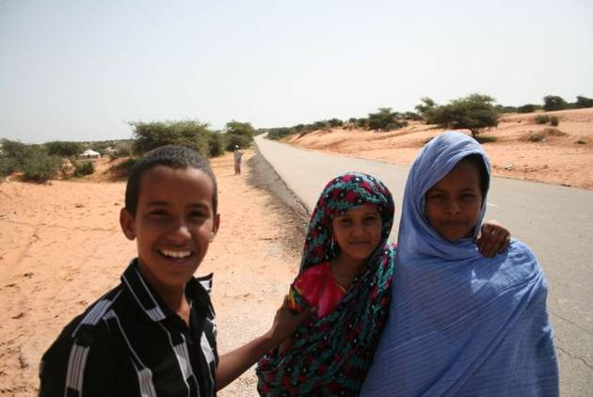
Heading south from the Mauritanian capital in mid September the desert gradually gave way to dry savanna and bush and as we neared the Senegal border the countryside took on an ever more tropical feel. After the solitude of the Sahara, passing the simple compounds of mud-brick huts and watching the daily goings-on of the villagers was a welcome distraction. As the afternoon temperature rose, groups gathered for a chat or a snooze under shady trees and many called out to us to come and have a rest. Having an entirely different conception of time and urgency, they were clearly baffled when we politely declined their offers, explaining our rush to reach the border.
We arrived in the frontier town of Rosso just as the sun was setting and perhaps it was just as well since the dimness masked some of the town's squalor and filth. Border towns are often dodgy places full of shady characters looking to make a quick buck on black market goods or dubious deals changing money, and Rosso was no exception. The immigration office having closed down for the day, we took a room in the town's tourist class hotel after Amaya turned her nose up at the budget accommodation which offered a dingy room with a couple of bare mattresses on the floor, leaky plumbing and the distinct oder of greasy food wafting up from the eatery below. Cost cutting has its limits.
Crossing the border proved trying. After being allowed behind the port barricade a uniformed official snatched our passports and disappeared without a word. We were herded on to the overcrowded ferry and wedged in between the vehicles, still wondering what had happened to the immigration agent. He appeared sometime later and demanded 20 euros for the 'formalities'. We had no intention of contributing to corruption, so under the guise of just wanting to have a look at the exit stamps, Amaya snatched back the passports and quickly hid them safely in her money belt. Seeing his chances for a hefty bribe greatly diminished, the official became livid and insisted we disembark immediately. We ignored his clamors and eventually he gave up insisting we pay the formality fee, surely sensing our resolve not to part with any of our cash.
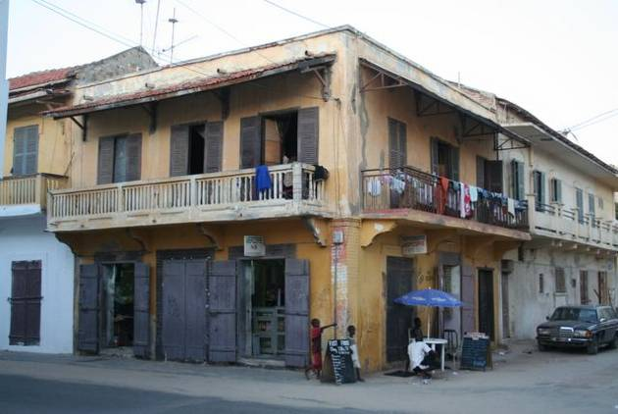
Once across the border a quiet backroad meandered through lush countryside dotted with acacia trees and in each village we passed we were greeted with enthusiastic shouts of 'Toubab', as whites are referred to in these parts. We weren't used to causing such a stir and by the end of the day we were hoarse, having tried to match the locals' exuberant greetings village after village in a fairly heavily populated area. Our first stop in Senegal was the former French capital, St. Louis. The houses are crumbling but the town still has a bit of flair and the surrounding wetlands made for a pleasant enough excursion. We ended up spending several days in St.Louis waiting for the customs agent at the post office to return from his holiday, so the backlog of parcels could be inspected and we could finally pick up our long-awaited package containing new tires. Patience folks, this is Africa!
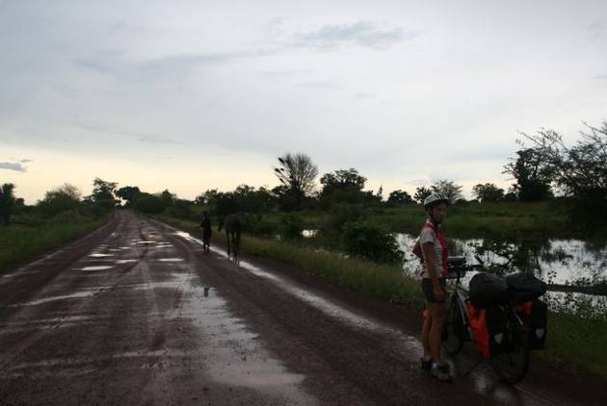
Dreaded Dakar, notorious for congested roads, pushy street vendors and oppressive heat, was our next stop. In fact, we would gladly have avoided the capital entirely, but a need to pick up a visa for The Gambia necessitated a visit. We made the best of things and chose to stay in the nearby fishing village of Yof rather than in the heart of one of West Africa's mega-cities. From the terrace of the guesthouse we watched the sunrise over the Atlantic and peered down at the hustle and bustle as the fisherman set off in their motorized pirogues. Late afternoon the beach was again abuzz with activity as the men returned with the daily catch, fishmongers vied for customers and boys tossed around a soccer ball among the stout women gutting the tuna and barracudas. This being the month of Ramadan, and the region being predominately Muslim, fasting is the norm for most people from sunrise to sunset. Restaurants are open but we're often the only customers and invariably the only thing on offer is Chep-bu-jen--fish and rice. Delicious the first 20 times, but after that a bit monotonous.
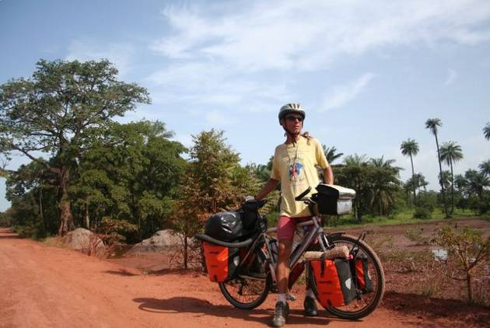
The Gambia, just over 300 kilometers in length and never more than 50 kilometers from north to south, slices through Senegal and takes its name from the river it surrounds. This tiny English-speaking country is a popular destination with British package tourists escaping the drab winter back home. If you confined yourself to the 10 kilometer beach strip where the hotels, restaurants and bars are all congregated, you would certainly have the impression that the country was fairly well-off. Venture further inland and another side of Gambia unfolds. The country is poor, even by African standards and the people are struggling to make ends meet.
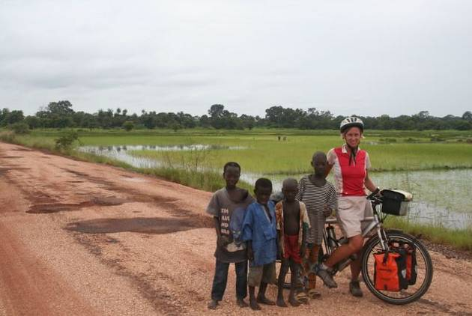
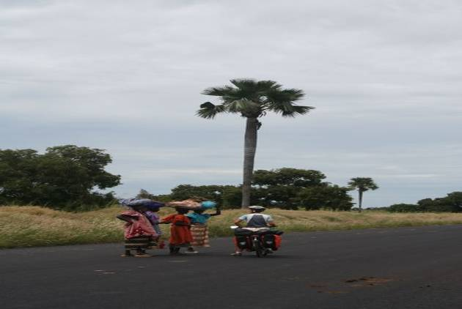
Basic goods are not cheap and there's little on offer in the local markets-- sweet potatoes sold in piles of three or four, a few onions, some okra and perhaps an over-priced aubergine or two if you're lucky. Pasta is sold in minuscule quantities, the smallest bag can't be more than 25 grams. Even bananas are sometimes hard to come by. Amadou, a newly-qualified and highly-motivated teacher who invited us to have a rest and a look at his school, can barely get by on his monthly salary of 1,800 Dalasis (approx. 50 euros) and farmers find it hard to pay for goods such as soap, gas and cooking oil. On a more positive note, school fees for girls have been abolished which means education is now more accessible than ever for females in the country. NGOs abound, new schools are being constructed and safe drinking water is readily available from the town pump or well even in the smallest of villages.
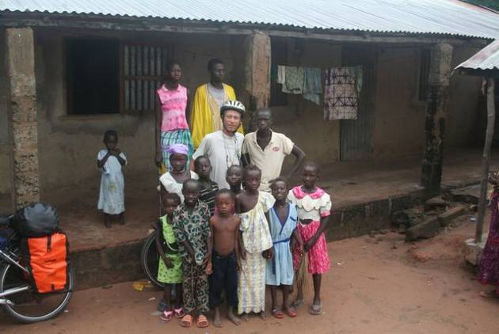
Cycling the south bank road we attracted the usual swarms of youngsters waving wildly after the toubabs and hoping for some handouts--money being top on the wish list. Riding along dodging the potholes also turned out to be a good way to get to know Gambians as the roads are busy with children on their way to school, groups of women filing past balancing loads of wood or buckets of water on their head, and men going off to work. We got a first hand glimpse of life in the countryside when the head of a roadside village invited us to spend the night in his compound. The chief is a man of 80 who lives with his extended family--about 100 people in all we were told--in a series of mud-brick dwellings surrounding a central courtyard. There was a flurry of activity upon our arrival as the men concurred as to where to lodge us, children scurried off to fetch buckets of water and the women rushed about rustling up a meal for us. The villagers were truly hospitable and we were mighty thankful for a roof over our heads when a violent storm broke out in the wee hours of the morning. The next evening we were again saved from a wet night in the tent (no hotels in the vicinity) when a schoolboy, Moutar, invited us to stay with his family. Their compound was simple and lacked the few 'luxuries' of the chief's. There was no radio or kerosene lamp and the children were running around in rags. Nevertheless, the family had somehow found the money to pay Moutar's school fees, there was abundant rice and fish and lots of laughter.
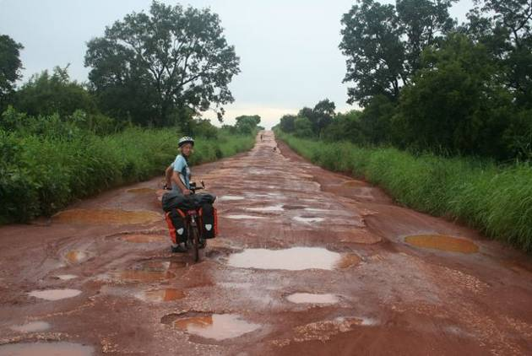
After our tour of The Gambia, we crossed back into Senegal and the picturesque, but troubled Casamance region. Humidity was high and the tension palpable as we cycled through the forests of hardwood trees and past emerald green rice fields to reach Ziguinchor. Once Senegal's leading tourist area, rebel activity and sporadic fighting have kept visitors away in recent years. We were told the area is calm at the moment, but truckloads of nervous-looking soldiers poised for action and tanks rolling past put us off from exploring the backroads.
While the past month has been devoid of 'attractions and highlights', it has been a good introduction to Africa and its people. We have found the locals to be kind, friendly and exceedingly optimistic in spite of conditions that are sometimes appalling. Africans are also a people on the move. We've met Mauritanian shopkeepers in The Gambia, a woman from Sierra Leone tending a restaurant in Banjul, a Nigerian man selling his art in St. Louis and countless others who have worked outside of their home countries, all hoping to better their situations. One afternoon in Banjul Eric even ran into a young Gambian he had met a month back in Mauritania's northern city, Nouadhibou. The man had come north looking for work and then got stuck toiling as fisherman when his money ran out. He was hard up and couldn't afford the trip back home. Fortunately for him, when election time in the Gambia rolled around the president sent three buses up to Mauritania to bring back the voters free of charge. These kinds of chance encounters, rather than imposing monuments and temples, have made the month memorable.
Tomorrow we'll take to the road again and have a chance to brush up on our limited Portuguese as we spend a few days in Guinea Bissau. Then it will be on to Guinea where we hope to find more plentiful fruit and vegetables and also more strenuous cycling as we tackle the hills of the spectacular Fouta Djalon region. The roads there--often no more than dirt tracks--are said to be unpassable in the rainy season which is just winding down. Let's hope for dry weather!
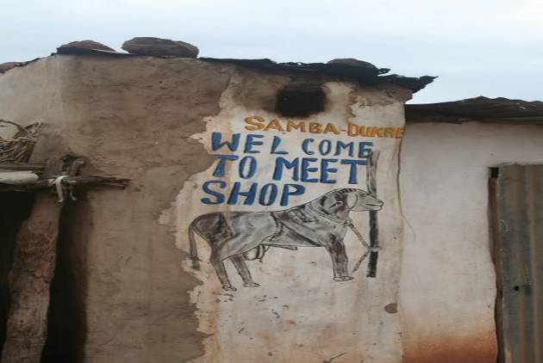
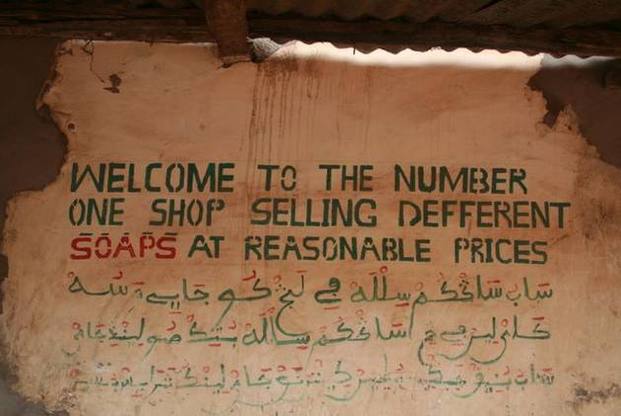
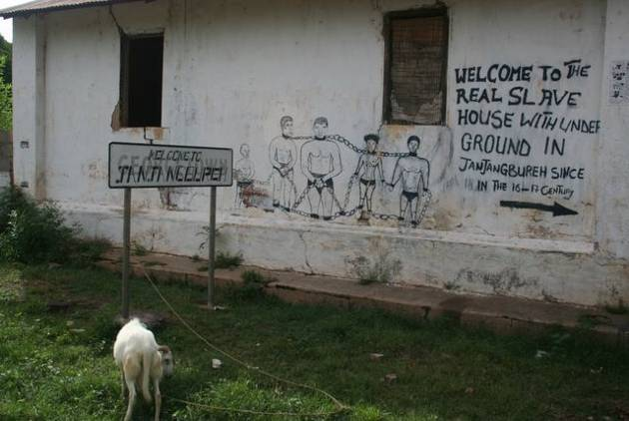
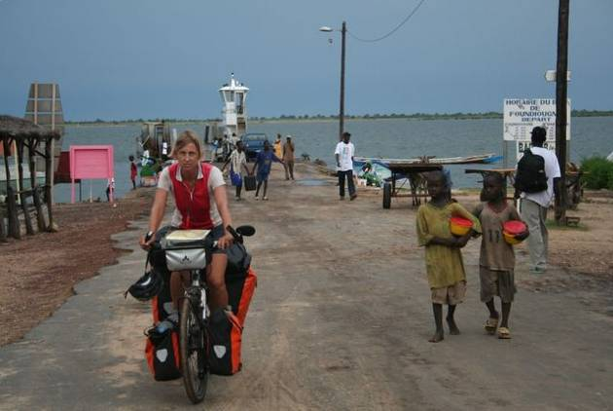
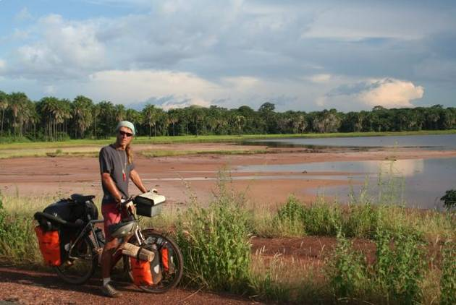
update 8. - off the beaten track
22 November, 2006
Guinea Bissau, Guinea, Sierra Leone
Total kilometers cycled: 11,800
Surely they are here to build a new road.
Their bags are full of medicine. They are doctors.
They are wanting to be in the Guinness Book of World Records.
Villagers speculating as to why we are cycling through their country.
Rough roads, violent storms and some pretty rudimentary conditions have been par for the course during this past month of cycling. Thankfully, friendly villagers, picturesque scenery and some improvements in the cuisine (although African food certainly won't top our list of favorites!) have compensated for the hard times. Leaving the beautiful Cassamance region in mid-October, we crossed the border into the former Portuguese colony of Guinea-Bissau. It was in this tiny country that we first discovered that running water and electricity are not things to be taken for granted--even in major cities. In fact, throughout the country there were indeed power lines in place, but no power. Hotels were fitted with taps and showers, but no water flowed from the pipes. Most hotels were equipped with a generator, so we could benefit from a few hours of electricity each evening, and of course water was available, it just had to be hauled from a distant well. There were no great hardships for us as tourists, but we imagine the locals must remember better days when public services were functioning and with just a flick of a switch there was light, and a turn of the tap, water.
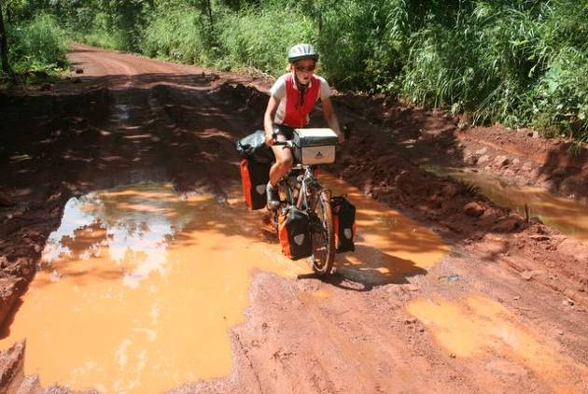
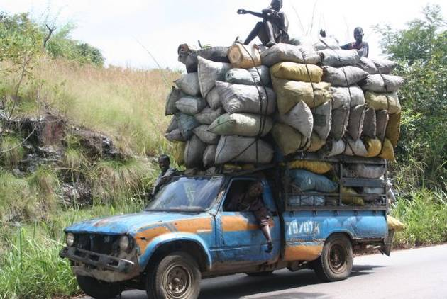
Guinea Bissau sees few tourists and we were typically asked which NGO we were representing rather than from which country we came. Children sometimes broke out in tears at the sight of the two pale-faced strangers, and in contrast to the incessant begging in Senegal, the only requests were for medicine and newspapers. We're not quite sure if the newspapers were wanted for reading or for wrapping, since food bought on the street always comes packaged in old newspapers from around the world. Starved for reading material, we find ourselves trying to decipher the top stories of June 21, 2005 in Norwegian or devouring the want ads in the New York Times. Things are calm in Guinea Bissau these days, and the country is slowly recovering from the bloody civil war that ended in 1999. Our only bit of adventure came when the ferry's engines failed, and we got stuck being transported in an over-sized, motorized pirogue which was crammed full with more than 100 passengers. The bikes were wedged in precariously between a satellite dish and some clucking chickens and we tried to hold them in place as we teetered on the edge of the boat which was sitting frightfully low in the water. The greedy men in charge kept trying to pack in just one more sack of rice or one more goat, but eventually the passengers revolted and said enough is enough, and we set off for the other side. Reaching firm ground again was a real relief!
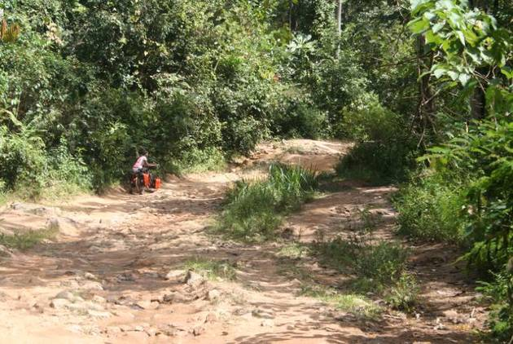
We were welcomed to Guinea with another half-hearted attempt at a bribe. The portly police chief at the customs post ordered us into his office, shoved a grimy piece of notebook paper at Eric and started barking orders. After Eric had noted our essential information, the officer demanded a 5,000 franc 'processing fee'. Amaya immediately dug out an old receipt (we later realized this was from Guinea-Bissau's consulate) and diplomatically argued that we had already paid our fees. Appearing a little crestfallen, he nonetheless conceded that there was 'no problem' and let us on our way.
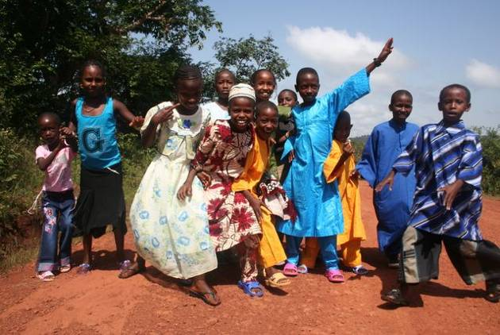
The 'road' beyond the border closely resembled a badly-maintained mountain bike path and we never ceased to be amazed when the occasional vehicle succeeded in making it past. It was rough going, but we were fortunate enough to meet up with some locals who knew the best way around the sandy areas and washed out sections of the road and following them we were able to pick up speed. Nevertheless, it was still nearing dusk when after just 95 kilometers we arrived in the northern town of Koundara. We looked in vain for the 'center' and finally realized that Koundara wasn't much more than a collection of mud huts and a bush taxi stand.
The next few days were spent making our way through the extraordinary diversity of the Fouta Djalon highlands. We passed through grassy plateaus and lushly cultivated valleys, peered over sheer cliffs, wondered at the fast-flowing waterfalls and conquered some mighty steep hills as we cursed the state of the road. The whole area had a wild, frontier feel to it and each day had its little adventure. Once we were caught in a violent thunderstorm and sat huddled with a local Fula family in their small mud hut waiting for the deluge to come to an end. As soon as the rain had let up a bit we set out for the last few kilometers into town only to find there was no accommodation available (camping hardly sounded enticing given the rain) and, after explaining our 'mission' were invited by the District Officer to spend the night at the local school. In the absence of bathing facilities, we lathered up and enjoyed a refreshing natural shower from the rain pouring down from the roof. Another day, we were transported across a narrow river in a manually-operated ferry, requiring two muscle-bound men to turn the cranks. And we celebrated Id al-fitr, marking the end of Ramadan and a marked improvement in eating options, good news for hungry cyclists. Everyone was decked out in new clothes for the occasion, many children choosing to leave on the price tags as proof of the brand-new status of their outfits. Villagers came streaming down from the hillsides to gather together in the mosques and later the streets were alive with women selling all sorts of tasty snacks to the sound of drums beating and music blaring.
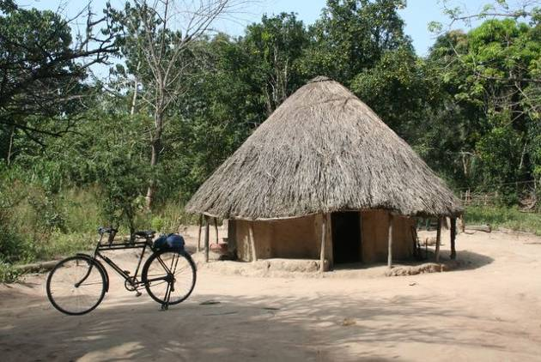
Labé is the economic capital of the Fouta Djalon and a nice spot to rest and enjoy some creature comforts and internet access. The town was crawling with Peace Corps workers and NGOs, but few tourists (we say just one, another cyclist no less). Eric had been feeling weak for several days, and it was here that the local doctor diagnosed him with a mild case of malaria. A short 48-hour wonder drug treatment followed, and within a week he was back in the saddle again and we headed towards Guinea's chaotic capital, Conakry.
It was a dusty and dirty 54 kilometer ride through sprawling industrial areas and shantytowns to reach the city center. The Catholic Mission offered the best budget accommodation, we were told, but they were picky about who they took in as guests. We were careful to wipe the layer of grime off before we presented ourselves at the reception, but to no avail--we we were turned down anyway. Perhaps one has to turn up toting a bible and sporting a large cross to gain admittance. We ended up staying at the Motel du Port, where Eric was asked if he would like the hourly or nightly rate and accommodation included free condoms.
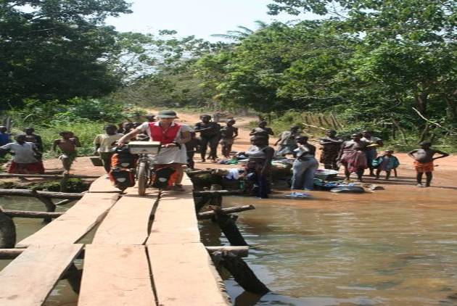
We were in Conakry for a visa run, and had to fork over $100 (payable in US dollars only, no local currency accepted!) for one to Sierra Leone. Mali's visa, at 16,200 francs ($2), seemed like the bargain of a lifetime in comparison. The visas in hand, we set off for the hellish 54 kilometer ride back up the peninsula and then turned south for Sierra Leone.
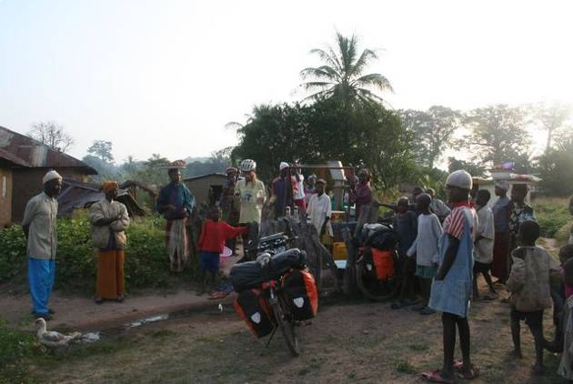
Although we had long debated whether to visit this struggling country, still coming to grips with a violent civil war in its recent past, we have had no regrets. Sierra Leone is steeped in atmosphere and has more to offer of architectural interest than any other West African country we've visited. Residents of the capital are surprisingly sophisticated and with the numerous Lebanese and Indian traders, as well as European and American aid workers, there's something of a cosmopolitan feel to Freetown. Sierra Leoneans being deeply religious people, the churches in the capital were overflowing on Sunday morning, women sporting fancy hats and the men in their best suits, shoes polished to a shine. There was such joy in the air, hands clapping, dancing in the aisles and lots of alleluias to be heard. The city, of course, is not with out its difficulties. Mutilated war victims are a common site, impoverished slums occupy the steep ravines between the city's many hills, and one has to keep an eye on the sidewalk so as to avoid falling into one of the sludge-filled sewers. Although our guidebook mentions that 25% of Freetown receives electricity at any given time, the residents we talked to found this laughable. Perhaps once or twice a month at most, they said, was power available.
Riding through rural Sierra Leone we attracted crowds of curious onlookers whenever we made a stop. There was pushing and shoving as the men gathered around to take a look at the map and always many disbelievers in the group. 'You come from France on this bike? No, it is not possible!' We've had hundreds of children staring at as we fill our water bottles from the local pumps, and at times, adults have resorted to shooing them away with a stick, so that we can continue our journey. All this attention and instant fame can be tiresome at times, and often we would just like to cycle by anonymously.
It was disturbing when one realized that many young men we spoke with were directly involved in the death and destruction caused by the civil war. We found it painful to see the shells of homes burnt down during the fighting and to listen as the locals recount tales of fleeing for their lives. But there's a glimmer of hope when one sees the astounding number of community based projects working towards reconciliation and reinsertion of former combatants. We were able to hear some success stories first-hand when Father Mario kindly offered us accommodation (our own bungalow!) at the vocational training institute he runs in Lunsar. The Italian priest stayed on throughout the civil war and after the peace accords, set up a program at his school to train former child soldiers. He has had remarkable results, with over 87% of the trainees 'changed men' as he says. There are aid agencies galore throughout Sierra Leone, and at the entrance of even the tiniest of villages there are always several signboards announcing the various projects underway: women for sustainable farming, reintegration and rehabilitation for war-mutilated victims, computer training, housing developments, school canteens..the list goes on and on.
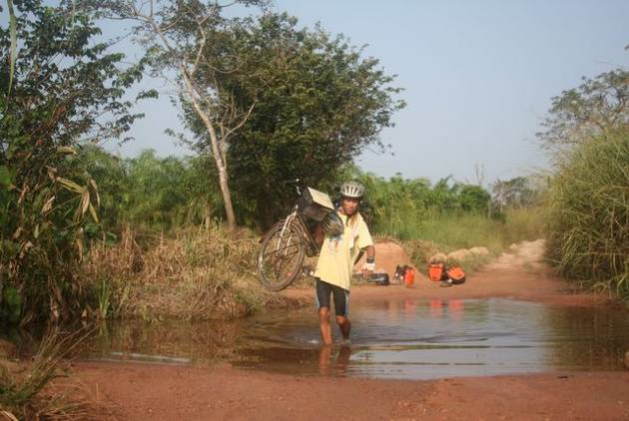
Some of our toughest days cycling came as we slowly made our way through the verdant highlands back to Guinea. Rock-filled roads rutted beyond recognition, in some places completely flooded forcing us to carry the bikes across the swampy areas. One day our average speed was down to just 9KM per hour. Not a car or truck in site, just the occasional motorcycle weaving its way around the potholes and past some far-flung villages. When we finally made it to the border and presented ourselves at the immigration office the men in charge didn't seem to have a clue as what to do with us. There was no stamp for the passports, so a brief note explaining our situation was scrawled on an old piece of notebook paper and we were told to present ourselves at the police station in the next town. So much for tight border controls.
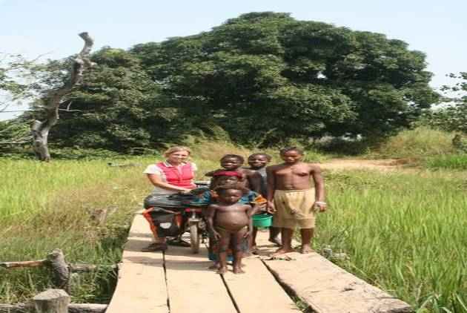
We're back in Guinea now (still without an entry stamp in the passport), so the cries of 'white man' have been replaced with the familiar foté and we've had to give up speaking Krio (Aw di bohdi?/ No bad, bohdi fine! = How are you? / Not bad, I'm fine!). The Guineans are among the kindest, gentlest people we have ever encountered and a world apart from the surly Senegalese. For foreign tourists, life here is incredibly cheap. A comfortable room with air-conditioning can be had for the equivalent of 5 euros. One euro buys you a huge pineapple, 40 juicy oranges and a large plate of potato salad. The climate (well, outside of muggy Conakry) is comfortably cool in the morning and even a bit chilly at night. We're in no hurry to leave, so we'll relax for a few more days before heading on to Mali, where the tourist season will be at its peak. After being so often stared at like exotic zoo animals, we're looking forward to hanging out with some other travelers for awhile and blending in with the crowd for a change.
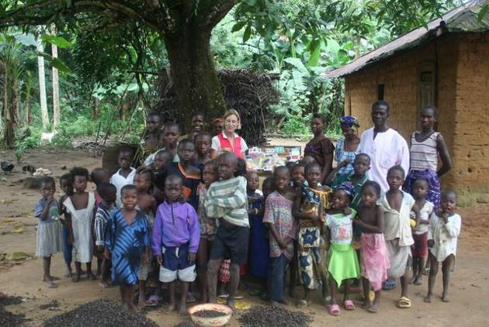
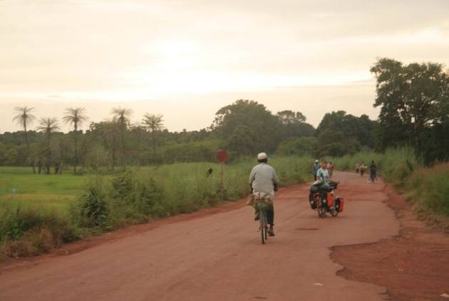
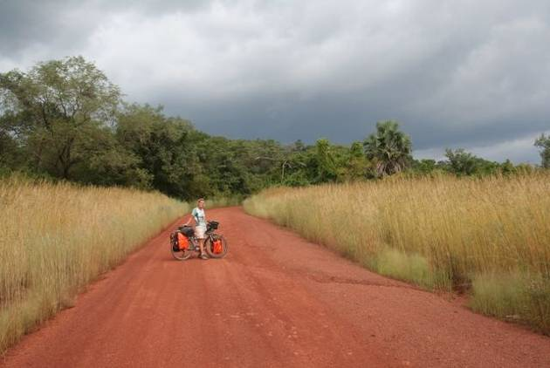
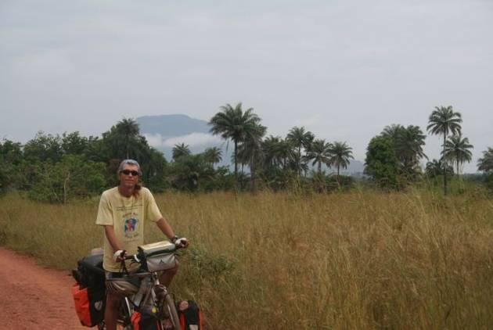
update 9. dust & drudgery in the sahel
27 December, 2006 - Mali and Niger
Total kilometers cycled: 14,023
Total flat tires: Eric: 19, Amaya: 3
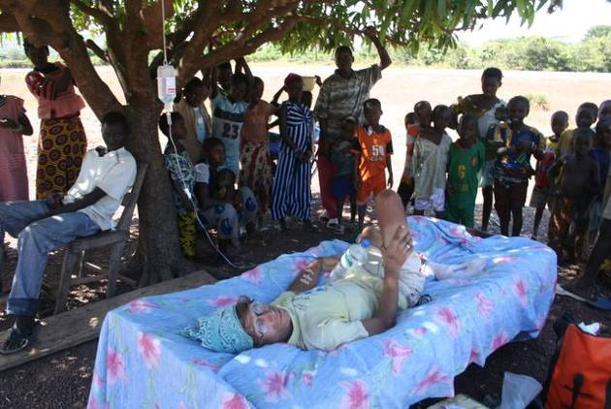
More than once during the past month we've asked ourselves what on earth made us decide to cycle through Africa. We've been plagued by ill-health, thorn-filled and puncture-producing pistes and growling stomachs, as Africa is no veggie heaven and we keep to a steady diet of rice and beans with the occasional salad being the culinary highlight. We strive to equanimously take the good with the bad, but, well, it's not always easy. Admittedly, we have passed through some stunning countryside and meandered through some very exotic Sahelian markets, and African hospitality never fails to impress us, but it would be nice if things got a bit easier!
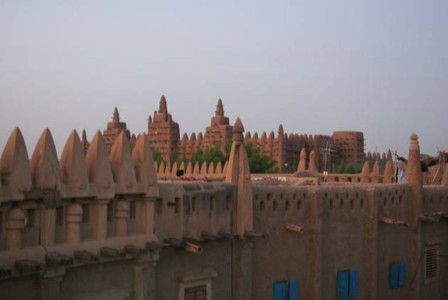
Eric had been having breathing difficulties and feeling weak in general, and as we cycled through the dry savanna of eastern Guinea, the situation worsened. At one point, completely devoid of energy, he flung his bike by the side of the road and lay down under the scorching sun--trees had become a rarity--to rest. He was seriously considering flagging down a passing truck, when a local passer-by informed us that there was a hospital just ahead. Lo and behold, there was indeed a health center, although no one was about even though the door was wide open. No worries, a crowd of local children quickly gathered to spy on the toubabs and a couple of boys soon scampered off in search of the 'doctor'. After noting Eric's ailments and briefly examining him, the young med student diagnosed him with another bout of malaria aggravated by pneumonia which, according to him, had been induced by the dusty roads. Now, our guidebook warns us about seeking medical assistance in rural areas, where hygiene is likely to be dubious and clinics ill-equipped, but the intern seemed competent enough and we didn't really have a choice. The treatment consisted of an IV, which he insisted on administering outdoors under a shady tree. This was surely for the entertainment of the local villagers, who never seemed to tire of watching white people. We spent the night at the clinic, and in the morning the village chief, having gotten wind that toubabs were in town, came by to pay his respects. We're still not sure what sort of a concoction was in the IV, but it seemed to do the trick and Eric was feeling well enough to cycle on to the next town.
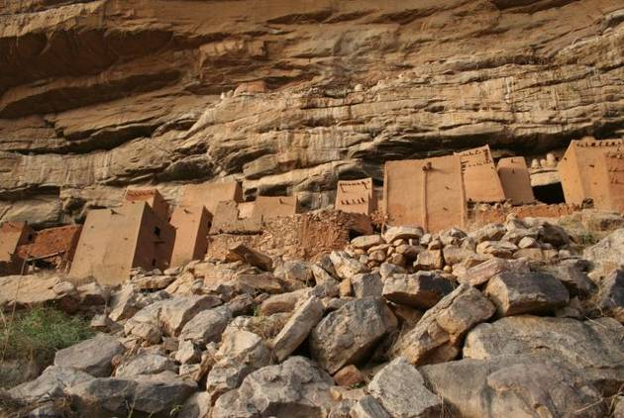
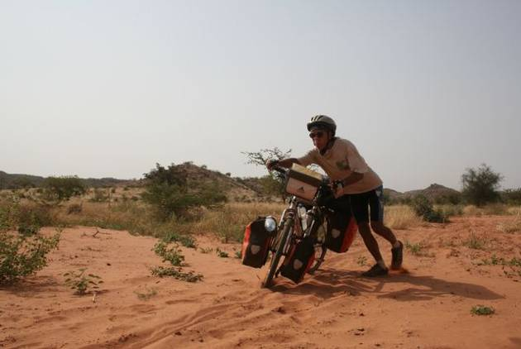
The first thing that struck us In Mali was the harmattan, the sometimes violent wind which blows down from the Sahara between December and February and smothers everything in a dusty haze. This is supposedly a north-easterly wind, but we swear that no matter in which direction we cycled, we were fighting a fierce headwind. This was tough on morale and severely hampered our progress. One of our first stops in Mali was the capital, Bamako, which was noisy and hectic like other west African cities and had little to hold our interest. We were there to pick up visas and were quite astonished to find out that fees are negotiable, well at least they were at Togo's consulate. The friendly honorary consul gave us a steep discount and even telephoned his counterpart at Niger's embassy to see if he would do the same for his new 'friends'. The Nigerien consul was very apologetic, but unfortunately the best he could do was offer us a cup of coffee and some insights into African mentality.
After the capital, we headed northeast towards the Inland Delta region, and couldn't help feeling that we were making a huge detour as we returned towards Europe and saw the distance from Cape Town growing rather than diminishing. Most of Mali lies within the Sahel, the desolate zone bordering the Sahara where the desert is fast encroaching. There is little that grows in such an arid region and vegetation is mostly limited to acacia and pesky thorn trees. The later of which perhaps explain Eric's prolific punctures, although it's a mystery as to why Amaya's tires have fared so much better. The landscape is largely monotonous and the kilometers seemed to pass painfully slowly. Settlements are spaced far apart and finding water and food was a real concern. Fortunately, this landlocked country has been blessed with some outstanding geographical features to break up the monotony of the flat plains and scruffy bush. 1,300 kilometers of the Niger river run through Mali and the sheer mesas and craggy rock formations found near Hombori have been compared to those in Monument Valley. The walled villages along the river are in the Sudanic style, molded from the grey clay of the surrounding flood plain.
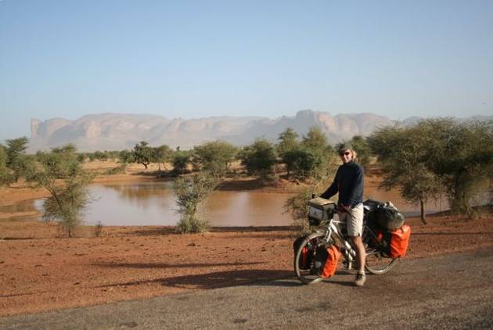
We followed some minor gravel roads and tried to follow the scenic river and its inland delta as much as possible. A highlight was our stay in Djenné, with its Grand Mosque and animated Monday market. At dawn, farmers and merchants from far-off villages arrived via the river in wooden pirogues and starting spreading out their wares on the central square. The melange of different ethnic groups--Moors in their flowing robes, Peul with their pointy hats and the nomadic Tuareg on their camels meant people watching was top on the list of activities.
Next, we found ourselves in Bandiagara, on the Dogon Country tourist track, being hassled by potential guides wanting to organize a trek for us to visit the cliffside villages and learn more about the ancient Dogon customs. We were in no mood to be hassled as our 63-kilometer ride to Bandiagara had been the most taxing to date. The piste we chose to take--30 kilometers shorter than following the paved road--was a barely visible sand trap branching off in so many directions that its a miracle we found our way to Bandiagara. We spent a good part of the day pushing the bikes, pulling out thorns, and for Amaya, shedding a few tears. Eric was busy repairing punctures and coaxing Amaya to get back on her bicycle! It felt like the end of the world and we were mighty happy to reach 'civilization' again and down a refreshing coca-cola.
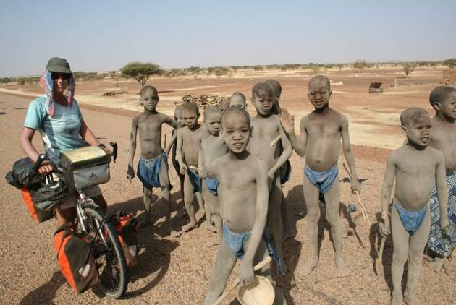The 150 euro asking price for a three-day trek seemed ridiculously high, so we decided to cycle down to the escarpment and organize local guides in individual villages. This turned out to be a wise decision and we were able to do some rooftop camping and hike up the cliffs to visit the ancient dwellings and learn all about the customs from one of the chief's sons. All we missed out on by not going on an organized trek was the 30 kilometer ride in the 4WD and our self-organized trek cost just 30 euros.
Hombori was our next destination and there were some truly stunning stretches of road as we passed by the pinnacles of the sandstone rock formations. Along the way, we camped with local families and were kept awake by the donkeys braying, cows mooing, goats butting horns and chickens cackling just outside our tent. The villagers greeted us enthusiastically and one day we were amazed to see a group of some 15 boys, all clad in blue loincloth, wielding a stick and covered in a layer of dust, rush out to greet us. They had recently undergone a circumcision ceremony and were in the care of a marabout (holy man). The sticks and layer of earth were to ward off evil spirits who might attack the boys.
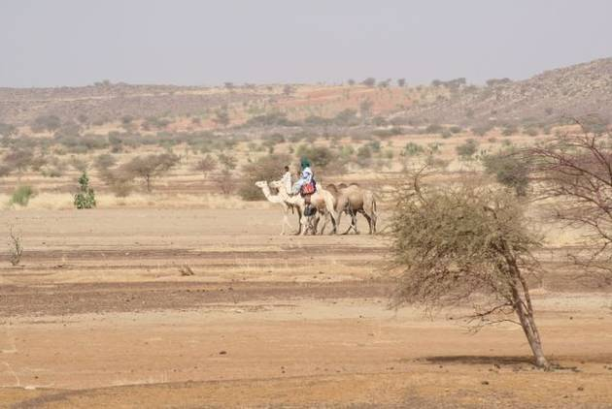
After Hombori, the scenery reverted to featureless flatlands and it was time again for the MP3 player. By the time we reached Gao, and finally turned south (this felt like progress again!) we had covered almost 1,500 kilometers. It had been a trying journey, mostly due to the monotony of the land, and we were looking forward to the trip south to Niamey. Our guidebook claimed that the road hugged the Niger river, passing through numerous picturesque fishing villages and the Michelin map had classified the 450-kilometer stretch as a scenic route. Locals told us that, although the road was not yet entirely paved, the foundations were in place, the sand had been cleared and cycling would be easy enough. What a disappointment when just a few kilometers outside of Gao the road turned into a sandy track and we were again pushing the bikes as 4-wheel drives flew by kicking up a storm of dust in their wake. Masks are a common accessory for motorcyclists in Mali and Eric donned his, which offered some protection. Nevertheless, cycling was extremely unpleasant and we were hardly enjoying the scenic route. Just when it seems that things can't get worse, they can. The route rarely 'hugged the banks' of the river and we saw plenty of signposts for those 'picturesque villages' indicating that they lay several kilometers down sandy tracks, and we were hardly in the mood for detours. Time for a confession. One desperate morning, when we could really no longer stand pushing the bikes through the deep, soft sand we loaded them into the back of a pickup and rode in air-conditioned comfort the last 100 kilometers to the Niger border. From there it was back in the saddle. The road and the scenery improved dramatically and after 50 kilometers we were back on tarmac.
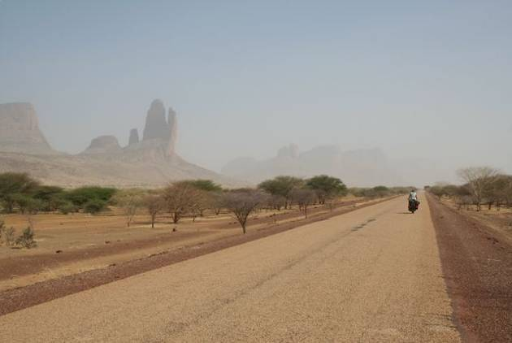Christmas eve was spent in the compound of some American Baptist missionaries in Ayorou. Our image of missionaries, we now realize, was severely out-dated. We imagined them 'living like the natives' in mud huts and cooking over open fires while preaching the gospel. Our modern missionaries came to greet us in their Toyota 4WD and let us pitch our tent outside their air-conditioned home--complete with flushing toilets, running water, satellite TV and an American-style kitchen. Ayorou is famous for its colorful regional market, attracting traders from as far off as Nigeria and Burkina Faso. After an early morning pirogue trip to see the hippos upstream, we wandered around the stalls and checked out the bustling livestock market which was doing a brisk business thanks to the upcoming Tabaski (New Years) celebrations. Well-to-do families are meant to slaughter a ram and share it with those less fortunate. Mini-buses were being loaded up with the animals strapped on the roof for transport back to surrounding towns and villages.
We rolled into Niamey Christmas Day and are spending a few days at the Catholic Mission enjoying some time off the bikes. Next comes Burkina Faso and visits to some of its national parks for animal spotting. Keep your fingers crossed for smooth roads and tailwinds!
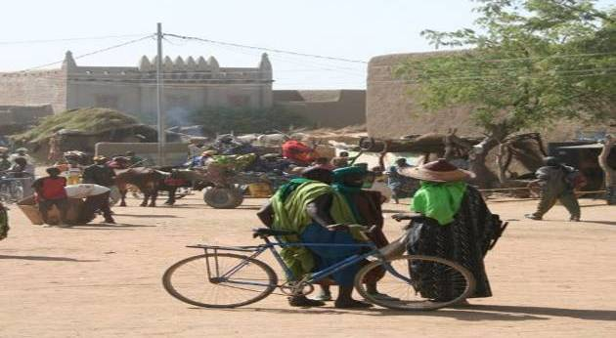
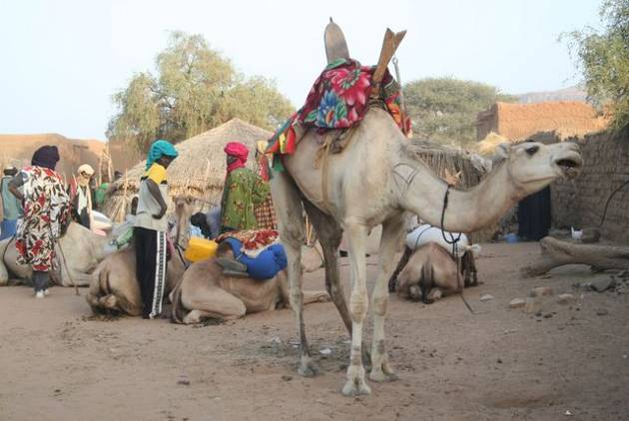
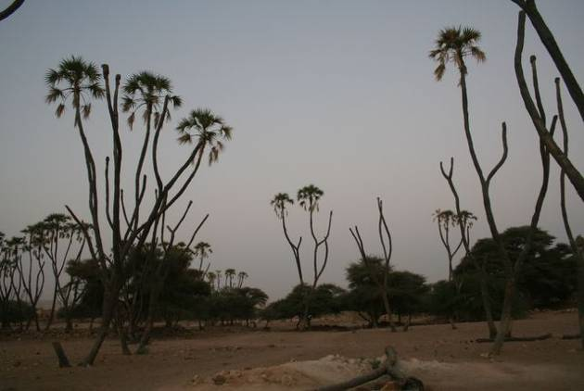
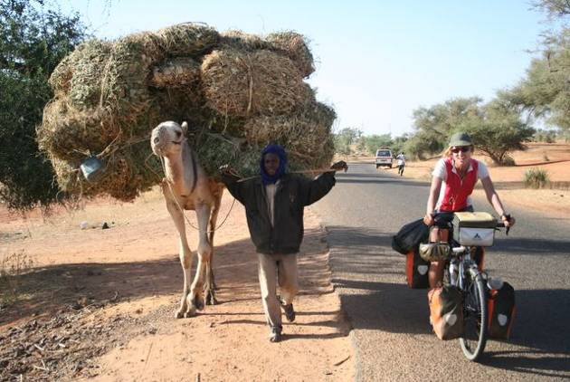
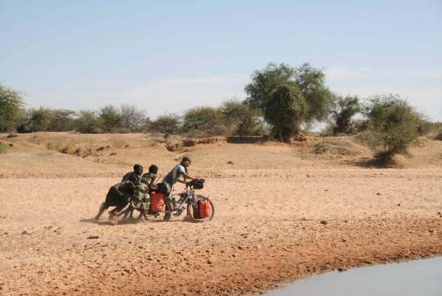
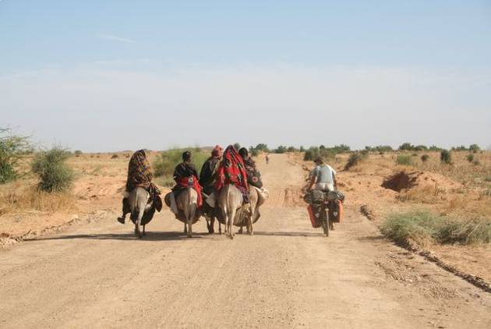
update 10. rediscovering the pleasures of cycling
30 January, 2007 Burkina Faso and Ghana
Total kilometers cycled: 16,459
Specific country info on routes & roads/food & accommodation/the locals available here.
We are always amazed at how kind people are to cyclists! Here are some of the nicest things people have done for us since we've been on the road.
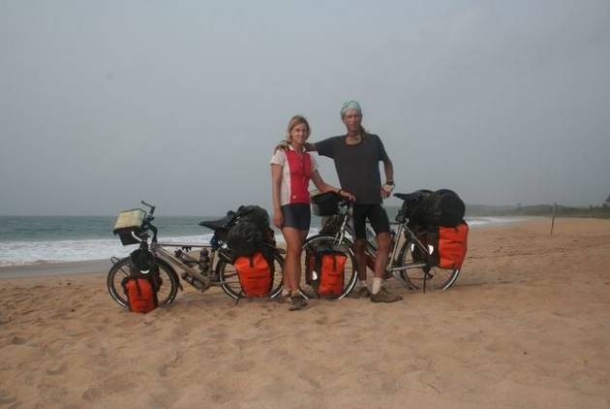
One incredibly hot afternoon in Senegal, a French motorist pulled over to where we were resting by the side of the road and offered us an ice-cold coke--really hit the spot !
When we turned up in a remote part of northern Sierra Leone and asked the village chief if we could pitch our tent nearby, he responded by opening up a local diplomat's home (he was on assignment abroad) for us to spend the night.
A kind woman in The Gambia woke up very early one Sunday morning to fry up apple fritters and fish pies for us to take along for a picnic lunch.
We must often look lost because we've been given maps four times so far on the trip. A big help as decent maps are hard to get your hands on in Africa.
Finding food on the road is always a challenge, and one afternoon in a small town in Guinea Bissau we were having particularly bad luck. Finally, a passing motorist came to our rescue and led us to a terrace where we were served a delicious vegetarian lunch on fine china. Turns out this wasn't a restaurant at all, just a generous family who had taken pity on two itinerant cyclists.
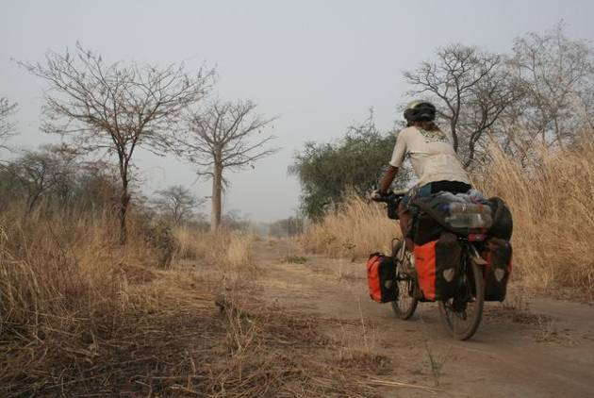
The thorn trees eventually tapered off, the dusty and desolate dirt roads gave way to modern highways cutting through the dense tropical forest, and we're finding evenings spent chatting around a bonfire at the beach ever so much more enjoyable than those spent repairing punctures. Yes, life has gotten better for your road-weary cyclists--we just might make it to Cape Town after all.
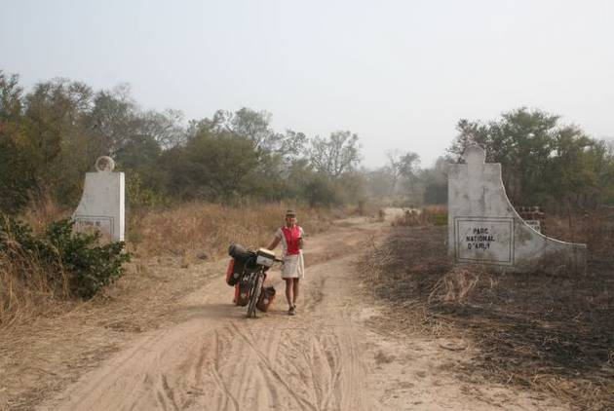
Not that the cycling has been a bed of roses since we left Niamey, where we last updated you. All was going (reasonably) well until we met up with a fellow cyclist traveling in the opposite direction, who suggested we alter our route to take in the Arly National Park in Burkina Faso. This meant 'extra' kilometers, and we were leery of giving up smooth tarmac for the unknowns of a secondary road. Now, we trusted our new bicycling buddy when he assured us that the road was in good condition and sand-free. What a mistake! We were in for three days of bone-jarring corrugations, potholes of unfathomable depths and the usual sandy pitfalls. All that pushing was good for buffing up the biceps, but constituted a big blow to morale.
After ringing in the new year over beans and beer in the roadside town of Pama, we took to the tarmac again and pushed on to Burkina Faso's capital, Ouagadougou. Time to pick up visas again, stock up on toilet paper and toothpaste and take in a locally made movie--Ouaga being home to a highly-acclaimed film industry. This was also one of our last chances to enjoy the crusty baguettes of the francophone countries--we were heading towards English-speaking Ghana and were in for the soggy and sweet variety of bread bequeathed by the British. Even worse,it turns out, than the bread Amaya was subjected to as a child growing up in Montana.
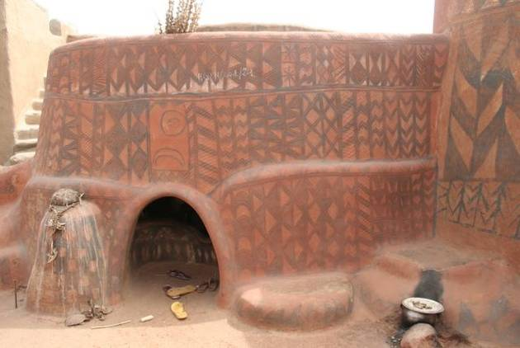
Our last stop in Burkina was the capital of Gourounsi country,Tiébélé, where, for a small fee, one of the chief's younger brothers gave us a tour of the rather pretentiously named 'Royal Court'. A literal labyrinth of intricately painted dwellings where one had to duck low to enter the circular mud huts. This was a security measure, we were told, to keep out foreign invaders during the tribal wars of former times. We declined the offer of rooftop camping in the compound (again for a small fee) and in spite of the midday heat, headed on to the Ghanaian border.
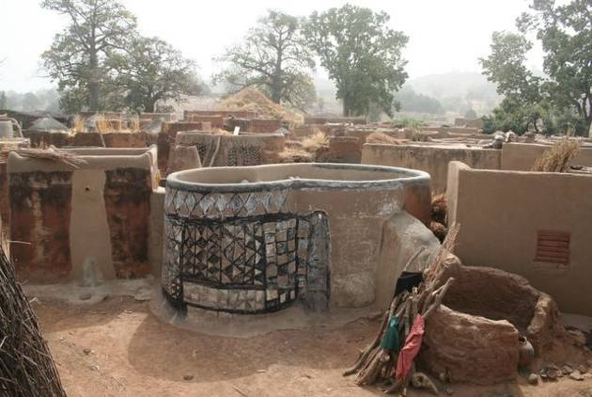
There was another traveler snoozing outside the border post when we pulled up on our bikes. Having roused him from his rest, he explained--and we detected a note of exasperation in his voice- that the official entrusted with the stamps had 'gone out'. By the time the stamp man had returened, we'd gotten to know Graham and accepted his invitation to spend the night in nearby Bongo, where he was teaching in a local secondary school. After a delicious dinner of veg curry and rice, we walked over to the adjoining hostel to meet some of the boarding students.
Despite the absence of adult supervision, the teenagers we met demonstrated remarkable maturity and discipline. In the girls dormitory, young ladies were busy sweeping the courtyard, cooking stew for the coming week and revising their lessons. And this was still the Christmas break! Conditions were cramped with more than 40 bunks crowded together with just enough room to squeeze by. No one was complaining though, because the girls had it quite good compared with the boys. They had no bunks at all, and slept on thin mats (which made our therma-rest knock-offs look downright luxurious). There was no toilet either for the boys, and those who want a little privacy get up before dawn to head for the 'bush toilet' to take care of their needs in the cover of darkness. The young men appeared to be just as studious as the girls, and we found most of them in an empty classroom poring over their books. We were impressed! Unfortunately, there are still many children who don't have the opportunity to attend school. If you'd like to support education for girls in Africa, please consider contributing to Camfed. More details here.
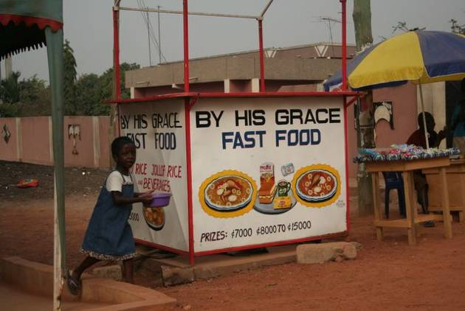
In the West, sex sells, but in Ghana it's God that brings in the business. Signboards everywhere make reference to religion: Christian prices, Baptist builders of blocks, In God we Trust Grocers. Oddly enough, alcohol also looms large in Ghanaian society. 'Drinking spots' are found almost as often as the prevalent places of worship, and sometimes the two are even combined--as in the case of the Catholic Mission Guesthouse in Tamale. It wasn't crucifixes and paintings of the Virgin Mary that adorned the courtyard, rather posters advertising Star Beer (for the foreign tourists who like the local brew) and Guinness (for the locals who prefer their beer from abroad).The country is also home to money launderers. No, not the kind that make ilegitimate money appear legitimate, we're talking about people who wash money--literally.
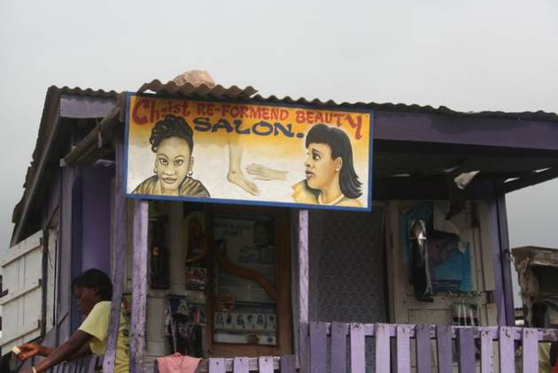
On the food front, Ghana's got bush meat for those who are daring. The busy roads are lined with men proudly displaying freshly-caught grasscutter. Prices seemed quite reasonable, but we decided to go for the juicy pineapples instead.
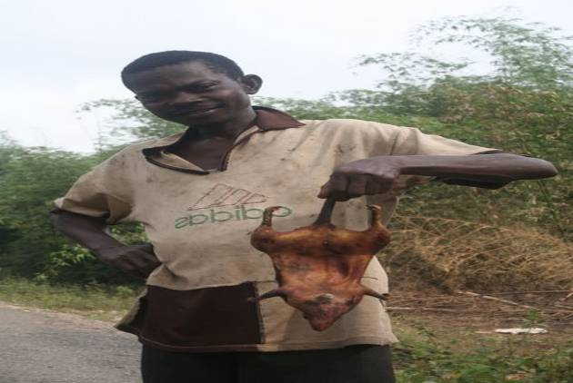
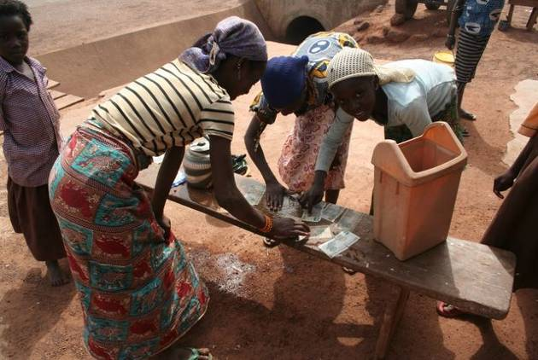
One thing you don't see much of in Ghana is beggars. And with good reason: the country is one of the best-educated and most prosperous and politically stable in the region. In neighboring countries (Mail in particular), the situation is truly troubling. Bands of boys, some as young as five or six from the looks of them, loiter at the roadside foodstalls waiting to gobble up what the customers leave behind. It's a sad sight to see these youngsters, usually shoeless and dressed in tatters, shivering in the chilly sahelian mornings waiting for a few bread crusts or perhaps a handful of beans. Hard to understand,too, why more isn't being done to end this suffering.
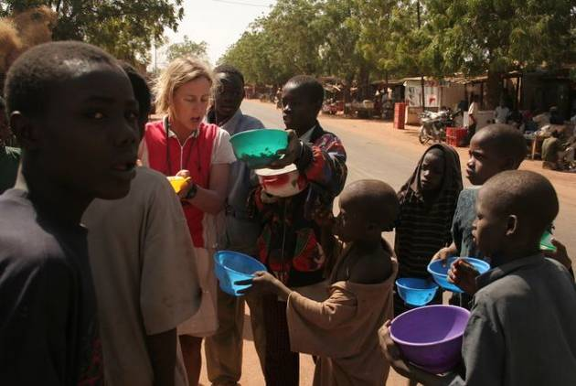
We've been doing lots of touristy things since we arrived in Ghana. First a visit to Mole National Park and an early morning walk in the savanna to observe the elephants, warthogs and crocodiles in their natural habitat. After conquering some unbelievably steep hills, we enjoyed time camping and chilling out on the shores of Lake Bosumtwi. Then on to the coast and a couple of relaxing days on the almost deserted beach at the Green Turtle Lodge. The canopy walk at Kakum National Park gave us a different view of the rainforest and left Amaya's head swimming (she'll remember not to look down next time!) And finally, visits to some of the coastal forts built by the Europeans gave us a dose of culture.
Soon the sweltering heat of the tropics will give way to cooler temperatures, as we cycle on to Togo and the picturesque plateau region. Who knows what they call white people on the other side of the border, but we hope it's not obroni. We can hardly go anywhere in Ghana without hearing shrieks of Obroni, Obroni--where are you going? or Obroni, stop, stop! I wanna talk to you. or even Obroni, tell me your name--who are you?. Tiresome as you can imagine, and simply ignoring all the attention gets us nowhere, as the children (and a fair number of aduts as well) only become more insistent. Haven't they got anything better to do with their time than worry about what two white people are up to? Ahh, the joys of instant popularity!
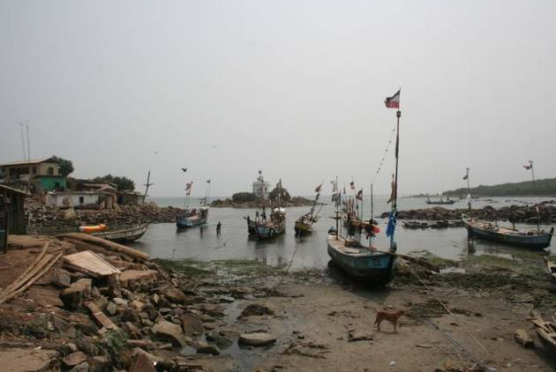
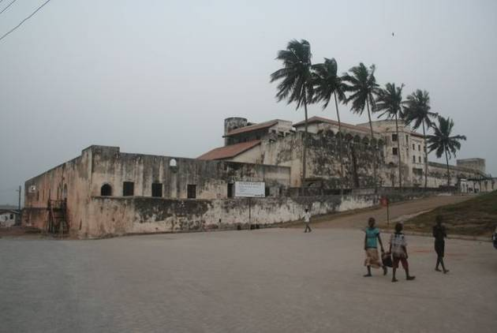
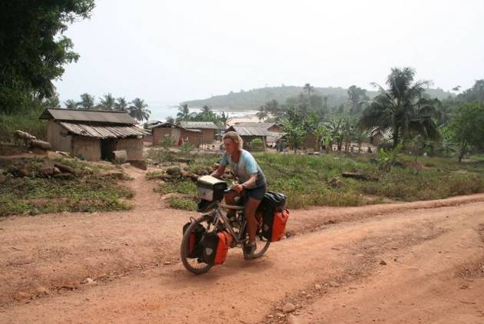
update 11. cool mountain air & voodoo
5 - 17 February, 2007 - Togo and Benin
Total kilometers cycled: 17,625
Specific country info on routes & roads/food & accommodation/the locals available here.
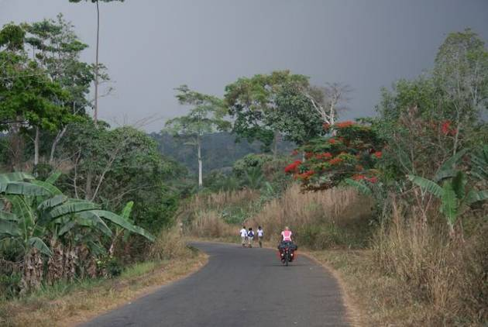
From Accra we might easily have continued along the busy coastal road, quickly passing through tiny Togo and Benin on our way to Nigeria. We were lured inland by the thought of cooling off in Togo's picturesque plateau region and exploring voodoo shrines in Benin. We were in for some leg-breaking climbs and spectacular scenery and even more spectacular storms as the dry season comes to an end and the first rains wash away the layer of dust that has settled over the land.
First stop over the border was Badou, a small town in the heart of the coffee and cocoa growing region and a good base for a visit to Togo's most impressive waterfalls, Akloa Falls. We paid the required fee and took the obligatory guide, which turned out to be a good thing as the vegetation was dense and we weren't keen on taking a wrong turn, getting lost and spending the night among the monkeys and mosquitoes of the forest. The climb was steep and strenuous in parts, and it was a real blow to the ego to be passed up by old women and children balancing large loads of wood and plantains on their heads as they practically ran up the slopes of the mountain. We were duly impressed by the waterfalls but the sky was quickly clouding over and it threatened to rain so we forwent a dip in the pool below the cascade.
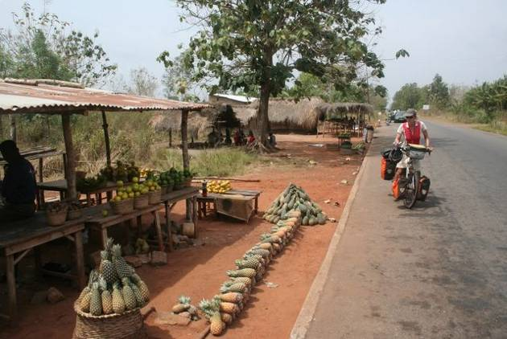
We continued through rural Togo, passing sheer cliffs and quaint villages all the while enjoying the relatively cool air that came with the climb in altitude. Our last stop before heading back towards the coast was Kpalimé, a favorite getaway of the Germans when they were the colonial masters of Togoland before World War I. Early one morning we cycled up the pretty road carved out by the Germans that snakes it way through the forest and up to Mount Klouto and enjoyed the view over the cocoa country and into Ghana. Then we ventured a look at the Chateau Viale where we were asked for our official authorization to visit. Not having the said document (surely no such thing exists) the caretaker assured us that he could perhaps bend the rules in exchange for a small gift. Yes, everything is possible here in Africa...for a price.
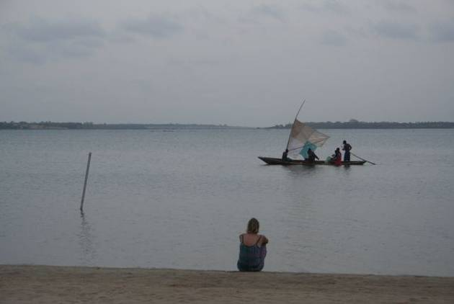
Lomé, Togo's capital, is a fairly low-key place and we took a room at Le Gallion, a Swiss-run auberge just 50 meters from the beach--which we didn't visit, incidentally, since it's too hot during the day and too dangerous at night. Instead, we relaxed on the shady balcony outside our room and watched the comings and goings of the expat community, for which the attached restaurant was obviously a favorite haunt. Lots of balding European men in oversized 4WDs pulling up with sexy young African women. You draw your own conclusions.
We would soon be leaving the West African Franc (CFA) currency zone and needed to get our hands on Nigerian Naira and some Central African francs used in Cameroon as well as stock up on dollars for Congo, where the greenback is king. Bank bureaucracy is tiresome and their exchange rates are poor, so we headed to central Lomé with its thriving black market to conduct a little business. Finding the right spot wasn't difficult, because there were several men on the aptly name Rue du Commerce waving wads of currency and shouting 'change money, change money'. We put in our order for the various different currencies and within a few minutes our contact man was back with the money. After carefully counting the bills, we paid up and the deal was concluded. A very efficient and time-saving process.
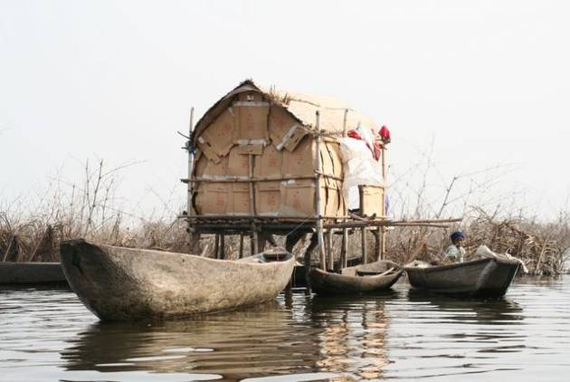
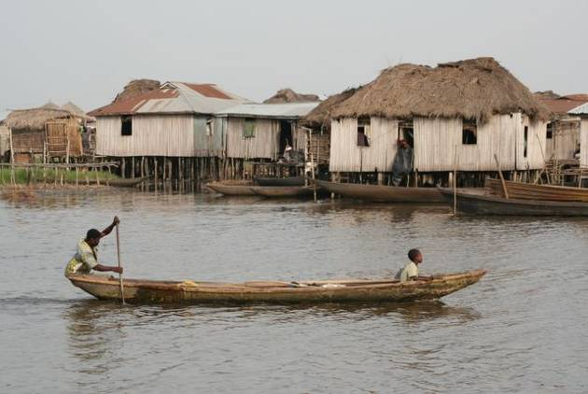
Palm-fringed beaches and inland lagoons line the coastal highway into Benin, but the ride was marred by the hectic traffic between the two capital cities. We steered clear of congested Cotonou and made our way instead to Benin's biggest tourist draw, the stilt village of Ganvié. Here we hooked up with three motorcyclists who were also following the West Africa overland route and swapped travel stories and tips. And together we did the obligatory visit of the village in a wooden pirogue, a boat obviously being the only way to visit a town built on a lake. It was a bit of a tourist-trap, but nevertheless a fascinating place. Some 18,000 people are said to live in the thatch huts teetering on stilts over the shallow (and mighty polluted it appears) waters. Transport is strictly by canoe and it seems even toddlers can maneouver a boat. We were passed by plenty of fishermen and women hawking their wares over the side of wooden vessels as they paddled through the marshy waters, and despite the touristy nature of the excursion there was a sort of magical quality to the place.
Benin is known as the cradle of voudou (vaudou or vodoun in some dialects), an ancient African set of beliefs centered around spirits and intermediaries possessing supernatural poweres as well as fetishes, charms and temples. We wandered around the voodoo strongholds of Ouidah and Abomey and tried to imbibe some of the eerie atmosphere. Unfortunately, most of the the temples are off-limits to outsiders and picture-taking is frowned upon unless you cough up a small tip for the pleasure of snapping. This kind of an attitude, as well as the constant request for gifts, took some of the charm out of our tour of Benin.
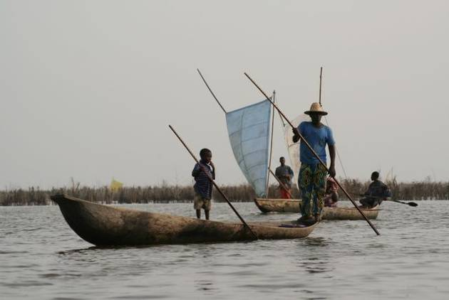
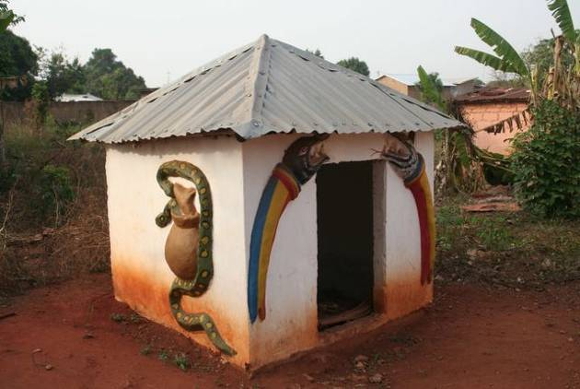
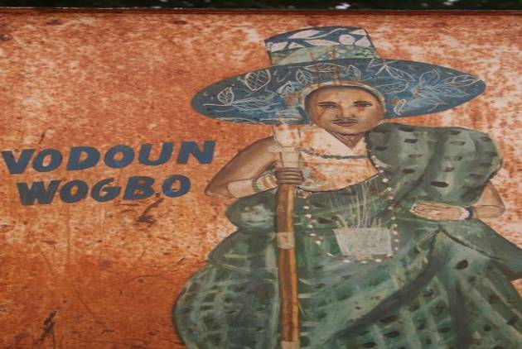Temperatures rose, the sun intensified and the tropical vegetation gave way once again to savanna as we continued further north to Save and the border crossing into Nigeria. Our Michelin map showed just one direct route into the country, so when the road forked we motioned towards the well-used track on the right and asked if that was the way to Nigeria. The response was affirmative so we rode on confident in reaching the border post, where we intended to spend the night, just 20 kilometers further on, according to the map.
We rode and rode and still there was no border post in sight. Finally a vehicle passed and we flagged down the driver who told us it would be another 80 kilometers before we reached Nigeria! This was alarming as it was late afternoon and there were no settlements in sight. After a protracted discussion with the driver, we realized there were two routes into Nigeria and that we should have taken the fork on the left. Not fancying a night in the bush, we turned around and had just enough time to make it back to Save before sunset.
There's a lot packed into these two tiny countries and it was well worth taking the time to explore them. Tourism is fairly well-developed so travel was relatively easy and we could rest up before facing the rigours of non-stop Nigeria. There was a dependable supply of water and electricity, tasty rice and beans, loads of fresh fruit and the ubiquitous FAN MAN, serving up delicious frozen yoghurt and ice cream. What more could a person want?
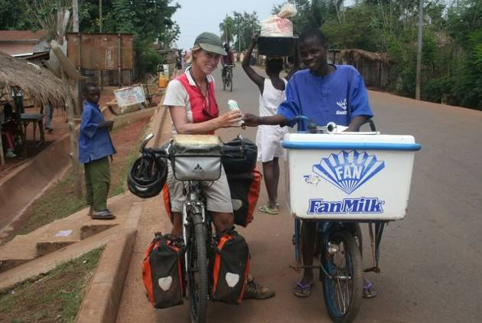
update 12. notorious nigeria
18 February to 6 March, 2007
Total kilometers cycled: 18,882
Specific country info on routes & roads/food & accommodation/the locals available here.
Nigeria's notoriety is unsurpassed in West Africa: institutionalized corruption at all levels, pervasive violent crime including highway banditry, and political and tribal tensions that risk to spill over into full-fledged combats at any moment. Our guidebook stated that they were unable to conduct on-the-ground research due to security issues in the country. Hardly the stuff that entices tourists. But, if we were to head further south we knew there was no way of circumventing Africa's most populous country, so we ignored the US State Department's travel warning and decided to give Nigeria a go.
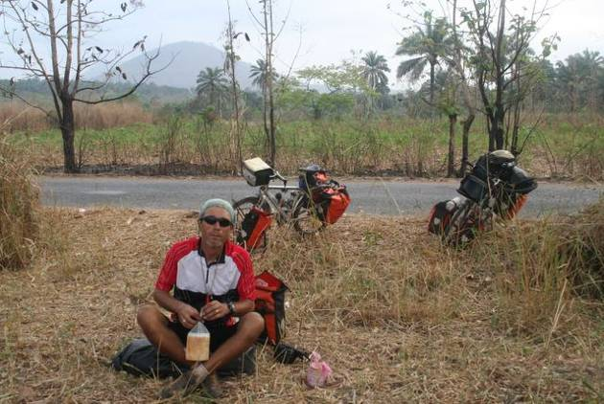
We had chosen a little-used border crossing in order to avoid Lagos, and as the tar road gave way to an ever narrower and bumpier dirt track, we were asking ourselves what was in store for us. As we rode up, there was much excitement at the border post on the Benin side--they were obviously not accustomed to foreign travelers passing through their tiny village. Someone was sent off to find the official and dig out the necessary exit stamp. The formalities were long and drawn out, and just as the official was placing the stamps in our passports, he informed us that he felt it was his duty to make us aware of the security situation across the border. "There's nothing but bush for the next 25 kilometers--no villages, no people, no water--absolutely nothing. It's not unknown for bandits to attack along that stretch of road,' he continued. 'Just last Wednesday some armed thugs attacked a mini-bus and and took all the passangers' money and valuables." Now, why hadn't he mentioned all this BEFORE he put the exit stamp in the passports? There was no turning back, so we took the precautionary measures of stashing our cash inside the pots and pans, and hiding the expensive camera in the bottom of the sack. We left some decoy money and the small camera in the bar bag.
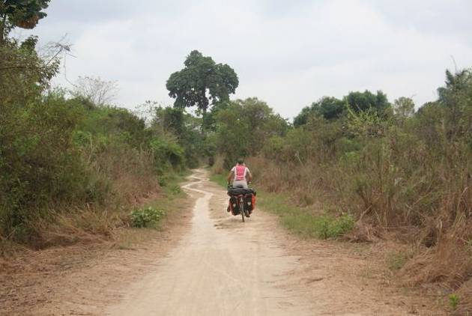
As expected, there was little traffic on the 'road', and the track on the Nigerian side was even sandier and rougher, which made progress very slow. After several kilometers of slogging along, we sat down by the side of the road for a much-needed rest. As we were downing the last of our provisions (we had expected to find shops and roadside restaurants)three men on a motorbike pulled up next to us. They didn't look dangerous and we'd been told that bandits normally hide in the bushes and then jump out for a surprise attack, so we weren't feeling overly threatened. In fact, the men were merely curious and just wanted to welcome us to Nigeria. We were relieved. 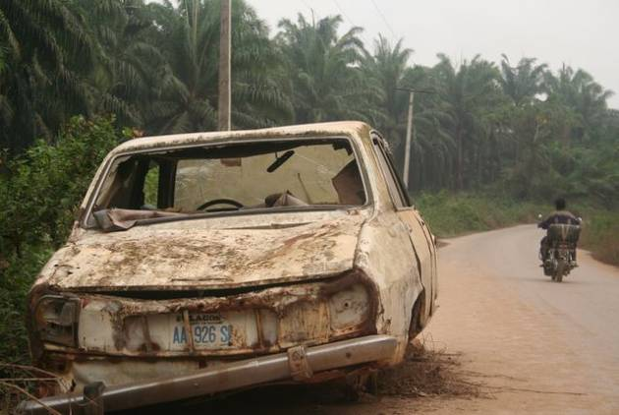
They confirmed that the road was indeed a favorite spot for attacks, and tried to reassure us by telling us that they would be 'praying that we meet no bandits in Nigeria'. Well, we didn't, and the people we did come into contact with were some of the friendliest and kindest we've met in Africa.
Yes, the people are lovely, but the country itself is in an advanced state of decay and dilapidation. Wrecked and rusting vehicles line the roads, attesting to the recklessness of local drivers. Porches are sagging, paint is peeling and once stately colonial-era buildings are now crumbling and occupied by poor families. Running water is a rarity and it's even hard to find a pump that's working--they're 'spoiled' as the people like to say and nobody knows to fix them. We saw electricity poles all over the country, but rarely was electricity supplied. "The NEPA (Nigerian Electrical Power Authority) has taken the lights again, we must on the gen (turn on the generator)." To the locals, NEPA is better known as Never Expect Power Again. Seems about right.
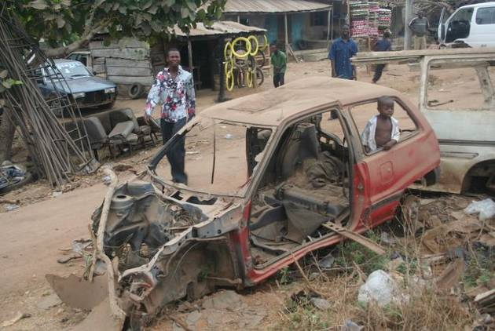
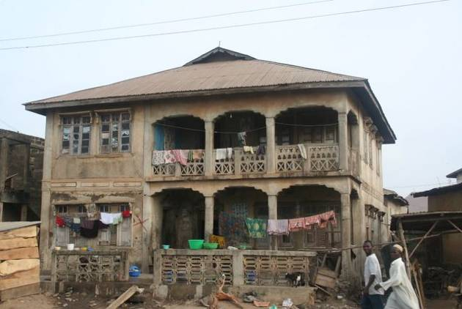
We cycled through Nigeria quite quickly, not taking a rest day until we reached the southern coastal city of Calabar (clean, green and well-ordered, unlike the rest of the country), just 120 kilometers from the Cameroon border. We followed a fairly central route, wanting to avoid the states north of the Niger River where Islamic sharia law is in force (given the heat, Amaya wasn't keen on covering up from head to toe) and the oil-rich southern Niger Delta region where kidnapping of expats is on the upswing. There were no spectacular tourist sights to visit, but cycling alongside a lorry which is being simultaneously overtaken by two other overloaded trucks on an uphill stretch of a two-lane highway while a motorcycle tries to pass on the right, leaving cyclists to flee for cover in the bush (shoulders on roads are also a rarity) is another kind of unforgettable experience. Nigeria brought a renewed sense of adventure we hadn't known since Sierra Leone.
Arriving late one evening in Uromi we got caught up in a local political rally. The streets were thronged with people shouting slogans and young hotheads on motorbikes were weaving wildly through the crowd. This was just the type of situation those travel warnings (and common sense!) told us to avoid. We did our best to remain calm, and there was no reason to believe that the demonstrators were anti-Westerners, but it seemed things could turn ugly at the slightest wrong move. We were in a hurry to find lodging, and relived to see a sign advertising the Moonlight Motel. The hotel manager, however, was reluctant to show us a room. "You white people cannot sleep in such a place, I am sure of it," he insisted. "Why not?" we asked. "There is not enough comfort for you. You do not know how to use a pit toilet". There was a toilet. This was good news. On our first night in Nigeria, in some remote village not far from the border with Benin, the only lodging available was a room behind a bar where it turned there was no toilet. We were told to use the bush, which was fine, except that in the middle of the night Amaya awoke with an urgent need to use the facilities and found the doors all tightly padlocked. It was a long and uncomfortable night.
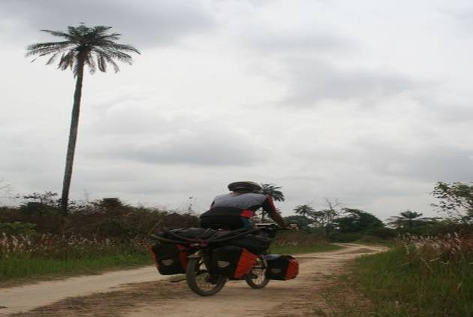
In the end, we took the room at the Moonlight Motel and had a pleasant evening chatting with Happy, the hotel manager, his two sisters and several neighbors who had come by to have a look at the exotic tourists. In out-of-the-way places we always attract lots to gawkers. Most adults are subtle about it, but when one man was asked what he was doing outside the guesthouse gate he shamelessly replied, "I have come to look at the white woman." As if Amaya were some sort of zoo attraction!
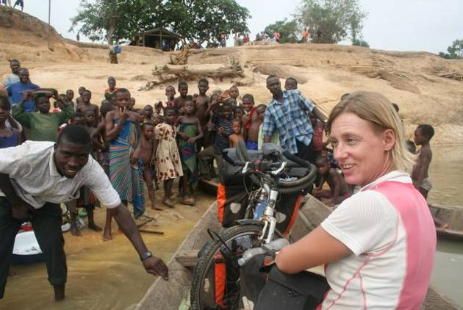
Nigeria boasts some of the highest highway death tolls in the world, so we prudently decided to stick to minor roads as much as possible. As we left Happy and friends behind, we set off on a fine paved road through some rolling hills, lush forest and wooded savanna. After a few hours ride we spotted the Niger River in the distance and soon arrived at the town of Illushi. Locals had assured us that there would be a ferry here to take us across (some even said there was a bridge!). There was nothing of the sort, and as we made our way to the waterfront a crowd quickly gathered. The villagers seemed perplexed and asked where we were headed. We too were perplexed, as we could see no obvious road on the other side of the river. After being assured that the road continued on the other side, we negotiated a canoe to carry us across the Niger. On the opposite shore of the river, the boatmen kindly pushed our bikes through the deep sand and told us they would take us to the road. They had been pushing an awfully long time and still no road was in sight. We were getting worried. Finally a narrow track appeared and then a cluster of huts. The road must surely be connected to this village, we thought, and said goodbye to the boatmen and thanked them for their help. This was a mistake since nobody in the village seemed to understand English (Nigeria's official language) and we couldn't find a road per se. Confident that we were headed in the right direction, we continued down the dirt track and hoped for the best.
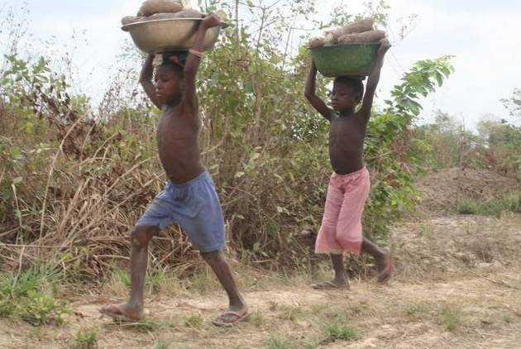
After an hour or so some motorcyclists appeared. We flagged them down and were thankful to find they spoke English. Apparently there was nothing in the direction we were headed. If we continued we would go only deeper into the bush and would never reach a road as such. This was bad news. We were told to backtrack and follow the piste along the river north to the town of Idah. We cursed our Michelin map for carelessly drawing a road where none existed and then turned around. It was an arduous day cycling, but when we finally arrived in Idah the locals were so welcoming that we soon forgot the difficulties. The next morning a local photographer was waiting outside of our room to 'snap' us with the proud guesthouse manager. We were very flattered.
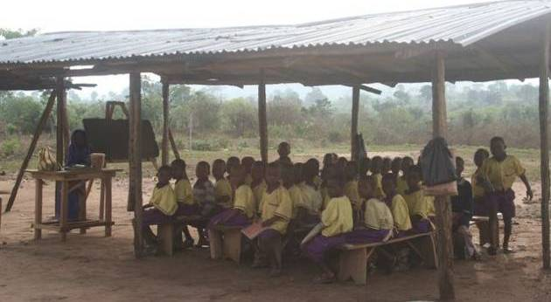
Roadblocks are commonplace throughout Nigeria. Ostensibly in place to maintain security and deter would-be bandits, in reality they're a lucrative source of income for the local police and military. Nobody's duped into believing the security forces are there to serve, and money can be seen changing hands quite openly. On busy roads we passed up to 20 roadblocks in a day and are pleased to report that we almost always road through without a hitch. Our strategy was to grin widely and wave furiously as we enthusiastically greeted the officers in charge ( Gooood moooorning, sir! Hooooow aaaare yoooouuuu?) and be on the other side of the checkpoint before they could stop us. The officers had no choice but to wave back and return the greeting, lest they appear inhospitable towards foreign tourists. Only once were we stopped by a military man toting some sort of semi-automatic rifle who wanted to get the lowdown on our trip and scrutinize our passports. He had obviously had too much palm wine and we let out a sigh of relief we he finally let us go.
Nigeria has left us with mixed feelings. While we loved the people, and enjoyed a variety of spectacular scenery from the stark beauty of the savanna to wild Tarzan and Jane jungle, we can't help being saddened and appalled at the lack of progress in a nation with such potential. Travel here isn't for the faint-hearted, but it does have its rewards if you keep an open mind and have a dose of good karma.
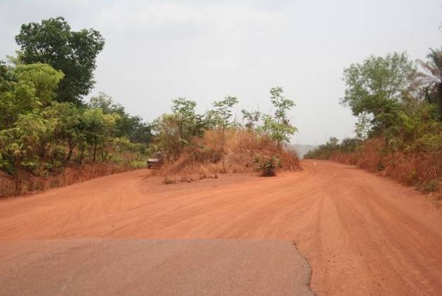
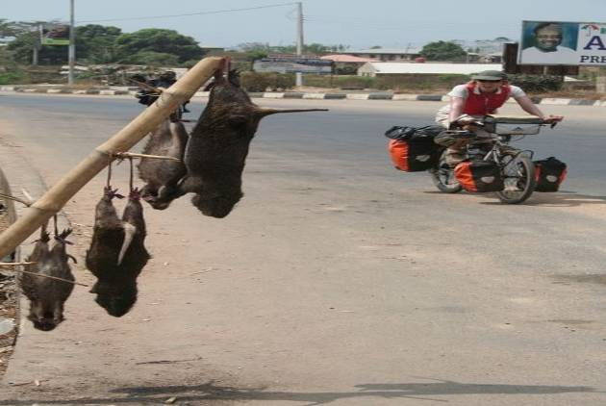
update 13. calamity in cameroon
7 March - 7 April, 2007
Total kilometers cycled: 19,250
Specific country info on routes & roads/food & accommodation/the locals available here.
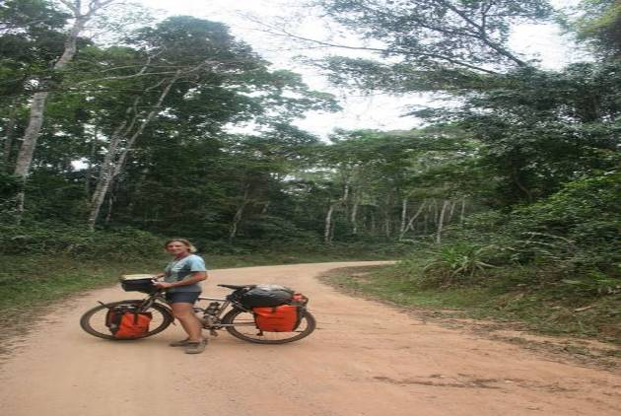
It was with a sigh of relief that we crossed the border into Cameroon. The last 100 kilometers in Nigeria had been trying and we weary cyclists were in need of some R&R. Given the often horrific African road conditions, our Kogas have performed admirably, but after almost 20,000 kilometers we were bound to have some minor breakdowns. The derailleur failed us first, and forced Eric to backtrack to Calabar to hunt down a replacement. Not as easy as it sounds, since (unusually in Africa) bicycles are a rare sight, After several hours making the rounds in the market he finally chanced upon a small shop selling shoddy Chinese made spare parts. The replacement certainly doesn't compare with the original Shimano XT, but it will do in a pinch. Next came the chain, which inopportunely snapped in two on a bumpy track 50 kilometers from the remote Ekang border crossing. This would have been a routine repair, except that the tool required to mend or change the chain (a so-called chain-breaker) also broke. Eric took to pushing and we prayed for a vehicle to pass. In good time one did, but seeing our desperation the driver tried to extort the exorbitant sum of $100 USD to transport us to the next town. Thoroughly disgusted by his opportunism, we continued our tramp through the jungle. Eventually we were spared a 50 KM trek by an ingenious villager who deftly repaired the chain using a big nail and a wrench (or spanner for those of you in the UK ).
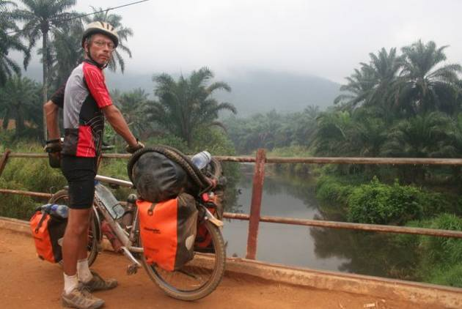
By the time we reached the border post, we were beat and bedraggled and hardly in the mood for hassles. The officer on the Nigerian side, who was obviously bored out of his mind, set off on a tirade as soon as we presented ourselves in his office. It was unacceptable for tourists to 'lollygag' about town 'consorting with idlers' before making themselves known to the proper authorities. After apologizing profusely for our breach of conduct (we had thought there would be no harm in drinking a coca-cola before exiting the country) he seemed to take a liking to us. In the end he was sorry to see us go and disappointed that we hadn't taken him up on his offer to camp outside his office. Our friendly official assured us that we were always welcome to come back and spend the night on the Nigeria side, where he could personally ensure our security and comfort.
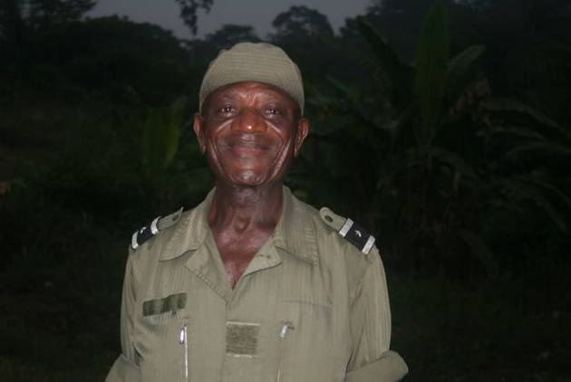
There was a long wait on the other side of the border because the Cameroonian functionary had gone down to the river to bathe. When the officer finally did return he struck us as a jovial type, and although we normally avoid all undue contact with officialdom, we saw no harm in taking him up on his offer to camp. We had a great time 'snapping' the officers, debating the merits of life in Africa versus Europe, gazing at the star-filled sky and even enjoyed a refreshing communal wash in the river. Our stay in Cameroon was off to a good start--too bad our luck didn't hold.
We were riding through unspoiled equatorial rainforest now and were thankful to be tackling the deeply rutted roads during the dry season, before they turned into a river of red-earth. Over the months we had grown used to potholes and sand, washboard corrugations and rocky surfaces that resembled riverbeds. It seemed hardly worth the effort to complain about the state of the road as this was par for the course in Africa. Instead we let ourselves be enveloped by the dense jungle-- the distant bird calls, the gentle trickle of a nearby stream, the incessant whining of insects and the heavy, humid air. The locals were friendly and when we stopped to fill up on water we were offered fresh pineapple and mangoes. Perfect cycling apart from the annoying chants of 'white, white, white' from adults and children alike.
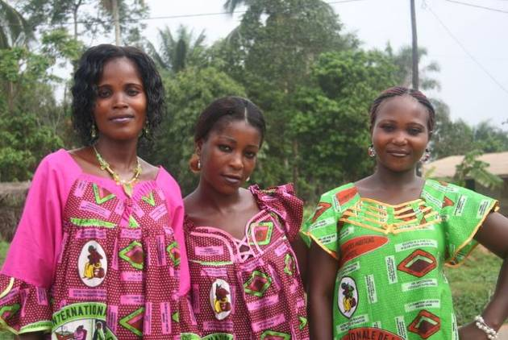
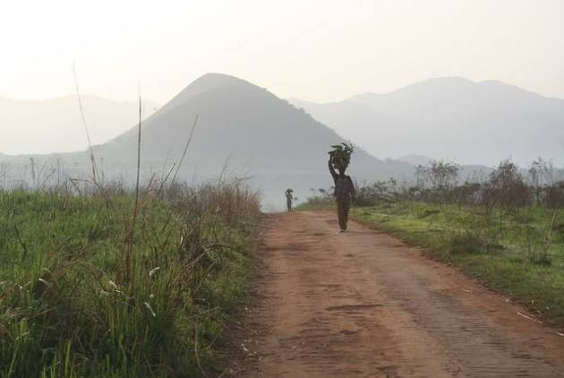
March 8th marks International Womens Day. Largely unnoticed in the West, this is serious cause for celebration in Cameroon. Throughout the day local politicians make lofty speeches, all-female teams take to the field for football matches, and young women in traditional attire move to the music of their ancestors. At sundown, as the official festivities wind down, the drinking spots start filling up, the music starts blaring and the locals get down to the serious business of getting very drunk. We'd done a fair bit of climbing on that particular day, had no interest in going on a drinking spree and wanted nothing more than to wash off the layer of accumulated grime and curl up in bed for a peaceful night's sleep. Difficult when you're being assaulted from all sides with a mixture of bad French rap and cheesy love songs being emitted from man-sized speakers at ear-shattering noise levels. We've also grown used to noise in Africa, but this was unbearable. Around midnight Amaya, suffering a severe migraine by this time, lumbered over to the nearest establishment and pleaded with the proprietor to turn down the music. He snickered at her request. In desperation she trotted off to the Catholic Mission Hospital up the road where an understanding Italian nun accommodated her in a quiet and spotlessly clean private room. In the morning we set off, Eric groggy and grumpy and Amaya energetic and refreshed, to face a demanding 20 KM climb snaking through Cameroon's tropical highlands.
Our arrival that afternoon in Bamenda coincided with the onset of the rains. The wind began to gust and then in quite spectacular fashion, the heavens opened and we were caught in the deluge. Fortunately, we found cover before the hail came thundering down, but the temperature plummeted so quickly we had to dig out our fleece jackets to keep warm. Everyone was in high spirits and the cool air was a relief after the hot and sticky weather we had endured. As we rode into town we spotted the first white person we'd seen since Benin. We couldn't help staring, just as the villagers do when we enter their settlements.
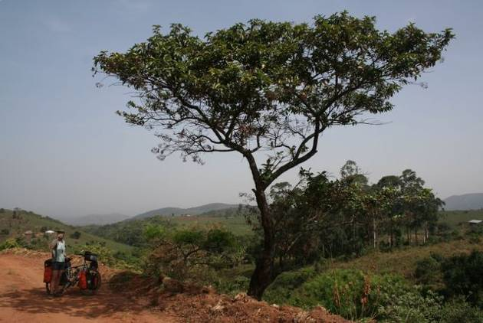
After treating ourselves to some decent meals and lazing around Bamenda for a few days, we felt ready to take on the Ring Road, reputed to traverse some of the finest scenery in all of Africa. We'd been forewarned of washed-out bridges, impossibly steep climbs and the usual dirt tracks supposedly impassable in the rainy season. Day one was a magnificent ride past terraced farmland and verdant rice paddies with volcanic mountains providing the backdrop. Day two proved to be one of the most demanding rides to date. Heading out of Wum we quickly left the rolling meadows behind and the gravel on the narrow track gave way to large rocks and deep crevices making riding impossible. We resigned ourselves to pushing and heaved our bikes up the steep inclines, slipping and sliding as we went. A gang of unkempt children with their pack of scrawny dogs followed silently behind. Ahead we saw the track winding its way around the mountainside and then disappearing into the distance. It was a daunting sight, even more so when a Fulani herder on horseback galloped by. This was obviously no place for wheeled vehicles. Nevertheless, we were reluctant to turn back--thus admitting defeat-- and so we struggled on. It was late afternoon and our arms were aching before we arrived in Fundong, at an altitude of 1400 meters, just 40 kilometers from our starting point.
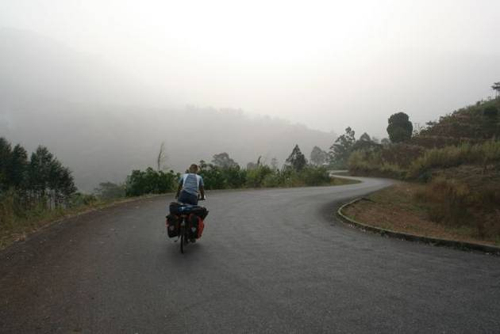
Day three of the Ring Road found us back on tarmac and Eric whizzed through the mist and down the mountainside at perilous speeds. Amaya, whose mother was a nurse and fed her a steady diet of gory tales from the emergency room throughout her childhood, clipped along at a more prudent pace. And then suddenly Eric was sprawled out on the pavement, his gear scattered by the roadside and his bike all bent out of shape. Someone had had the bright idea of putting a speed bump at the bottom of a very long and steep hill. This was bad news for unwary cyclists and Eric had been taken by surprise. Almost immediately concerned passers-by pulled over to help. The locals ousted the goats they were transporting in the trunk, loaded Eric and his bike into their car and carted him off for treatment as a nearby Baptist mission hospital.
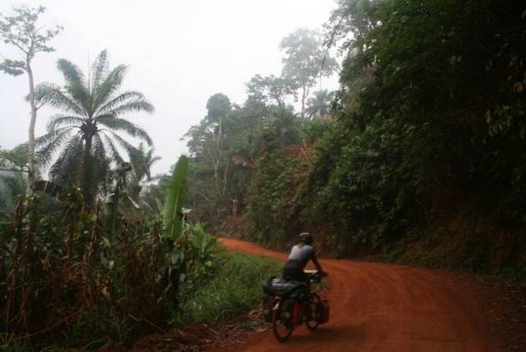
The upshot of this little mishap is that we've had to extend our stay in Cameroon. Eric's got a fractured clavicle and the doctor recommends at least 4 weeks off the bike. We've found a small house to rent here in Bamenda and are passing the days reading novels from the British Council Library, solving Sudoku puzzles, practicing yoga, volunteering at a local NGO and frittering away the rest of the time on the internet. In an effort to keep fit, Amaya has taken up jogging, and most days is followed around the field by a group of giggling school children.
Extending our visas was a taxing experience and a test of our patience and ability to...er...kiss ass. Cameroon was ranked dead last in a recent corruption index. Unless you want to fill the director's car up with petrol or slip a little something extra to the man in charge, playing the obsequious and grateful "whiteman" is the only way to get things done. We were shuffled around from office to office for four days before the pompous officials deigned to give us the magic stamp allowing us to spend 30 more days in Cameroon. You would think the country would be happy to take our 50,000 CFA (100 USD).
So, what's next? We would like to continue down the west coast of Africa through Equatorial Guinea, Gabon and the Congos and then on to Angola, Namibia and finally South Africa. This route will be complicated due to the rains in Gabon, the recent fighting in Kinshasa and the Angolan's unwillingness to grant visas. For now, we're just focusing on rest and recovery, we'll let the future sort itself out later.
contact us at: worldbiking@gmail.com
Support our chosen charity and help educate girls in Africa-more info here
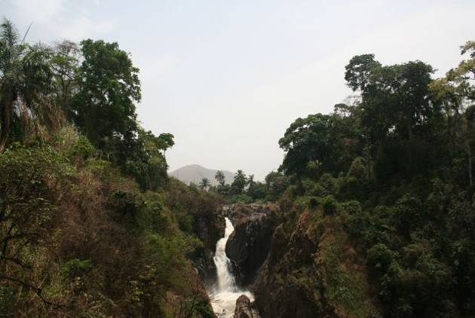
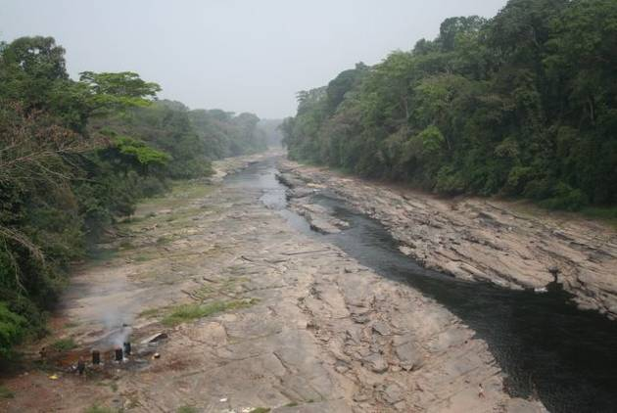
update 14. drunken officials, steamy jungles and a whole lot of rain
8 April - 16 May, 2007 Equatorial Guinea and Gabon
Total kilometers cycled: 20,894
Specific country info on routes & roads/food & accommodation/the locals available here.
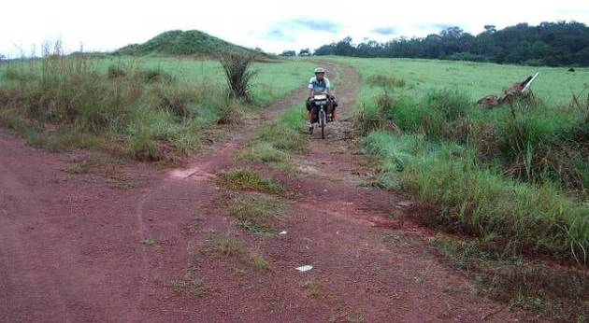
We were feeling quite smug having just made it through our 10th police roadblock without a problem. The consensus among posters on Lonely Planet's Thorntree travel forum was that in postage-stamp sized Equatorial Guinea, bribes were unavoidable: No Pay--No Pass. Obviously these travelers didn't have our finesse with feisty border guards and greedy bureaucrats. So we weren't expecting trouble when we rode up to our 11th roadblock. The sound of our pedaling roused the young soldier on duty who was dozing by the side of the road. He was dressed in a vaguely military get-up and quickly slipped his t-shirt on before motioning for us to approach. Taking the passport details down proved challenging for the young man, so Amaya dictated the required information which he painstakingly transcribed in a large ledger. Some 20 minutes later, when he'd checked and double checked his work, and we were preparing for a round of cheerful goodbyes, he informed us that we would have to wait for el Jefe to return. This sounded ominous.
In good time the boss stumbled in, obviously back from a drinking spree in the local bar. He was slurring his Spanish so badly we could hardly make out what he was trying to say, but it seemed to boil down to us paying 2,000 CFA each for the privilege of passing his checkpoint. We pointed out that no one else at the previous 10 roadblocks had asked for any money. Our resistance set him off on a tirade and he began ranting and raving for a good 15 minutes. When he had calmed down a bit, we restated that our visas and passports were in order and kindly asked that he allow us to continue on our way. Wrong move. He started in on another harangue and then disappeared (with our passports in hand) to return toting his Kalashnikov. We got the message and quickly dug out the 4,000 CFA to pay up. Only now it was 'too late' he said and we 'disrespectful foreigners' would have to return to Bata (100 kilometers away) to obtain a travel and photography permit. He was a 'professional' after all and couldn't allow undocumented visitors to traipse around his country without the proper authorization. We were in a bind. Being in the midst of yet another downpour we decided it was best just to sit obediently in our corner and wait to see how the situation played out. When el jefe referred to Eric as hermano and suggested he roll the bikes in out of the rain, we began to have glimmer of hope. After all, we told ourselves, there is a good side to everyone--even armed thugs in uniform. In the end, he let us go, but the passage fee had gone up to 6,000 CFA and naturally no receipt was issued. $12 was a small price to pay for our freedom we decided.
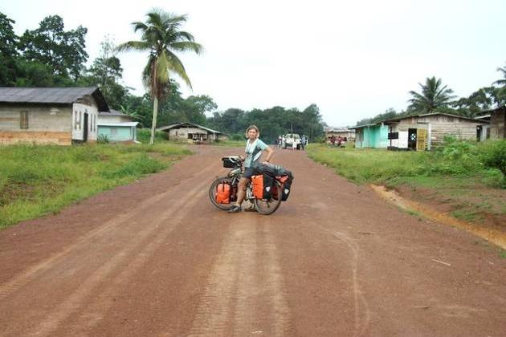
We rode off to loud snickering from the on-lookers and the humiliation we had endured at the hands of the corrupt official left us fuming. It was getting dark, rain was still falling heavily, the road was a muddy mess and we were longing for civilization. Jungle camping held no appeal for us, so we asked around in one of the many villages bordering the road if we might be able to pitch our tent under some type of shelter. African hospitality being what it is, we drenched cyclists were offered comfortable lodging at the vice-president's home. This small settlement of perhaps fifty families had no lack of leadership--a president, a vice-president, and two chiefs, each representing a different clan.
Equatorial Guinea oil-rich and at l east some of the wealth seems to have trickled down to the lowest levels. Our hosts lived in a well-built wooden home and even had a TV and DVD player. The government had yet to provide running water or electricity, but the generator was turned on especially for our visit and we enjoyed (well not really) an evening of African pop videos with the family.
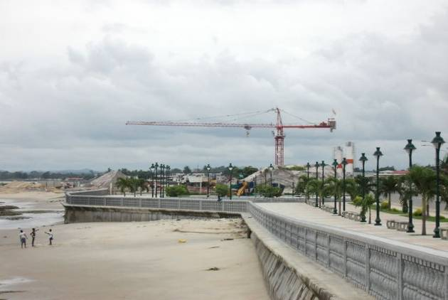
The next day's departure from Equatorial Guinea involved an hour-long ride in a motorized-pirogue through an estuary to exotic-sounding Cocobeach across the border in Gabon. The run-in at the roadblock had put a damper on our fun and we weren't sorry to be leaving the tiny, Spanish-speaking country. We had been impressed by the smooth new roads being paved through the dense forest, appalled when we found out the president is using government money to have a flashy airport built in his home village where giant A380 planes will be able to land and amused when the children called us 'Chinos'. The Chinese moved in swiftly as soon as they realized there was money to be made in Equatorial Guinea. They're behind most of the road building projects, they run most of the pharmacies and small shops selling household goods and Chinese doctors (or those claiming to be) have set up clinics all over the country. They're everywhere. Bata, the mainland's economic capital, boasts swanky restaurants, modern shopping complexes and a new waterfront promenade complete with palm trees and granite benches. Even small towns have sidewalks (unheard of in this part of the world) and surprise, surprise there's even garbage pick-up. There's obviously money in the country, yet the government still struggles to provide running water in the cities and towns and since education' isn't free, parents still struggle to pay school fees. Not a lot of social justice it seems.
But back to our departure. This is Africa and It goes without saying that the boat was seriously overcrowded. We were wedged in under the weight of the bicycles and on top of those were gigantic woven baskets and various sacks of goods. The man steering the boat from the back had zero visibility and relied on a boy atop our bicycles to navigate him through the waters. Apart from the numbness in the lower body things weren't going too badly until we hit some choppy waves. The canoe started taking in water, women started screaming, babies started crying, men started shouting and through all this we tried to remain calm despite being surrounded by panicking Africans. There were only six life jackets for the 40-odd passengers aboard and we were not among the lucky recipients. Well, we didn't capsize. but that little adventure sure got the adrenalin flowing.
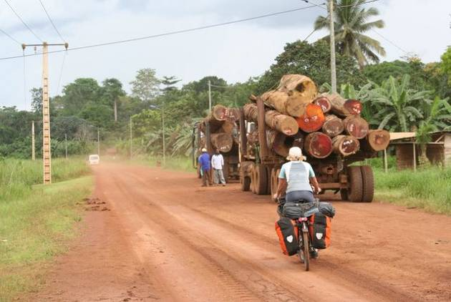
The first thing that struck us about Gabon was the convoys of logging trucks carting off the nation's natural wealth. It was a sad sight to witness and even sadder when you know that most of the money generated from the sale of timber is lining politician's pockets rather than being used to pay teachers, build schools or pave roads. What's left of Gabon's rainforest just doesn't compare with that in Equatorial Guinea, which is so dense that when you stop and look for a spot to take a break you realize that the wall of massive trees and dense vegetation is almost impenetrable. In spite of the negative effects of poorly-regulates logging, this region is the real heart of tropical Africa: fast-flowing rivers spanned by rickety wooden bridges, exotic bird calls and monkey cries provide the background music and insects buzz, bite and suck your blood until your limbs are just one big red blotch.
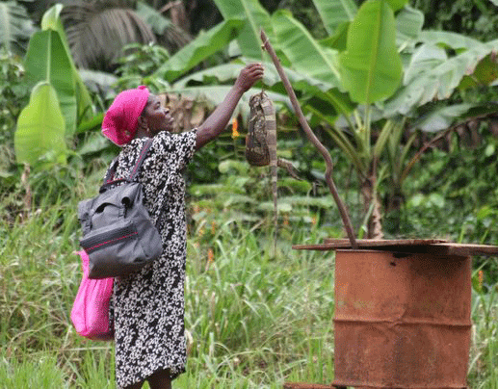
Gabon, with a GDP of $3,780 (2002-OECD) is so much wealthier than neighboring West African countries whose GDPs hover around $300 to $400 that it attracts a multitude of workers from as far off as the Sahel. Mauritanians man most of the small supermarkets, Cameroonians have the bar and bakery businesses wrapped up, Senegalese run the restaurants and Malians tend the market stalls while the enterprising Togolese have opened up small hotels. This situation seems to have created tensions and left many Gabonese resenting their dependence on the large foreign workforce. If you speak with the guest workers they'll tell you that the Gabonese all aspire to cushy office jobs where they can sit behind a desk, sign a few documents and then head off to a nearby bar to spend the afternoon downing beer. They're right about the beer. Even as we head to the bakery to buy bread just after sunrise the bars start filling up with businessmen types on the way to the office. As for us, we always feel a certain comradeship with the other 'foreigners' and love to sit around sharing our experiences of travel in their home countries.
Pythons, crocodiles, monkeys and turtles...everything is fair game for the cooking pot in Central Africa. Bush meat is a staple in this part of the world and often it's best not to peek under the lid to see what's cooking. Beans --with a generous serving of mayonnaise and Maggi-- continue to be our staple meal outside of larger towns (where we might hope for an omelette and rice), and while they used to be a meal of last resort, we now count ourselves lucky when we come across them. Nobody comes to Africa for the cuisine.
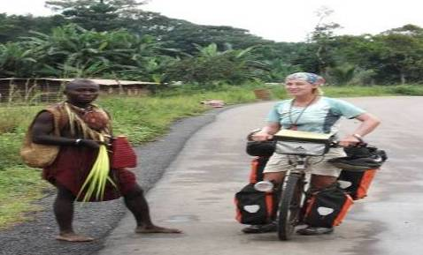
In the big cities you can find pharmacies selling all the latest western drugs, but villagers still like to rely on traditional methods of healing. One Sunday morning we were greeted by a group of men in traditional dress (much more exotic than the jeans, trainers and t-shirts that is the usual attire) preparing for a tribal dance in celebration of a successful healing. The patient had apparently been a little off in the head, but was now cured thanks to a mixture of tree bark and medicinal plants. Such remedies had even successfully cured several cases of HIV the villagers proudly boasted. This was a sacred affair, we were told, so we wouldn't be allowed to stay around for the dancing and watch them apply their make-up, unless of course we agreed to a generous contribution to the village coffers.
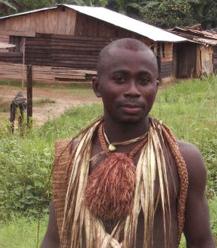
We've been reading warnings in our guidebook about impassable roads since we reached Guinea way back in October. Still we were surprised to find a veritable river flowing some 300 meters across the 'road' where we were supposed to pass on our way to the Congo border. We hopped off our bikes to do a little reconnaissance and were soon joined by a fully-loaded mini-bus and a pick-up. The men rolled up their trousers and trudged off to check out the depth of the water. It didn't appear to be deeper than mid-thigh, but the current was strong and we could see that the Africans were having trouble staying upright. Looked like a no-go for us on our heavily-loaded bikes.
As we continued to contemplate the crossing, a Land Rover arrived from the other direction, gathered up speed and plunged through the flooded area in quite spectacular fashion. Four more such crossings awaited us on the road to Ndendé, the driver told us. In one 500 meter inundated section, he explained, the water was waist deep. This was definitely not doable on the bikes. By this time other vehicles had pulled up, were dissuaded by the news and decided to turn back. We waited around for another hour in the hopes of hitching a ride on a passing truck, but the stream of traffic had dried up. Word about the bad road conditions had obviously gotten around.
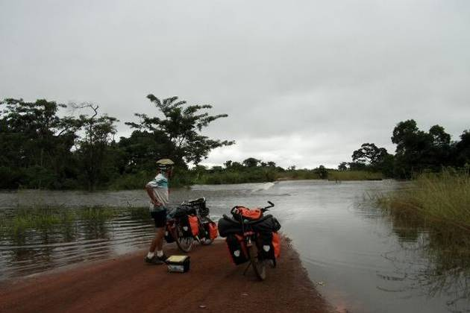
The next morning as we headed out of Mouila on our way to the border for our second attempt, we stopped to chat with some truck drivers and get an update on road conditions. It had rained during the night, so we weren't expecting good news. The flood waters had subsided, they reported, but thought passing on a bicycle would be impossible. We were in a dilemma. Should we check back into the hotel and wait another day, knowing the rains could continue and the situation might worsen? Should we ride on and risk getting stuck between two flooded areas in some godforsaken village where it would be a question of going hungry or munching monkey? Or, should we take the wimpy way out and hop on this sturdy-looking 12-wheeled truck and make it to Ndendé in a matter of hours rather than perhaps days. We opted for the truck.
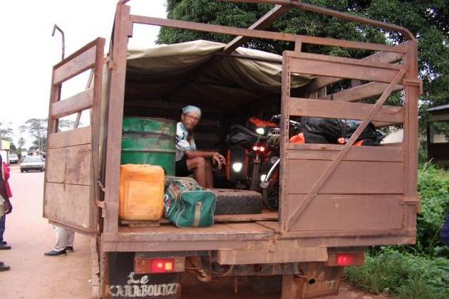
We write to you now from Ndendé and, having seen the condition of the road, don't regret our decision. We saw pick-ups passing, but the water was up to the bed. The only way mini-buses could pass was to cut their engine(this prevents damage to the motor) and have the passengers strip down and the push the vehicle through the waist-deep water. It was awesome to see the skill of the African drivers and a real adventure even if we had to enjoy the spectacle being tossed around in the back of the truck rather than being bumped around on our bikes.
A trip to the local hospital confirmed that Eric has come down with malaria for the 3rd time in less than a year. He's fighting a high fever and aches all over, but should be feeling better as soon as the anti-malarials kick in. We've had our share of bad luck (Eric's accident, broken low-rider, damaged camera, a bout of malaria for each of us, two chipped fingernails) over the last few months, and sometimes we're not far from throwing the towel in.
Less than 50 kilometers separate us from Congo. The locals tell us road conditions deteriorate on the other side of the border, so travel won't be easy. Another obstacle to steer clear of will be the so-called 'ninja rebels' who are running a low-level insurgency in the region near Brazzaville. Travelers before us have been strongly advised (and some forced) to take the train rather than risk a possible attack on the road. Both physically and mentally, this is a tough part of the continent to cycle through. Fortunately, the kindness of the locals and the beauty of the landscapes keep our spirits up (and of course your emails of encouragement help, too).
The coming weeks promise to be full of adventure and a few hardships as well. We'll update you soon to let you know how we fare with the rigors of the Congos.
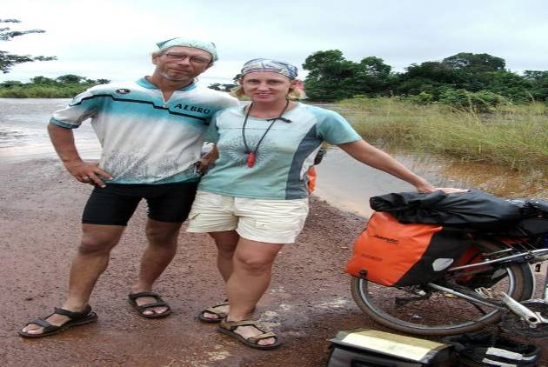
contact us at: worldbiking@gmail.com
Support our chosen charity and help educate girls in Africa-more info here
update 15. chaos in the congos and holidays at home
17 May- 1 July 2007
Total kilometers cycled: 22,477
Republic of Congo, DR Congo and a slice of Europe
Specific country info on routes & roads/food & accommodation/the locals available here.
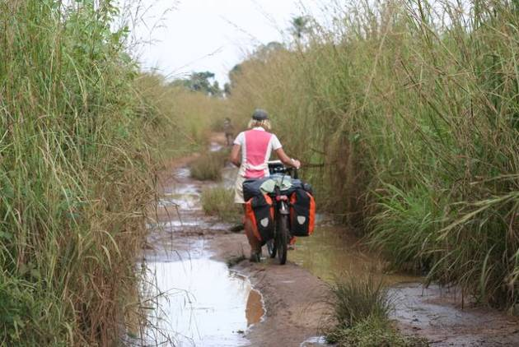
No, we haven't been kidnapped by gun-toting ninja rebels and Amaya hasn't been made the umpteenth wife of some minor African king: we've been on vacation in Europe! More about that later. The last update of our African saga (and sufferings) left off with Eric in the throes of his third malaria bout in Gabon just 50 kilometers from the Republic of Congo border. The rains had yet to wind down, travel was rough and morale low. Medical care in the remote border outpost was basic at best and the only doctor in town had traveled to Libreville for medical assistance. The hospital staff could do little more than dish out malaria medicine, so when we returned two days later worried that Eric's fever had yet to come down and he had developed a nasty looking rash, they were of little help. Finally we resorted to self-diagnosis and with the help of our Lonely Planet Africa health guide we decided he must have contracted Typhoid fever. Luckily we were carrying the recommended medicine for treatment. He started the course of drugs and within a few days we were back on the bikes headed down a narrow, muddy track surrounded by tall grass on our way to Congo.
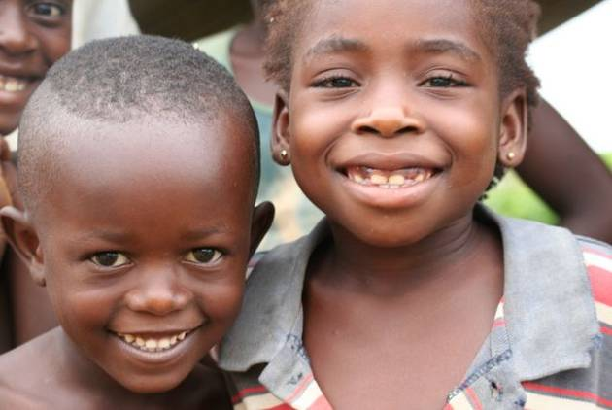
Progress was fairly good given the less than ideal road conditions and by mid-day we had reached the border. Here we nearly got lost in the labyrinth of customs, immigration, police and military posts all staffed by dodgy officials carefully scrutinizing our documents and looking for ways to eke a bribe out of us. Despite the scorching sun the customs guy even insisted on searching all our panniers for illegal weapons--guess he thought we might be arms-dealers masquerading as simple cyclists. The police wanted proof that we were really tourists and entitled to enter on a tourist visa. This was tricky--how can one prove he is a tourist? Several hours were wasted with this nonsense, until the officials eventually tired of the games and realized no money would be forthcoming. Fortunately the farther we rode from the border, the friendlier the officials became. At the next town our passports were returned before the officer in charge asked for a small donation to pay for fuel for the generator. 200 kilometers down the road the police were giving us directions, offering us mandarins and guiding us to a hotel. Things were looking up.
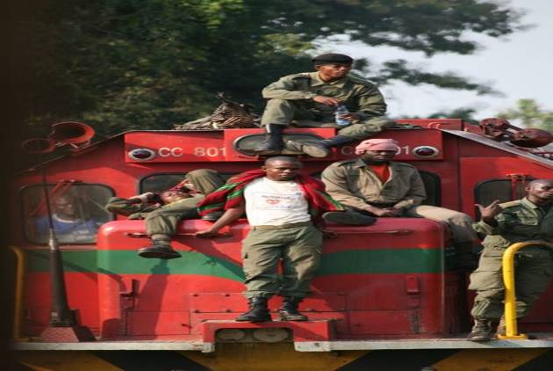
Cycling came to a halt as we pedaled into Loutete. This was the last town before the Ninja-zone where drugged-up and well-armed rebels were known to hassle passing motorists. They were unpredictable, we were told, and although the peace process was underway it was best not to take chances. A freight train under military escort was leaving that evening and the officer in charge said we were welcome to come along for the ride. 10 PM, the scheduled time of departure, came and went. We found the young commandant, his colleagues and some scantily clad female companions downing Ngok beers in the bar next door. He was unfazed by the delay and told us to check back again around midnight. We had had the good sense to take a room at one of the small auberges, so we went back to the hotel, turned on the fan full-blast in hopes of drowning out the music and set the alarm for 12:00. No train at 12:00, nor at 2PM when we next checked back and by 4PM everyone appeared to have conked out (although the music was still going full blast). When the train finally did arrive at noon the following day, we were given the place of honor right up front in the caboose next to the driver. Our bikes were securely tied down on to the roof just behind the machine gun which was mounted to deter would-be looters and sundry bandits. Our military escorts were a ragtag bunch--many in flip-flops, others with the soles of their boots worn through, some in ripped trousers and wearing an array of t-shirts and camouflage gear. They were keeping watch from the roof, with AK-47s casually slung over their shoulders and some armed with rocket launchers and grenades. The train was ancient--a cast-off from the South Africans--and at the slightest incline we would slow to a crawl, going no faster than 20 kilometers per hour. The conductor relished in pointing on the remains of various derailments and rickety bridges and a look of glee crossed his face as Amaya cringed. The exhausting 200 kilometer trip took nearly 12 hours and the dark streets were almost deserted when we pulled into Brazzaville station.
Our stay in Brazzaville was a pleasant one as we basked in relative luxury as the guests of Olivier (himself a fellow cyclist) at the Hippocampe Hotel. Hot showers, satellite TV, rubbing elbows with UN workers and embassy staff at the buffet--a welcome change from roughing it on the road. But we eventually had to tear ourselves away from all the indulgences and head over the river to Kinshasa in DR Congo since our visas were about to expire. There was a flurry of a activity at the border crossing: a brass band was warming up, a red carpet was being unfurled, sharp shooters were positioned on the rooftops of surrounding buildings and truckloads of soldiers were rumbling by. The DRC's president, Joseph Kabila, had come for a visit to Congo-Brazzaville and the border was closed. We were turned back and told to come the following morning when the ferry would be again running as usual. What luck we thought...our visas will be expired and who knows how much the officers will try to extort from us.
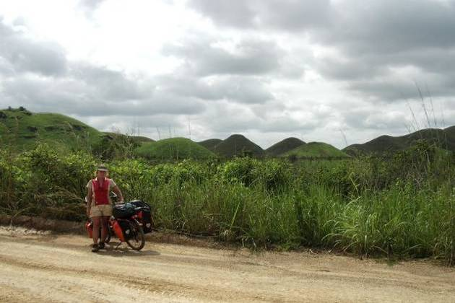
Cycling back to the hotel we were bemoaning our situation when a sign proclaiming 110,000 FCA Brazzaville-Brussels caught our eye. 165 euros for a flight to Europe? Impossible we thought. Further investigation revealed that the airline, Hewa Bora, was owned by President Kabila's family and this special round trip flight at a rock bottom price was being offered to the people of Brazzaville as a gesture of goodwill. We snapped at the chance and 48 hours later were on a plane headed home.
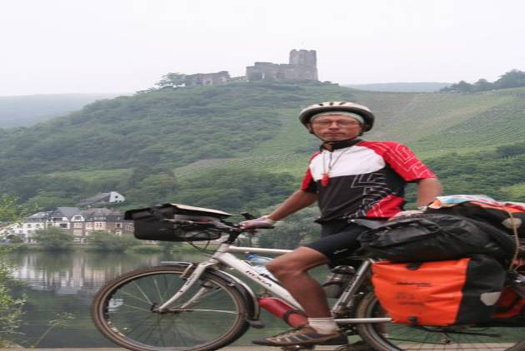
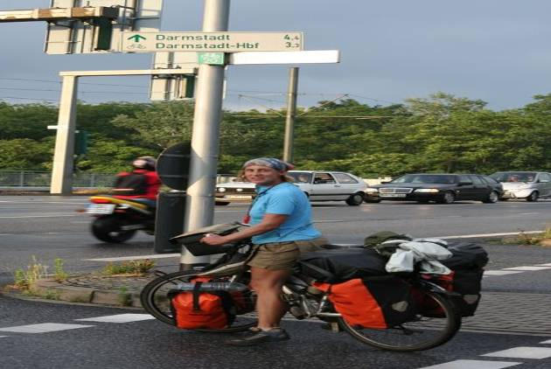
Three weeks of visiting family and friends, gorging ourselves on pizza, pasta, chocolate and croissants and getting the bikes back in shape. We got up late, lounged on the couch, marveled at the selection of food available in the supermarkets and generally enjoyed ourselves. All this plus squeezing in 1,200 kilometers of cycling between Belgium, Germany and France. Surprisingly, the riding wasn't as easy as we had anticipated. We were faced with a bewildering number of choices of roads on the old continent and, with the advent of the GPS, locals are often at a loss when asked for directions. After getting lost for the 12th time in two days, Eric finally broke down and shelled out 6.50 euros for a map! On our return trip to Brussels we arranged lodging through Hospitality Club and Warm Showers. We were warmly welcomed by all our hosts and found this to be a terrific opportunity to get to know people from all walks of life and sample some delicious home cooking.
Our streak of good luck came to an abrupt end in Kinshasa (DR Congo) when our bikes and baggage failed to turn up at the airport. The place was complete chaos with passengers jostling each other as they vied for a place around the luggage conveyor belt, porters tugging at bags hoping for work, policeman keeping back the crowds of itinerant vendors with the help of menacing sticks and absolutely everyone shouting at the top of their lungs. Talk about sensory overload.
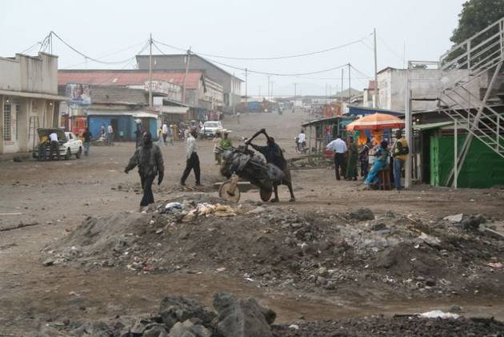
Several days were spent in this mega city of more than 5 million trying to sort out the mystery of the disappearing luggage. Thankfully an efficient Belgian gentleman by the name of Monsieur Lesergent took charge of the matter and we headed on to Goma near the Rwandan border where we were overjoyed to be reunited with our bikes two days later. Goma is something of a latter-day Pompeii, having been smothered in molten after the eruption of nearby Nyiaragongo volcano in 2002. The streets are still littered with lava rocks and many entrances to buildings in the center of town now stand two meters under street level after having been dug out from the flow. Natural disaster coupled with the civil war has left the town battered and it was a dreary place to spend a few days. The high point of our stay was the Salt and Pepper Indian Restaurant just across from the barracks of the Indian contingent of UN peace keepers...spicy curries beat bland manioc any day.
One final hurdle awaited us before being able to bid a final farewell to the Congos. While American citizens are admitted to Rwanda with a simple stamp in the passport at the border, the government in Kigali has broken diplomatic ties with France and now requires their citizens to apply for entry in advance, either in their home country or via internet. We weren't privy to this information and it came as a surprise to us when Eric was initially turned back at the border. Would we never escape from the claws of the Congo? A little wangling and some charm did the trick and he was eventually allowed entry.
We write to you from Gisenyi, Rwanda, a pleasant lakeside town with wide tree-lined streets, tidy well-stocked shops, inviting restaurants and fantastic views of the surrounding mountains. There's an optimistic feel about the place and we're eager to get back on the bikes and do some exploration of the land of a thousand hills.
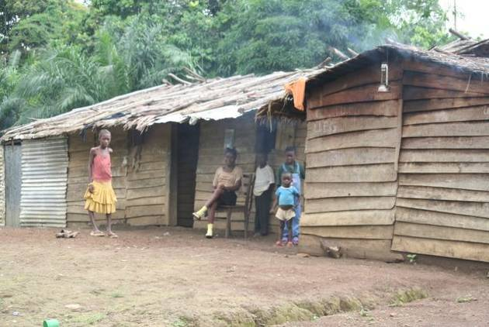
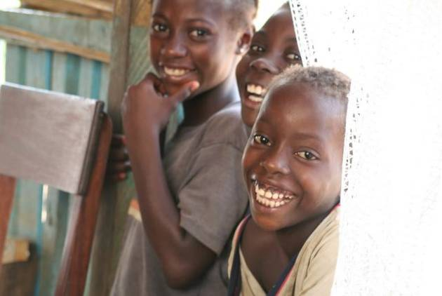
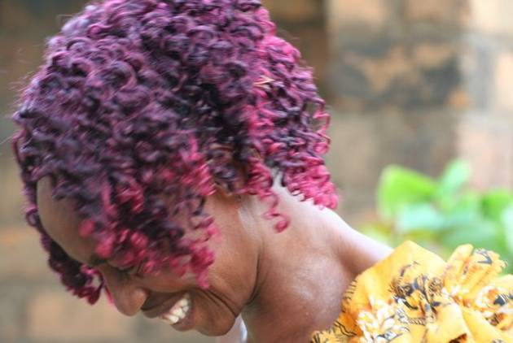
contact us at: worldbiking@gmail.com
Support our chosen charity and help educate girls in Africa-more info here
update 16. misty mountains and weary legs
2 - 26 July 2007 Rwanda and Uganda
Total kilometers cycled: 24,186
Specific country info on routes & roads/food & accommodation/the locals available here.
Whoever came up with the slogan 'Rwanda: land of a thousand hills' certainly wasn't exaggerating! With more than 24,000 kilometers of painful pedaling behind us, including the Pyrenees, the Atlas mountains in Morocco and the highlands of Guinea and Cameroon, we somehow thought the climbs would be less excruciating. Fortunately our efforts were rewarded with some spectacular scenery... volcanoes towering in the distance, verdant tea plantations stretching like a ribbon across the hilly highlands, patchworks of neatly laid garden plots, and fragrant pines 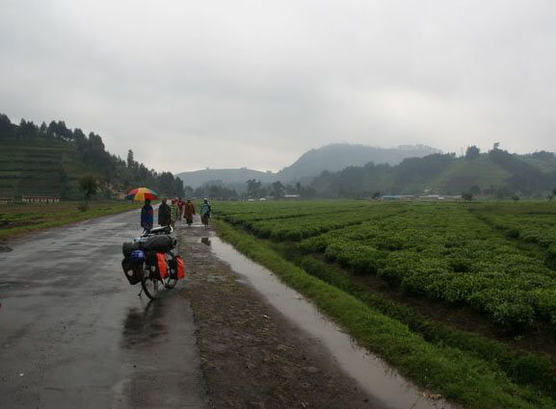
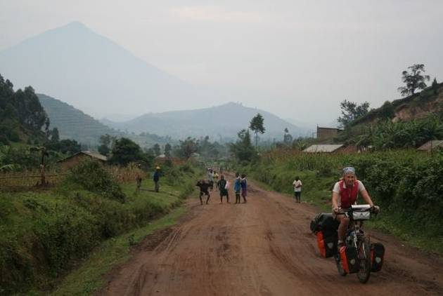
and eucalyptus providing shelter from the afternoon sun. Uganda is known as 'The Pearl of Africa' and with its picturesque crater lakes, majestic mountain forests, terraced hillsides and lush countryside, this nickname isn't just tourist brochure hype. Add to all this natural beauty some incredibly friendly people and the tastiest food we've had since Morocco and you'll see why morale is on the upswing and fantasies of returning to the stationary world are on the wane.
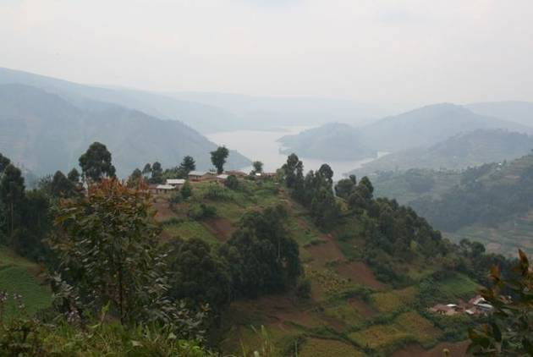
This past month has been decidedly un-adventurous--no close calls with rebels, no tropical illnesses to contend with and no hassles or haggling with officials. Mom and Dad will be glad to hear this, and our apologies to those armchair travelers who were counting on us for a bit of excitement to spice up life in the cubicle. Yes, after scrutinizing our stat-counter we see that peak visit times to our site are during working hours--obviously you've all got better things to do on the weekend.
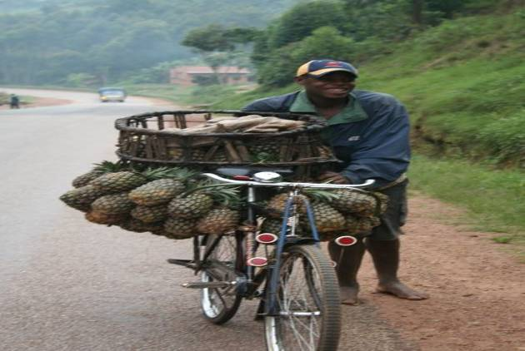
We are attempting to cycle to Cape Town and would indeed have arrived there about 10,000 kilometers ago and five months back if we had followed a direct route like some saner cyclists we know. In our quest to discover all parts of Africa (minus war-zones--we've no desire to discover what a bullet entering the body feels like) we sometimes feel as if we're zig-zagging across the continent. Well, one final detour we told ourselves with a sigh as we headed towards Uganda and cycled across the equator for the second time, re-entering the northern hemisphere after having already spent more than two months south of the equator.
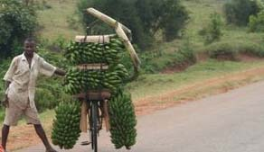
Deterioration is probably the one word that best describes our overall impression of Central Africa. Roads had deteriorated--often not more than muddy, overgrown tracks, the food had deteriorarated--we didn't fancy monkeys and crocodiles on the dinner plate, and worst of all the work ethic seemed to have really gone to pot in this war-scarred region--loitering on the side of the road was a full-time occupation for many. All this has changed--for the better--in East Africa. Rwanda's highways were faultlessly smooth as we swooshed down the winding roads. Thanks to the intense cultivation of the region, markets abound with fresh produce: potatoes, tomatoes, beans, peas, pumpkins, pineapples--even 'exotic' vegetables like cauliflower can be found. And the people of Rwanda and Uganda are perhaps the most industrious we've seen on the continent. At dawn we can hear the whoosh of the brooms tidying up the simple mud-brick compounds before the real work of hoeing and harvesting begins. The roads are buzzing with activity. Throngs of children heading off to school in tattered uniforms, muscle-bound men on overloaded bicycles balancing on their back racks everything from farm animals to furniture and passengers to pineapples. Woman with babies on their backs and tools slung over their shoulders trudging off to the family farm. Optimism floods the air.
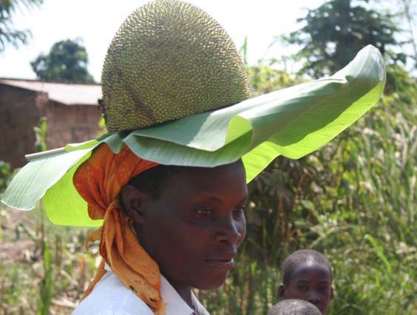
One thing that strikes us as odd in this part of Africa is the number of people running around barefoot. Perhaps memory is failing us (Amaya slipped into her forties in Nigeria)but we recall only those on the bottom of the heap--orphans and beggars--being without shoes, sandals or at least a cheap pair of flip-flops in West and Central Africa. In sharp contrast, we saw the entire student body of a primary school (when we passed they all rushed to greet us) without a single piece of footwear between them in one remote area of Uganda. Even lots of adults, mostly women, can been seen barefoot scampering up slippery slopes schlepping a load of firewood or jerry can filled with water.
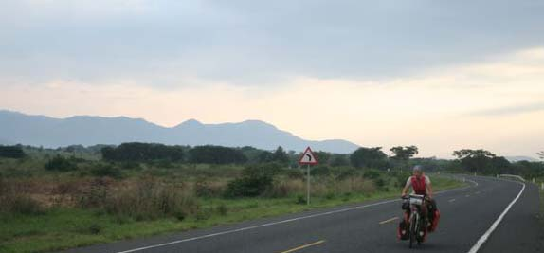
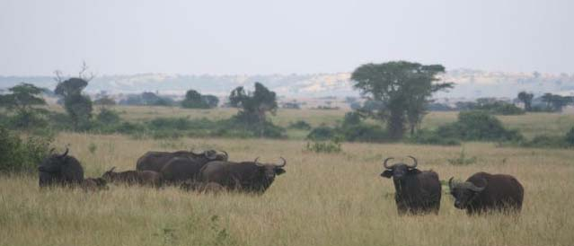
East Africa is famous for its national parks and bountiful wildlife. We were hugely disappointed after having made a detour of several hundred kilometers to reach Murchison Falls National Park in northern Uganda when we were turned back at the gate. No cyclists allowed--we would be just too tempting a treat for some hungry lion on the prowl. This came as a surprise after having been assured at the Office of National Parks in Kampala that we could ride through without a problem. Our only consolation and chance at game spotting was when we passed through Queen Elizabeth National Park early one morning and caught site of warthogs, monkeys and a herd of African buffalo grazing by the roadside. Amaya sped past knowing these animals are regarded as the most dangerous of the 'Big Five' (lion, leopard, black rhino, elephant and Cape buffalo). Eric was less informed and lingered to snap a few shots.
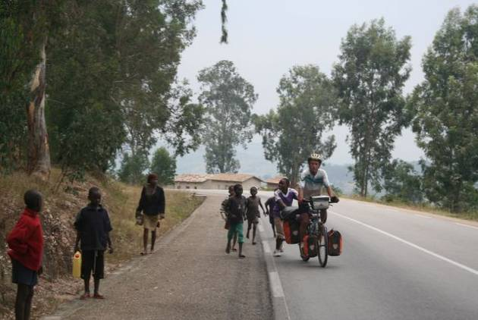
Recently our biggest challenge has been trying to find a bit of privacy when nature calls. The Rwandans in particular find us so fascinating that we hardly have a moment to ourselves the entire day of cycling. Some will ride along side for 10 or 15 kilometers and then, with a quick wave, turn back and head home. Others like an impromptu race to the next village with the locals always amazed to see a woman pedaling instead of riding side saddle on the back. Lots of encouragement for Amaya and shouts of 'go, sister, go' can be heard from the onlookers. At first we found the children slightly annoying with their constant shrieks of excitement and cries of Mzungu, Mzungu and tendency to run alongside the bikes on the long slogs uphill. Then we discovered their astonishing strength and endurance as we realized they could quite easily be cajoled into pushing us up the long hauls. Most even seemed pleased and proud to expend their energy for the benefit of the Mzungus. Since its rare to have television and most kids don't have any toys, we're the best entertainment around.
Next up is Burundi. Another country that's been torn by inter-tribal violence but is currently on the mend. It will be our last Francophone country before we move into the Anglophone countries of the former British Empire. We're looking forward to some flatter roads along lake Tanganiyka and are hoping for another month of adventure-free cycling.
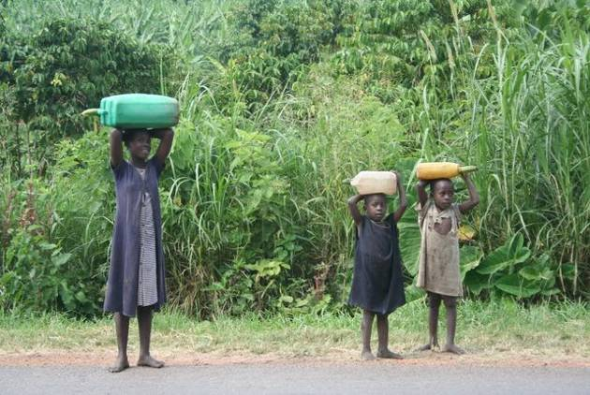
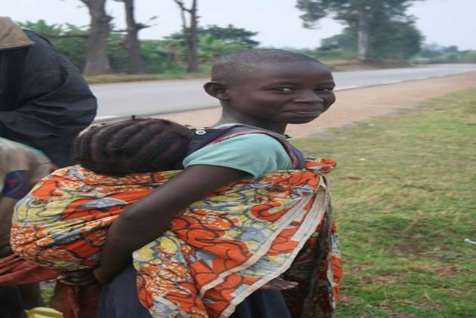
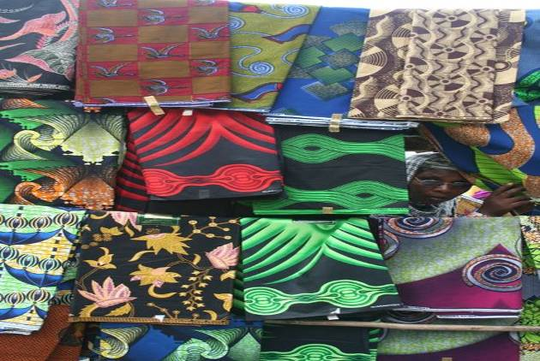
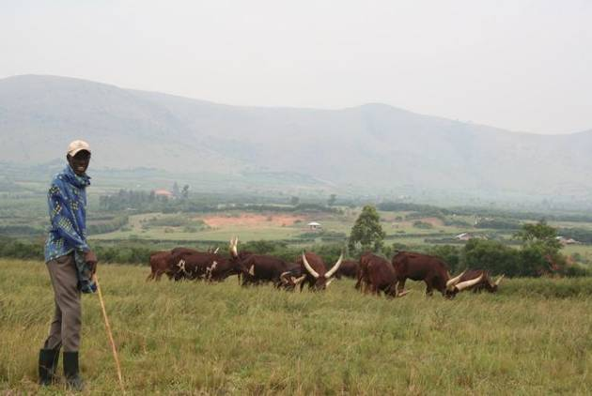
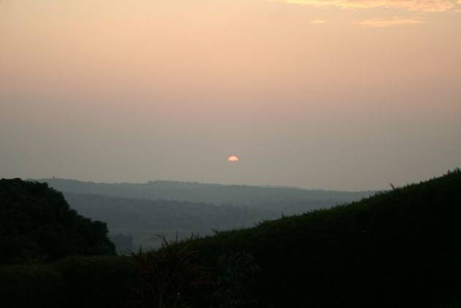
update 17. living on africa time
27 July - 4 September 2007
Total kilometers cycled: 25,887
Burundi,Tanzania and Malawi
Specific country info on routes & roads/food & accommodation/the locals available here.
After 15 months on the road, the pace is slowing and we're finding it easier and easier to conjure up excuses for hanging around 'just one more day' when we stumble upon a nice spot for a rest. Comfy couches at backpackers hostels, warm showers, Shoprite supermarkets and a decent selection of books are all too alluring after so many months of rest houses cum brothels where murky water for bathing comes in a bucket, kerosene lamps provide light and 'the toilet' is of the long-drop variety--a crudely cut hole, often not larger than a grapefruit, where one must squat and take aim. We'll have to pick up the pace if we want to avoid the sweltering summer heat of the Namib desert and make it to Cape Town before the Christmas rush to the coast.
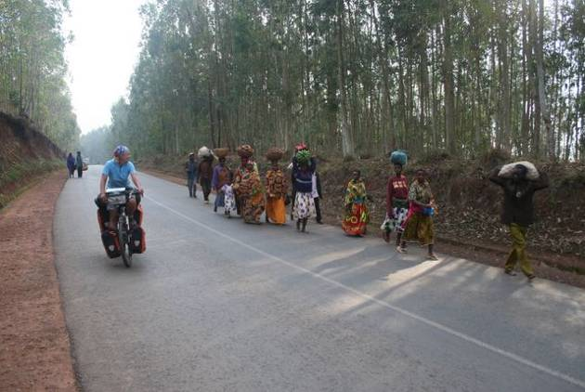
In Burundi we were welcomed with wide, toothy smiles and exuberant greetings from the locals who were unused to seeing foreigners after more than a decade of armed conflict that all but killed tourism in this tiny land-locked country. The steep climbs we had come to know (and dread!) in Rwanda continued. Fortunately, there always seemed to be gaggles of energetic kids willing to push us for kilometers through the heavily-terraced countryside and fragrant forests of eucalyptus and then watch us swoosh down the descents, obviously proud of their efforts. The roads buzzed with activity and nothing was deemed too large or cumbersome to fit on the back of a bicycle. Bike-pooling was the norm with two and sometimes three passengers squeezing onto the back rack and occasionally a small child teetering on the handle bars. Only a foolish Mzungu would peddle up the hills--clued-in locals always latched on to a passing truck and hitched a ride up the torturous mountains.
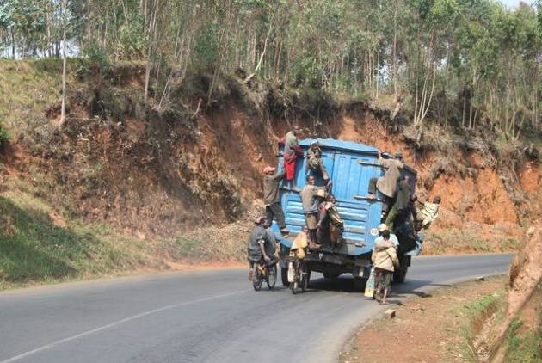
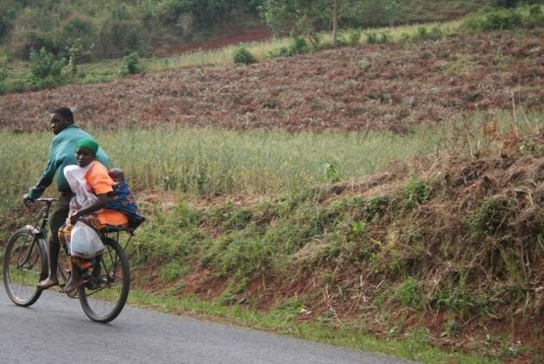
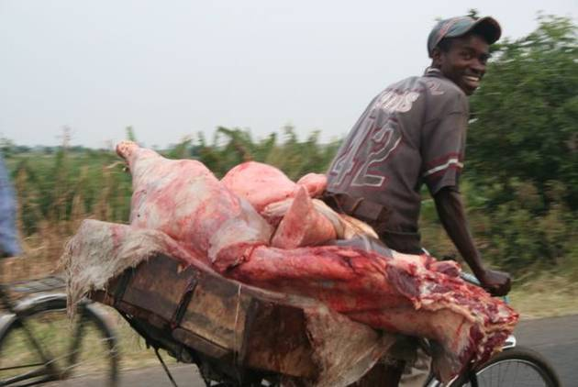
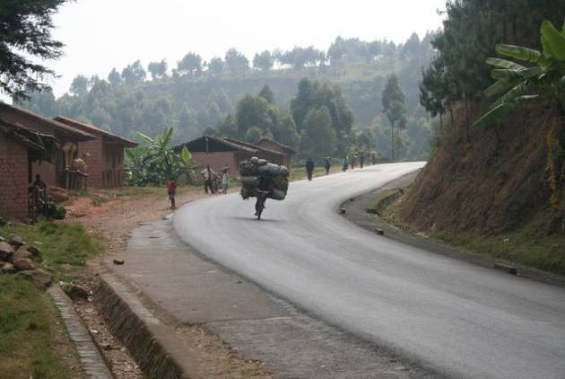
Just before entering Burundi a BBC World Service report informed us that the leader of the only remaining rebel faction had walked out of peace talks in Bujumbura, and, although his whereabouts were unknown, it was hoped that he would soon return to the capital. With this in mind, we weren't sure whether the groups of bored-looking and well-armed soldiers lounging under trees every few kilometers alongside the road leading to the capital should alarm or comfort us. The guest house owner assured us that there would be no trouble, the rebels were 'far away'' yonder hiding out in those low-lying hills.
We arrived safe and sound in low-key Bujumbura, treated ourselves to cakes at the Kappa bakery, rode out past the sprawling UN Peacekeepers camp and went for a swim in the turquoise waters of Lake Tanganyika. Despite 90% of the population reportedly living on less than $1 a day and virtually no tourists, Bujumbura had a surprisingly good range of restaurants and we splashed out on a mushroom pizza for dinner (we've surely long ago reached our lifetime threshold of rice and beans). Of course there were few locals eating at the restaurant. Most of the other diners were expats, in some way attached to the aid industry. They arrived in shiny new white Land Rovers driven by a local man--always one of the best educated as jobs with an NGO are highly-prized- and didn't gasp at the prices like we did. We are pleased to report that we've never seen a white Land Rover with Camfed on the side and you can rest assured that your donations are going to help educate girls and not to foot the bill for the extravagant lifestyle of some career 'aid worker'.
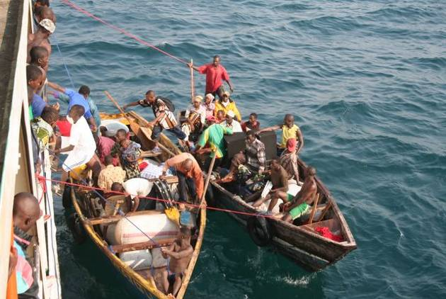Our original plan was to have one last adventure and cross remote Western Tanzania entirely by bicycle. We came to our senses after speaking with an ex pat who had done the 600-odd kilometer dirt-track journey in a convoy of three Land Rovers and claimed that unbelievably deep sand and a very rutted and rough road meant he had progressed not more than 100 kilometers on some days. Being stranded in the bush forced to dig for water in dry-river beds doesn't rank high on our 'must do' list so we opted instead for a voyage on the aging MV Liemba.
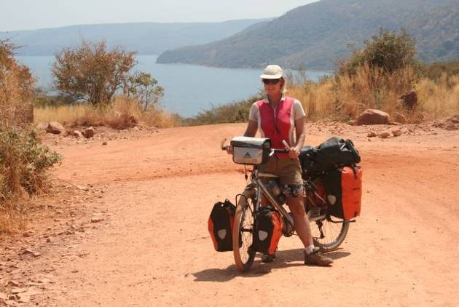
This German-built ship has been plying the waters of Lake Tanganyika for more than 80 years, serving the small lakeside fishing villages that would otherwise almost be cut-off from the rest of the country. Since there are only three real ports along the way, small boats carrying goods and passengers come out to meet the ship when it docks off shore. There's a frenzy of activity, day and night, as passengers heave themselves out of the boats and then shimmy up the railings and onto the ship. Everything from satellite dishes to 50 kilo sacks of sardines somehow make it on and off the small boats as they bob up and down in the often turbulent waters.
After two nights aboard the ship, we arrived in Kasanga and faced a 300-kilometer stretch of unpaved roads. On our three-day ride we encountered all the usual obstacles: knee-deep sand , bumpy corrugations prone to inducing early arthritis, and the ever-present predatory drivers. Eric gave one of these maniacs the finger after he nearly grazed us when he sped by in a cloud of dust. To our surprise, the man behind the wheel screeched to a halt and put his vehicle in reverse. Fearing there might be bloodshed, Amaya pedaled off in a flurry. Eric held his ground and was in fact greeted by a friendly family of Tanzanians who mistakenly thought he was signaling for help.
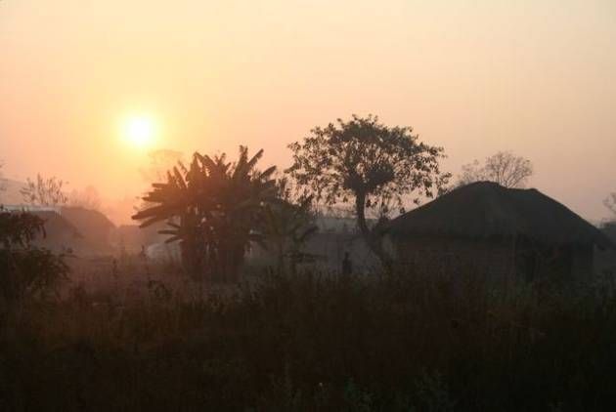
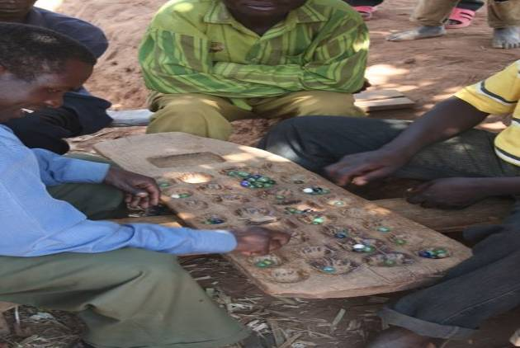
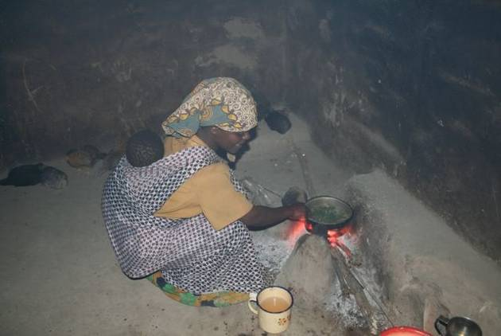
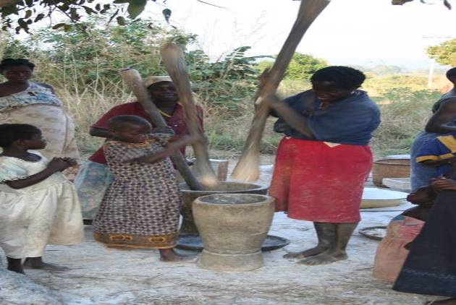
The last rains had fallen months ago and the land was parched and cracking. When the sun rose high in the sky it was scorching hot, but evenings and early mornings were downright cold and bathed in soft pinks and brilliant orange light. When no accommodation was available we explained our mission to the headman of a village and asked for permission to camp, just as we have done in many other parts of Africa. Later we saw travel agencys offering 4-hour cultural tours of 'authentic villages' for $25 a pop. And imagine, we got to stay in the villages for free and were treated like honored guests.
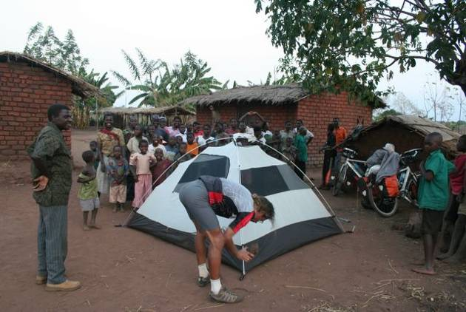
In comparison with a busy western lifestyle filled with long hours at the office, regular visits to a sports clubs to keep the ever-expanding rear end in check, loads of activities designed to provide fulfillment and relaxation plus unlimited entertainment options, life in an African village appears quite simple. A woman's day revolves around preparing food, minding children,keeping the hut tidy, fetching water and firewood and doing small-scale farming. Men are responsible for transporting large loads on bicycles, building fences and huts, and some of the heavier farming tasks. They have much more leisure time and like to gather under trees to play some sort of complicated-looking game with marbles and chat with their friends. Everyone rises by dawn and a few hours after sunset villages usually go quiet. Thin mats are rolled out onto the floor and everyone drops off to sleep. Entertainment is hanging out on a rickety wooden bench in front of the local shop and maybe splurging on a bottle of warm coca-cola. Somebody might be lucky enough to have a radio which inevitably belches out more static than music. Sunday is a day of rest and religion and for males, bouts of drinking the potent local brew. The routine is broken up by visits to relatives in neighboring villages and maybe an occasional trip into the nearest town to stock up on supplies. Certainly we couldn't bear such a lifestyle lacking in western-style comforts and diversions for too long, but most villagers we meet seem to be quite content with their lives.
After climbing 35 kilometers over a torturous 2,500 meter pass, our last stop in Tanzania was the picturesque town of Tukuyu, surrounded by rolling hills covered with tea plantations. We had meant to spend just one night before swooping down to Malawi, but a case of nasty saddle sores kept us almost a week. The elderly doctor at the government hospital was keen to 'operate' , but, given the sensitive location of the inflammation, Eric balked away from potentially being butchered by a slip of the knife. A course of antibiotics and a good deal of squeezing eventually did the trick.
So with a slight delay we made it to Malawi and got down to the serious business of relaxing. Like many travelers before us, we were seduced by the beauty of the lake and the laid-back atmosphere of the lodges dotting its shores. Nkhata Bay is almost an obligatory stop on the overland circuit and we spent several days there lazing on the rocky beach, snorkeling, raiding the bookshelves of the guesthouse and trying to get some decent photos of the sunrise. Each evening the lake was lit up by the parafin lamps of fisherman in dugout canoes. These men cast their nets under moonlight and paddle back to shore just as the sun is rising.
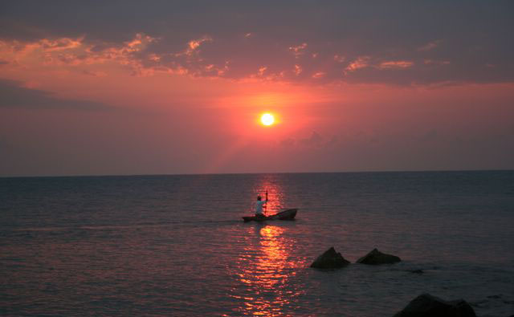
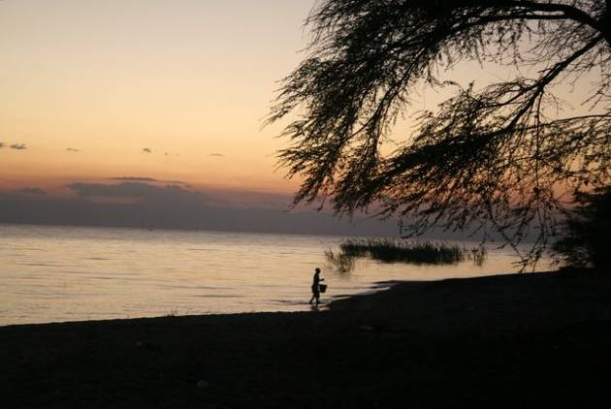
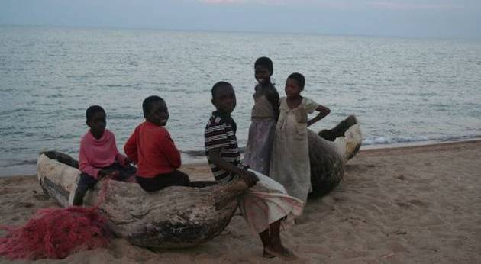
Dickens was one such fisherman we met when a puncture brought us to his small village along the main lakeshore highway. He immediately approached us offering assistance and sending off a child to fetch water so we could test our inner tube. He was particularly articulate and we at first assumed he was the village teacher which brought out a small chuckle from the bystanders. No, no he assured us, just a simple fisherman. He would have liked to continue his studies, he explained, but his father had died and his mother's meager earnings from selling vegetables weren't enough to keep the family afloat. He didn't earn much either, perhaps a 100 Kwacha (80 cents) a day, but it was enough to buy sugar, soap, batteries for his radio and school uniforms for his 3 younger siblings. He was frustrated though and didn't see how life would ever get any better for his village. They were forgotten he said. They did have a pump now in the village which made life much easier, especially for the women, but there was still no electricity and never any visits from government officials or NGOs. He wasn't really complaining about his life. In general, Africans are resilient people who will make the best of the lot they've drawn in life without whining about their circumstances. He only wanted more than his village had to offer.
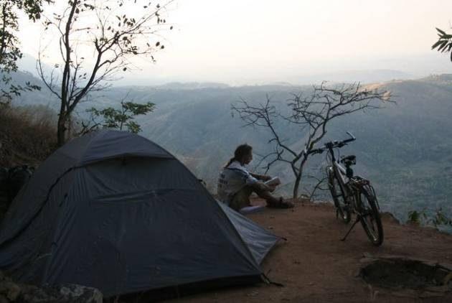
Our only strenuous cycling was a trip up the escarpment to Livingstonia to visit the old colonial buildings and hospital. The gravel road up consists of 20 hairpin bends and with little traction, we had to resort to pushing on the steepest turns. This was the site of our first clothing casualty as the sole of Amaya's left shoe detached itself from the upper. Several days were spent riding with a sandal on the left foot and a shoe on the right. Nobody looked at her oddly, in fact maybe they thought she was making a fashion statement. After all, we'd seen two women sharing a pair of shoes, one wearing the left and the other the right with each having one foot bare. Why not try mix and match? Our campsite on the escarpment was one of the most spectacular of the entire trip. We could look out over the slate-blue mountains and down on the sparkling lake below, we just had to watch our step lest we plunge over the edge.
It's been a restful month, but our Malawian holiday is coming to a close and tomorrow we head off towards Zambia. We've finally traded in our East Africa Lonely Planet for Southern Africa so the end is drawing near...if we get a move on that is and get down to the serious business of cycling.
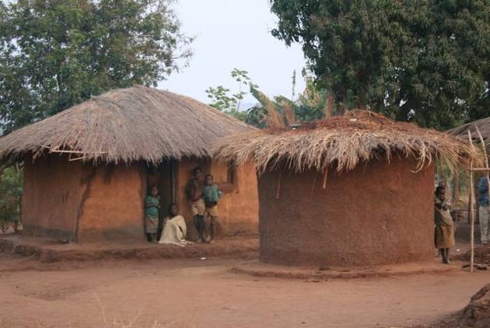
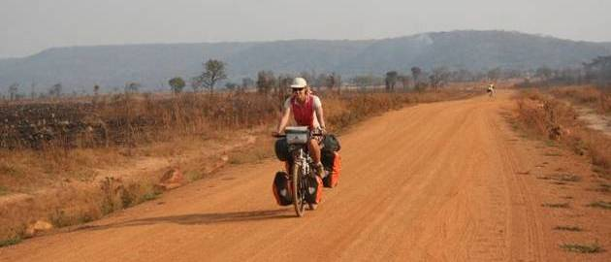

update 18.

fauna, falls and...frost!
5 September - 9 October 2007
Total kilometers cycled: 28,918
Zambia, Zimbabwe and Botswana

Graceful giraffes loping across the road, unhurried hippos munching next to the tent and enormous elephants wandering through the campsite: and there's even more to see inside the national parks! Bicycle is probably not the best means of transport in this part of Africa where hungry lions roam freely, elephant dung litters the roadside and families of warthogs are far more common than any of the human variety. Distances between settlements are long, water is scarce, the wind can be fierce and the sun is unrelenting. Reasonably smooth, flat paved roads is the only concession this harsh environment makes for foolhardy cyclists bent on tackling the region.

Fortunately we didn't meet up with any lions while we were pedaling, although plenty of locals warned us about their presence in the Maun-Nata area in Botswana. 'Don't sleep in the bush whatever you do!' was a common refrain. 'A soldier was eaten last year, only thing left was his boots'. Hmmmm. Some food for thought.
Our lion sighting came from the (relative) safety of a Land Rover while we were on safari at South Luangwa National Park in Zambia. I say relative safety because our guide insisted on driving right up within arm's reach of the lion whose chest was heaving from the effort of digesting his most recent kill, a hapless zebra whose carcass lay nearby. Apparently lions in this state are so satiated and lethargic that a Landy full of tourists won't stir up ideas of dessert. On our two safaris with Flat Dogs Camp we saw crocs basking on the shores of the Luangwa River, amorous giraffes mating, elephants wandering through the tall caramel-colored grass, and numerous kudos, pukas, impalas and zebras--only the leopard remained elusive.

In Zambia we started seeing bikes with the World Bicycle Relief logo. Being curious as to what this is all about, we stopped a few riders to find out more. The enthusiastic new bicycle owners explained that they had received the bikes free because they were essential community workers. One man we met is a care giver for HIV patients and makes home visits to deliver food and medicine and a woman we met is a primary teacher at a rural school. Both were thrilledd to have bicycles because this means they don't have to waste many hours walking and they can put more effort into their work. A simple and cost effective initiative that is making a real difference in the lives of Africans. Surely this is more sensible than trying to give every African child a laptop.

The Zambians we met were some of the most cheerful and friendly people we've run into so far on the trip--everybody seemed to be on a happiness high and the women in particular were always laughing and joking with each other. We asked several people what the trick was to being so upbeat and the answer always went something like this: 'It's just our way. We suffer, of course, but we must go on and make the best of what God has given us. That's how we can be happy even with all our troubles'.

Religion looms large in the life of most Africans and along with the Catholics, Presbyterians and Methodists there are an increasing number of evangelical churches and sects that are gaining in popularity on the continent. The well-kept Kingdom Halls of the Jehovah's Witnesses are a common sight even in very remote areas. We shouldn't have been surprised, then, when we pedaled into a small village just before sunset and starting in on our usual spiel about needing a place to pitch our tent and could we please see the headman,we were lead instead to Elder Samson who took us to the Kingdom Hall compound.
These people are obviously getting a lot of money from the church's New York headquarters because they'd constructed a whole village within the village just for Jehovah's Witnesses gatherings (and the odd itinerant cyclist). Immaculate huts, showers, toilets and even their own bore hole. One of our favorite campsites.
Yes, we enjoyed camping at their compound but maybe the Jehovah's Witnesses need more practice at drilling bore holes. When Amaya complained about the shiny metallic substance floating in her water Eric's rather unconvincing explanation was that it was only iron and iron is good for the body, so she should drink up, which she did and regretted doing for the next two days as she lay moaning and groaning in the stifling tent. This meant Eric had some time to explore Lusaka on his own. It's a modern city with 4- lane highways and soulless shopping malls where bicycles aren't allowed to be parked near the entrance because it spoils the image and a small army of security guards chase away beggars and hawkers. On the upside everything imaginable is trucked up from South Africa so the supermarkets are chock-full of tempting treats. The only problem is that everything seems to cost at least the double of what you would pay in North America or Europe.
After Amaya's stomach had recovered we set off towards Livingstone and Victoria Falls. 'The Smoke that Thunders', as the falls are known in the local language, were impressive even though this being the dry season the flow was only about 10% of what it is during the rains. After a few days relaxing poolside at backpacker mecca Jollyboys, we headed across the Zambian border into Zimbabwe to get another perspective of the falls and find out for ourselves if all the stories of food shortages and empty shops were true. A quick look around the Spar supermarket confirmed the rumors. No bread, no milk, no meat. A few light bulbs on the shelves, some laundry detergent, a couple of jars of jam and a few other odds and ends made up the entire stock of the grocery store. We'd heard that most everything could be bought on the parallel market and casually asked an employee if there wasn't some yogurt to be had. After a quick glance around to make sure no one was listening he said he might be able to find something for us in the back.

The Bata shoe shop had nothing for sale, but their was a sign in the window proclaiming 'We buy used Wellington boots'. The sports shop had a single soccer t-shirt going for 57 million Zimbabwe dollars. At the official exchange rate of 30,000 Zim$ = 1US $ that would have been around 1,800 US dollars. Of course nobody changes at the official rate and on the black market you'll get 10 times more. Since the Mugabe government forced shop owners to cut food prices in half last June most products have disappeared from the shelves to avoid selling at a loss. Those with money can still find a way to get what they need but those less fortunate simply have to do without. The locals are really suffering and young people are leaving the country in droves. Tourists have all but disappeared from Vic Falls and luxury hotels remain empty. On our short walk through town to the entrance of the falls we were approached by dozens of hopeful young men trying their hardest to sell artwork and handicrafts. Everything was going at rock bottom prices and the sellers were so desperate they were willing to take our beat-up sandals, old t-shirts or even a bottle of shampoo in exchange.

The Wimpy's fast food joint was fully staffed yet there was just one customer when we had a look around lunchtime. Another one of Mugabe's new laws forbids businesses from laying off workers and has frozen wages. With inflation estimated at 6,700 % yearly these 'workers' have virtually no buying power. It is a miracle that the Zimbabweans keep their sense of humor and smile, but some how the do. We popped into local shop to get advice about traveling further through the country but were dissuaded by the prudent shop owner. 'If you had asked me three months ago I would have told you to go without giving it a thought. But now the situation in rural areas has become so bad that the people might just stop you and rifle through your bags looking for food. They're desperate.' she explained.

Regrettably our Zimbabwe tour was limited to Vic Falls and the 70 kilometer ride to the Botswana border. It is one country we definitely want to return to one day when the political and economic situation has improved. CAMFED was started in Zimbabwe and continues to help the increasing number of needy girls throughout the country complete their secondary education. Zimbabwe will need an educated workforce to rebuild the economy once good government has been restored. Click here to find out more about how you can help.
The Botswana immigration was impressively modern with flat-screen computers, air-conditioning and efficient clerks. A far-cry from the ramshackle sheds, ancient ledgers and shiftless officials of West and Central Africa. We were in and out in a flash with no one hassling us about a carnet for the bicycles, a 'processing fee' to be paid or proof that we were actually tourists. The 'authentic' and far more exotic Africa that we had a love/hate relationship with had all but disappeared. In Botswana, water comes from taps, no one shouts Mzungu when white people pass, vegetables are wrapped in cellophane and come from the supermarket, roads are paved, electricity cuts are rare and policemen are your friends.
We got to know the policemen rather well because we spent several nights camping at their compounds. This was a tip from Russian cyclist Yuri whom we met on a lonely stretch of road between Pandamatenga and Nata. As we mentioned earlier in the update, there are lions, elephants, zebras and giraffes roaming about freely in this part of the continent so wild camping is not exactly risk-free. The Botswana police always welcomed us warmly and found a quiet game-free spot in their compounds for us to spend the night. These were long days of riding through the bush, skirting around the Kalahari desert where the road seemed to stretch on into eternity with never a turn right or left for 300 kilometers. The monotony was only broken up by spotting a group of elephants, zebras, giraffes or an ostrich bobbing up and down in the distance. Seeing these animals while on a bicycle in what felt like the middle of no where was so much more thrilling than encountering them while on safari with a group of giggling tourists behind us discussing their nights out partying in Cape Town.
We're writing to you from Namibia's capital Windhoek, having covered almost 3,000 kilometers in the last month. The city lies up at 1,700 meters and the weather has been downright chilly with temperatures below freezing one night. The coldest weather in 50 years we're told. But summer is on its way here in the southern hemisphere and we're already enjoying more daylight as the days grow longer. Locals have convinced us to forgo the main road (flat and paved) in favor of heading towards the inland roads (mountainous and rough). We must be fools.

We'll let you know how it all turns out in our next update which should come to you from SOUTH AFRICA. Yes!
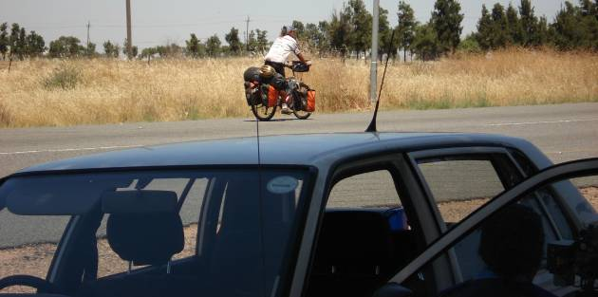
November 1st -They had heard about Eric’s speeding and in South Africa the traffic police, using their radar, finally caught him in Piketberg
- update 19.

drama in the desert or what are we doing here?
5 September - 5 November 2007
Total kilometers cycled: 30,518
Namibia
Specific country info on routes & roads/food & accommodation/the locals available here.
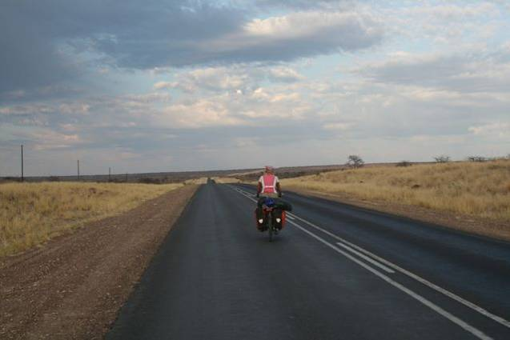Much of Africa is dry and desolate country. Our first encounter with the desert was a 2000 kilometer ride through the Sahara a little more than a year ago. This always impresses people. They imagine us heaving our bikes over sand dunes, camping alongside turban-clad nomads and drinking sweet camel's milk to quench our thirst. Western knowledge of African geography being what it is, few people will ooh and ahhh when you tell them you've made it through Namibia. They should.
In fact, there is an easy way through Namibia. It's called the B1. A nice paved road which slopes gently downwards towards South Africa. A sort of dream come true for two cyclists who've endured 16 months on some of the roughest roads in the world. So it was with some surprise that we found ourselves heading out of Windhoek on a gravel road. Perhaps some higher being was trying to send us a message when the lycra-clad mountain biker ahead of us turned back at the point where the tarmac came abruptly to an end. But at that point, we were still in high spirits anticipating this one last little adventure through the desert before the orderliness and easiness of South Africa. We pressed on through the sand.
Those who had recommended this scenic jaunt through the Namib desert had assured us there would be no sand. We were suspicious. We'd been on plenty of tracks in arid Africa and there was always sand. The Namib turned out to be no exception. In all fairness, the road really was quite well-maintained in most parts. In a 4WD, 500 meters of soft sand poses no problem. 10 kilometers of corrugations pass in a flash. Crosswinds go unnoticed. A 100 kilometer stretch of uninhabited terrain is a romantic wide-open space. For a cyclist, 500 meters of sand can mean 50 minutes of additional agony under a scorching sun. 10 kilometers of corrugations rattle your bones for an hour. Crosswinds can bring you crashing to the ground and uninhabited terrain means a parched throat as you ration your diminishing supply of water. Never ask a motorist for advice on which route to take if you're cycling.
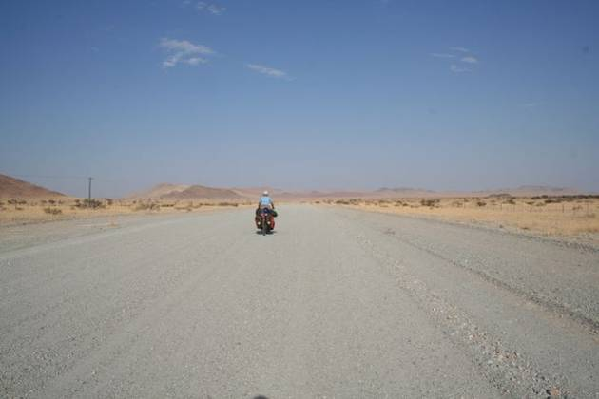
That was our mistake. We'd listened to these motorized tourists as they described the beauty of the apricot-colored Sossusvlei dunes at sunrise. They'd entranced us with talk of endless mountain vistas and the eerie silence of the lonely plateau. And they'd absolutely scorned our plans to follow that smooth, flat highway. It'll bore you to death, they'd all agreed.
So what's 900 kilometers on gravel roads through a desert we told ourselves? But our hearts weren't really in it. As we stopped for a quick break not more than 20 kilometers out of Windhoek, a couple of tourists pulled up in a 4WD and Eric's first remark was 'maybe they'll give us a lift if we ask nicely'. Amaya was appalled. 'Almost 30,000 kilometers through really rough places like the Congo and you want to wimp out in Namibia?' Not that the idea wasn't appealing to her. There was nothing she would have liked better than to load those 50 kilos onto the bed of a truck and ride in comfort. But it would be far too humiliating.
We pedaled on in the oppressive heat until mid-afternoon when another stretch of sand brought us to a grinding halt. Where were the vistas and the dunes and the glorious sense of being alone on the planet that we had been promised? Thick-necked farmers in baakies (as they pick-up trucks are referred to in these parts) had been covering us in dust all day. We were hot, tired and didn't want to contemplate the almost 900 kilometers of dirt track that separated us from the South Africa border and return to tarmac. In a moment of weakness we turned the bikes around and decided to find our way back to the main paved highway. 'Who cares of it's boring' we told ourselves trying to justify our decision, 'We've had enough suffering.'
Knowing we would reach the tarmac road, civilization and therefore supermarkets the following day, we broke into our food reserves and gobbled down all the cookies meant for the next three days. We went to sleep on full stomachs and awoke the following morning smiling knowing tarmac awaited us. Setting off down the road we stopped to take just one last picture on the track to commemorate the experience. And wasn't it a beautiful place, with the mountains in the distance bathed in a soft orange light. And this road really isn't all that bad. Oh and I'd hate to miss those dunes. They're really not that far. And before you knew it we had turned around again and we weren't heading back towards the tarmac but deeper into the desert.
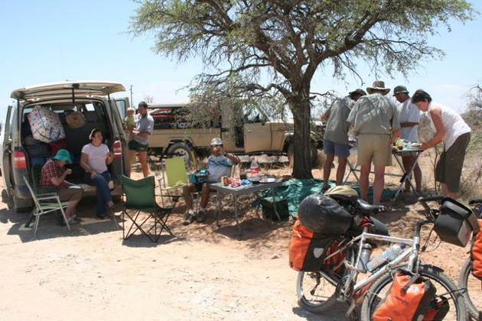
I wish we could say we never regretted our decision. It was now day two of our desert drama and we were meant to climb the Spreethoogte Pass. The traffic thinned out and the farms were spaced wider and wider apart until we began to understand that 'alone on the planet' feeling. No farms meant no water and we were running low. We had set off that morning with 10 liters of water between the two of us. Unfortunately, we'd lost 3 liters when the bottles we had strapped on the back bounced off without us realizing it. To be on the safe side, we decided to flag down the next vehicle that passed and ask for water. We started waving frantically at the next cloud of dust that approached and, with a screech of the brakes, the 4WD came to a halt. After getting over his initial shock of seeing two cyclists in the desert, the driver hopped out of his Land Rover, popped open the back and presented us each with a two liter bottle of ice-cold water. Then he glanced at his watch and suggested we join him for lunch. Cold water and food all in one go...this is something like having your cake and eating it too for a cyclist. Just too good to be true. These people had tables and chairs. They weren't crouching in the sand like we usually did. They offered us cold cokes, 3 kinds of cheese, sausages (for Eric, the ex-vegetarian)cookies and crackers and so much food! Much better than warm water and cold baked beans from a tin.
Hospitality in Southern Africa is something very special. In Europe we'd been turned down by farmers when we'd simply asked to pitch our tent on their land. They eyed us suspiciously and directed us to the nearest country inn. In Namibia we'd been offered accomodation by a complete stranger who saw us in front of the supermarket. Tina gave us the guest room, introduced us to her family, cooked us a delicious dinner and then insisted we stay another day to rest up. When we knocked on a farmer's door in Seeis, Patrick answered, and again we were given a room when all we had requested was a patch of grass. I'm sure nobody in this part of the world would turn us down for camping.
As we set off to tackle the final 50 kilometers up to the pass, our stomachs and water bottles were full and our spirits high. Reaching the small settlement of Nauchas we violated a cardinal rule by passing a source of water without filling up our bottles. We didn't want to waste time fetching water because it was getting late in the day and we wanted to make it up to the pass where supposedly there was a campsite.
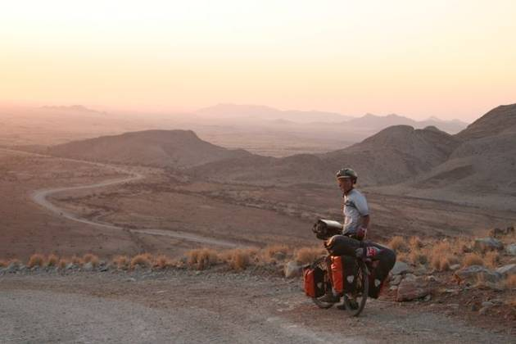
Amaya had her doubts. What fool would put a campsite on a windy mountain pass? Only 12 kilometers to go but the road was getting steeper and steeper. As we neared the top, there were gradients of up to 25%--no wonder only 4WD vehicles were allowed to attempt the pass. Our legs were burning and our strength almost gone as we finally made it up the last steep incline, but the incredible view that opened up before us (almost) made us forget the pain. No campsite was in view and poor Eric was hit with a barrage of I told you so's and ' I knew we should have-- filled up our water bottles when we had the chance/ camped at the settlement 12 kilometers back/followed the paved road/stayed in Europe/never quit our jobs to cycle through Africa etc. Amaya was so riled up by the thought of spending the night in the bush with just a liter of water for drinking, cooking and bathing that the reproaches would have continued till morning had not a small sign reading 'campsite' come into view just as we began to lose sight of the setting sun behind the mountains. Saved again.
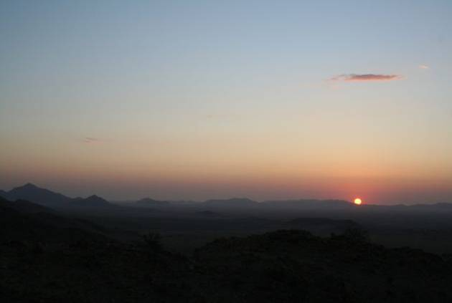
It was time to change the brake pads when we made it to the bottom of the pass early the next morning. Temperatures were well into the 90's (35 celsius) by mid-morning and we were roasting by the time we arrived for a pit stop in aptly named Solitaire, some 40 kilometers from where we'd camped. The town consisted of a few houses, and a filling station , shop, café and motel all rolled into one. It was nevertheless an obligatory stop because there was simply nothing else out there but sand and the odd sheep farm. Moose makes a mean apple strudel and after 4 helpings we were ready to face the desert once again.
We were headed toward Sesriem, the jumping off spot for visits to the famous dunes of Sossusvlei, and every half hour or so we'd be passed by cheerful-looking tourists in air-conditioned 4WDs. The passengers would hang out the windows, give us a toothy grin and snap our photo. We hated them. The traffic dropped off at about 4PM and around 7PM we finally made it to the campsite, having spent more than 9 hours in the saddle being scorched by the sun, tossed around by the wind and humiliated by fellow tourists who treated us like exotic zoo animals. We were more than fed up.
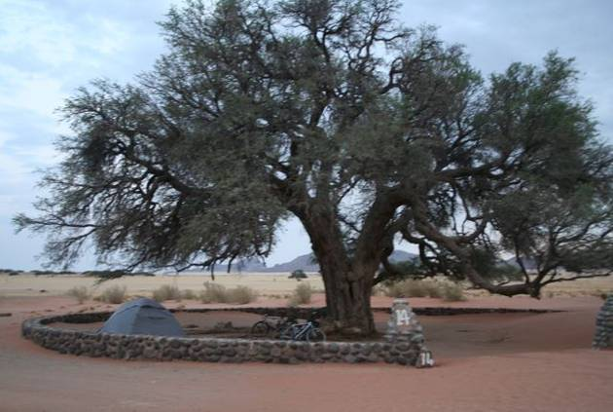
As is often the case, when you finally reach your breaking point something wonderful happens that makes you forget all your trials and tribulations. Sossusvlei is the most popular spot in Namibia and as such you must reserve well in advance for a campsite. Of course we hadn't done this, so the kindly gentleman in charge motioned to some distant spot where we might pitch our tent. We were probably quite a sight as we struggled to push our overloaded bikes on the sandy track in search of the 'overflow' camping. It was now dark and we'd obviously taken a wrong turn and our bikes weren't going anywhere in the deep sand. And then came our savior, Barry, beckoning to us to join him at his campsite. Barry is South African and the South Africans must be the most hospitable people on the continent (although the Moroccans come close). He helped us settle in and then invited us to a braai. Within an hour all thoughts of the day's horrors had been dispelled and all this thanks to Barry's 'intervention'. Left to our own devices we would have surely been squabbling, grumbling and arguing about who gets to finish off the last of the peanut butter.
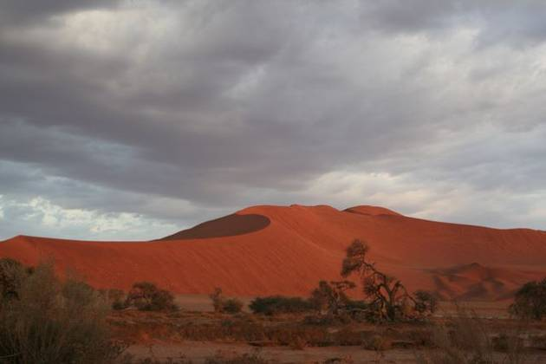
The following day was a 'day off' to visit the dunes. Still, we were up at 5AM in order to hitch a ride to the dunes, 60 kilometers away, for sunrise. Sossusvlei is spectacular and the visit was only marred by the arrival of a boisterous group of German pensioners on a package tour. Fortunately for us, most of them obviously enjoyed their Beer and Bratwurst a little too much and, after much huffing and puffing and a half-hearted attempt at climbing the dunes, they turned back, leaving us in relative peace.
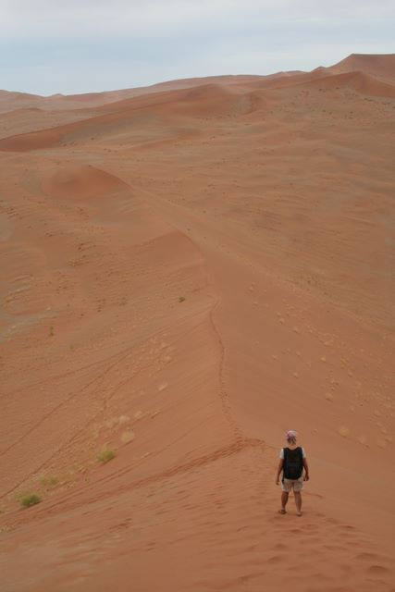By mid-morning we were back at the campsite which Barry had kindly bequeathed us, having himself cut his trip short in order to make it back to Cape Town to catch the World Cup Rugby finals. The previous day's long ride had exhausted us, but the tent had heated up like an oven and we were drenched in sweat almost as soon as we lay down to rest. Sleep was impossible. In a brief bout of industriousness, Amaya attacked the laundry, hung it to dry and then burst into tears the next time she looked up and saw that the line had snapped and the clothes were being buried in the sand. The physical exhaustion meant we weren't faring very well emotionally either and the slightest trouble would set us off. We knew it was time for an extended break and were anxious to make it to South Africa.
During the night, the cool breeze turned into a gale and sand streamed into the tent through all the minute holes that have multiplied over the months. By morning the force of the winds had barely diminished and packing up camp was a nightmare. Cycling was no better, as we were caught in a crosswind and it took most of our strength just to keep the bikes upright. Reaching a crossroads, Eric suggested we bring an end to all the suffering and wait there until a passing truck picked us up. Great idea in theory, but chances of this happening were slim. We were nearing a private nature reserve and the only people on the road were tourists in their rental vehicles. We pedaled onwards, but the strong gusts hampered our progress and morale was at its lowest ebb.
All the heat and sun were draining and we again found ourselves dangerously low on water. We'd already drunk most of the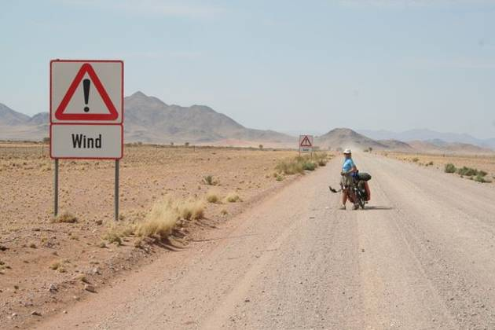 10 liters we'd started off with and there had been no sign of human existence for several hours. We flagged down the next vehicle we saw, a Land Rover (rented) full of tourists. What a shock we had when, after requesting some water, the women in the passenger seat turned to her husband, her voice filled with annoyance, and remarked in German, 'aber wir brauchen das Wasser für 3 Tage,' which translates into 'but we need that water for 3 days.' Absolutely no pity for two thirsty cyclists stranded in the desert. Her husband, a much more sympathetic type, gave us each a small bottle of water. Being rather desperate we accepted with a smile, all the while fuming at what we saw as petty selfishness. They were motorized and only 60 kilometers from a settlement where there was piped and potable water! Before they parted they informed us that they'd seen no farms or any type of dwellings for a very long time and we certainly wouldn't reach water or shelter before nightfall. And then they were off, leaving us alone to contemplate our dilemma.
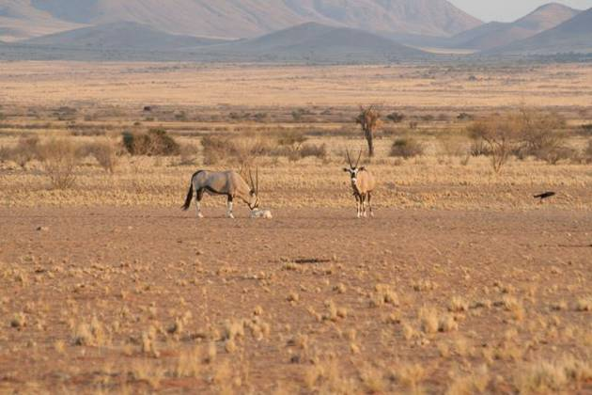Most people who cycle through Africa are avid bush campers. That we had made it almost the entire length of the continent without having spent a single night alone in the wilds of Africa is an oddity. If only we had some water.
A few more tears were shed and Amaya thought seriously about what she could have done to bring on this bout of bad karma. She finally concluded that it was a result of her own refusal to share her water with a young Zimbabwean when she had been in Vic Falls. 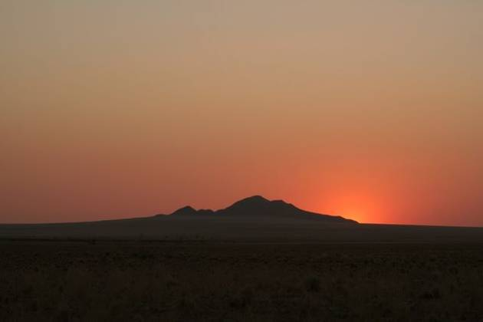 Fearful that if she let him have a sip he would run away with the precious Nalgene bottle that was so coveted by all the young men, she had turned him down when he asked for water. What goes around, comes around as they say.
Imagine our surprise and delight when, in the distance, we started to make out what could only be a dwelling of some sort. As we drew nearer we saw that it was a large house set a few kilometers back from the road. A sign at the turnoff read 'Namib Rand Private Reserve Warden's Residence'. What luck! We wouldn't die of thirst, be killed by a band of marauding bandits or eaten by a pack of hungry mountain zebras after all. Nils, the burly warden, welcomed us with a warm handshake and acted as though he had been expecting us. There was no need to explain our predicament. Hospitality came naturally to him and he lead us to the fully-furnished guest bungalow and told us to make ourselves right at home. Whew--things turned out alright in the end yet again.
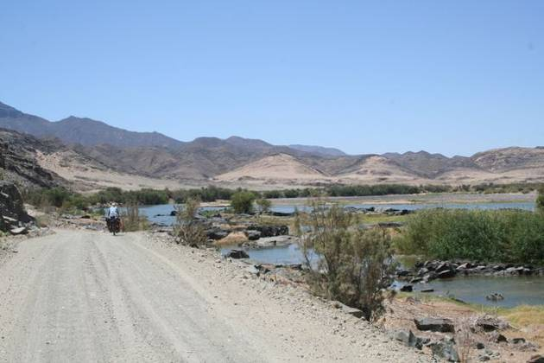Four more uneventful days hammering on through the desert and we made it to the Orange River and our first view of South Africa on the far side. The slender patch of vegetation near the river banks was a veritable oasis after seeing so much sand. We were so overjoyed to be out of the desert that we didn't even mind all the hills. At one point we entered a 'Restricted Diamond Mining' area where a sign warned that leaving the main road was forbidden. Spotting a water tap not far from the road, we took our chances and ventured over to see if we might be able to fill our bottles. Almost immediately an AK-47 toting guard was at our side. We took his grunt as permission to fill the bottles, but as we were dismounting the bikes, two Rambo lookalikes pulled up in a pick-up and gave us the evil eye. They were clearly highly disturbed by our presence and might have been trigger-happy psychopaths for all we knew. We did our best to look like 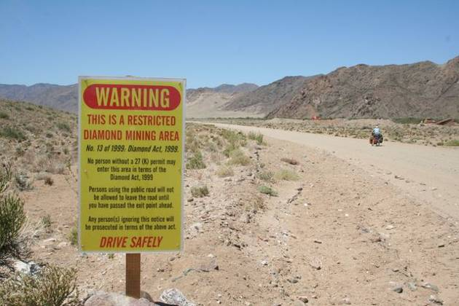the innocent tourists that we are and hurried on our way.
Some 10 kilometers before the border post we hit tarmac again and solemnly promised each other to stick to paved roads in the future. Namibia was quite an adventure: intense highs as we swooped down a mountain pass or gazed at the ever-changing dunes in the distance and horrific lows, as encounters with the elements sapped our energy and will to continue.
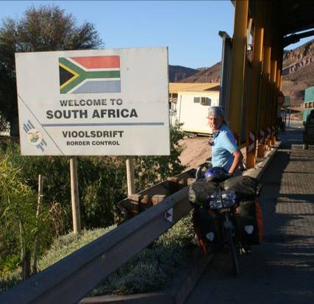
Perhaps we're being a tad melodramatic in recounting this past month's events. Put it down to the accumulated fatigue of almost a year and a half on the road. At the moment, we're being spoiled as the guests of Ken and Angela, two intrepid adventurers who have criss-crossed Africa by land rover, bicycle and motorbike. They tell us their home is technically within the Cape Town municipality, so maybe we'll pile the bikes in the back of the baakie for the final 45 kilometers into Cape Town proper. It is tempting. Stay tuned, another update coming to you soon!
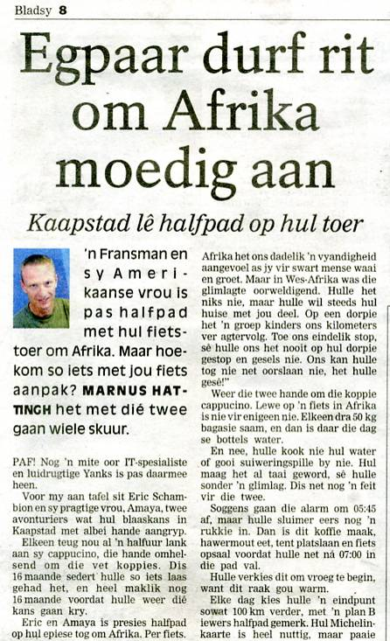
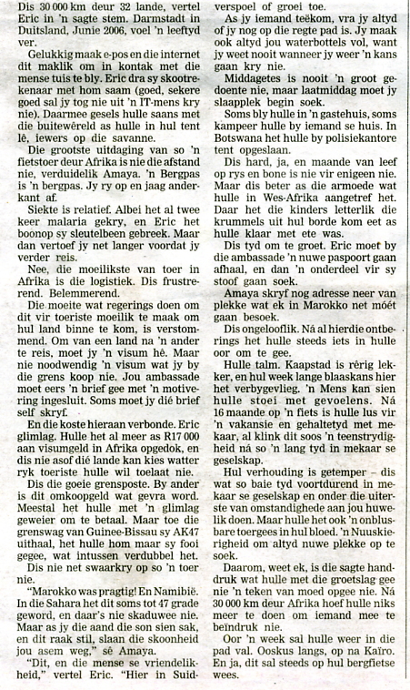
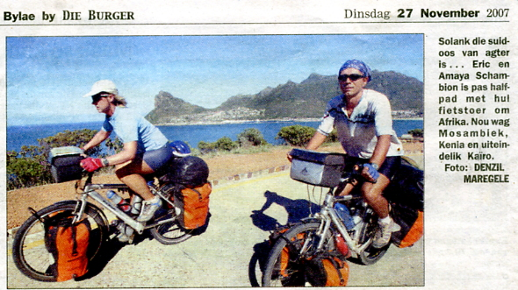

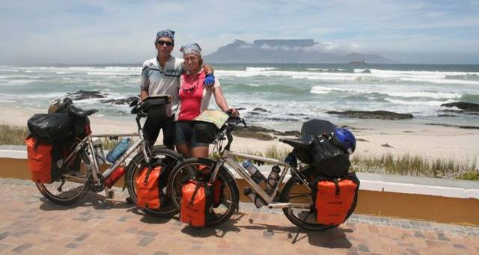

20 arrival at the cape - a decision to make
27 November 2007
Total kilometers cycled: 30,677
South Africa: Northern and Western Cape
Specific country info on routes & roads/food & accommodation/the locals available here.
That's Table Mountain you see in the background, marking our arrival in Cape Town on November 13th after traversing 32 countries (29 in Africa) and pedaling a total of 30,577 kilometers. Whew! We finally made it.
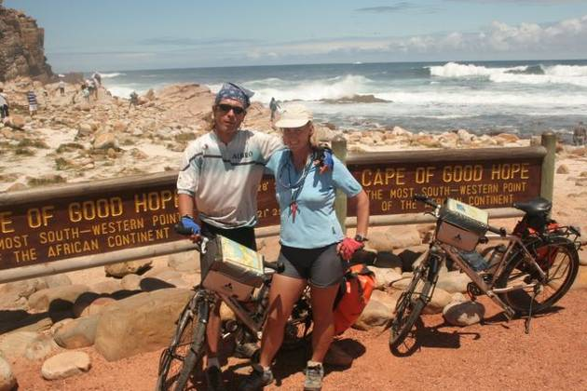It is, of course, a wonderfully satisfying feeling to have achieved what we set out to do some 17 months ago. Certainly there were trying times when we had our doubts about ever reaching South Africa. The long slog through Mali, flooded roads in the Congo and most recently the bitter battle with winds and sand in Namibia were all tough tests of our determination and will to succeed. It is no exaggeration to say that we would have never completed the tour had we not had the good fortune to be helped and encouraged by so many kind individuals along the way. Offers of accommodation, motorists who stopped to offer us a cold drink on a hot day, emails from our 'admirers' as Eric likes to call them, friendly greetings from villagers, the laughter of children as they vied to fill our water bottles--these are the sorts of things that kept us going.
It's more than three weeks now since we first arrived in the Cape Town municipality and we've ridden just 275 kilometers in that time. A good long rest was in order. Ken and Angela are spoiling us on their farm north of The Mother City, as Cape Town is affectionately known, and we're finding it hard to tear ourselves away from the delicious home-cooked meals, leisurely days and moral support from two fellow cyclists. Having met our initial goal (Cape Town!), we are now faced with the difficult task of figuring out what to do next. After much hemming and hawing we've decided to prolong the agony of cycling in order to avoid the agony of plunging back into a more conventional life during the throes of a European winter. All melodrama aside, we really do think it would be a pity to miss the sunsets on Mozambique's idyllic beaches, the climb up mist-shrouded Mt Kenya, jaunts through the colorful Maasai villages of Tanzania and encounters with the stone-wielding children of Ethiopia (after all it can't all be fun and games!).
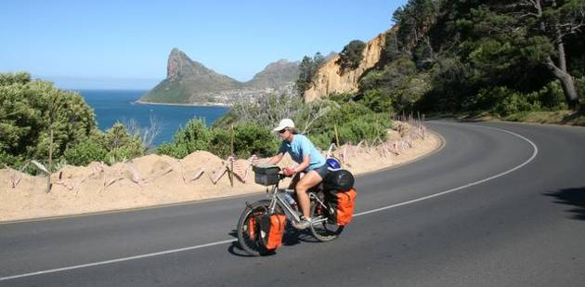We're marooned in Malmesbury for the moment, waiting for a replacement tent to arrive from the US and our much abused laptop to be repaired. The days pass surprisingly quickly. A trip into town to see the dentist or do the shopping is all we can seem to squeeze in between mealtimes. But all this relaxation must come to an end, so within a few days we expect to be bike on the bikes, a few kilos heavier, infinitely more relaxed and ready to face the challenges of an African cycling expedition again. A mere 8,000 kilometers separate us from our next milestone, Ethiopia's capital, Addis Ababa. No doubt there will be more run-ins with unsavory officials, rickety roads to be reckoned with and a dearth of decent food.
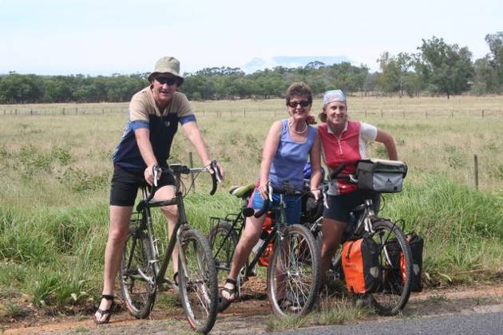But surely these sufferings and vexations will be balanced out by the same types of kindness and generosity that we have known over the past 17 months and more spectacular African scenery. The first episode of World Biking Africa: northward bound will come to you from the mountain kingdom of Lesotho. Stay tuned to find out if we are able to conquer the tortuous cork-screw road of Sani Pass, return to the tent after weeks in a king-sized bed and again accustom ourselves to rice and beans after having indulged ourselves in Angela's fine cuisine for almost a month!

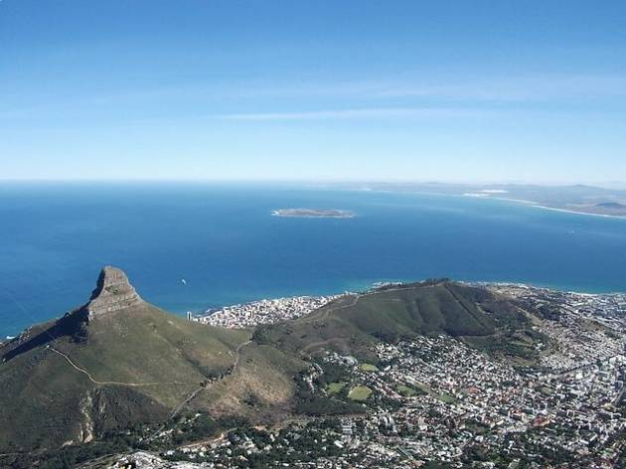

Tour statistics.
days since departure: 517
days in the saddle: 295
rest days: 222
This may sound like a lot, but remember we were forced to stop in Cameroon for 5 weeks while Eric's collar bone healed and many 'rest days' were spent at various embassies sorting out visas for onward travel. Resting also included days recovering from illnesses.
average distance cycled per day: 104 kilometers
longest distance covered in a single day: 215 kilometers
This was an epic ride from Nouakchot, Mauritania to the Senegal border post at Rosso. Time was 9 hours 1 minute with an average speed of 23.83 km/hour. A flat highway, strong desire to make it out of the desert and a tailwind helped us along.
longest time spent pedaling in a single day: 10 hours 18 minutes
punctures eric: 51
punctures Amaya: 20
maximum kilometers ridden on one set of tires: 22,000
total cost of visas: 1,778 euros ($ 2,420)
average daily expenses: 22.15 euros ($31) for the two of us (This includes food, accommodation, visas, health insurance, transport (flight back to Europe, ferries) and misc).
illnesses eric: malaria twice, typhoid fever, pneumonia, dysentery and a serious case of saddle sores
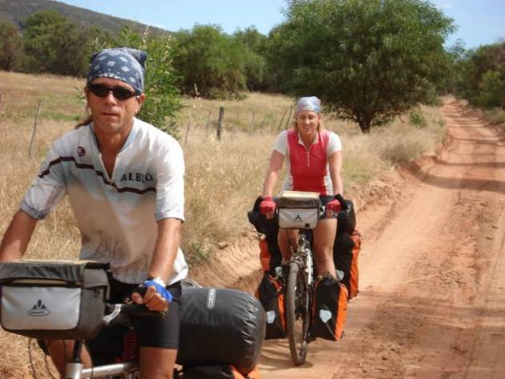illnesses amaya: malaria twice and the occasional stomach upsets

thank you.
We are immensely grateful to all the villagers throughout Africa who invited us into their humble homes, made sure we had water for cooking and bathing and shared their lives with us. Their warmth and generosity will never be forgotten. Many amazing people have been part of this cycling expedition. Our special thanks to:
Fabrice for organizing parcels and looking after things for us in Obernai.
Jean-Paul for faithfully scanning the mail and sending it off every Sunday.
Cathy and the crew at the Obernai Hospital for looking after our health.
Glen and Shirley for letting us know that we were always welcome should we find we'd had enough of cycling.
Luke and Anna for inspiring this ride.
Ralf at Bikemaxx for sharing all his cycling knowledge an kitting us out with the best possible of bikes.
Karen in Griesheim for acting as a parcel receiver.
Pierre for finding the time to hunt down all the odds and ends we needed to have sent.
Stephane for transporting all those odds and ends we needed to Strasbourg
The employees of Eumetsat and Merck for their generous contributions to CAMFED.
All the people from Hospitality Club and Warm Showers (Tine Miet, Hildegard, Gerhard, Luc, Sabine and Damien) who hosted us during our 'holiday' in Europe.
Lee and Kob for the kind use of their apartment in Darmstadt.
Joe and Brighde for a relaxing stay at their holiday home in Portugal.
Marceau for sorting out our low rider catastrophe.
Matt and Pino in Spain for the great Moroccan food and accommodation.
Our new Moroccan friends, Radouane and Abd Elvahed for the tour and treats in Nouadhibou: you made an unbearable place bearable.
Yema from Sierra Leone who woke very early one Sunday morning to make us apple fritters and fish cakes to take with us for lunch.
Father Mario in Lunsar, Sierra Leone for providing us with a very comfortable bungalow when were road weary and worried about pitching a tent in the bush.
Olivier and Catherine for their exceptional hospitality: we were very well looked after in Brazzaville!
Marcel from Bravo Air Congo who tracked down our bicycles in Kinshasa.
Tina and Colin for letting us feel like part of the family in Gobabis, Namibia.
André and Joanne from Gekko Backpackers in Citrusdal, South Africa for a great stay by the river.
Christelle and Jako of Puccini Guest house in Windhoek, Namibia for a delicious vegetarian braai and some of the most peaceful days we spent on the entire African continent.
Ken and Angela in Cape Town for allowing us to wind down from the ride with the luxuries of a comfy bed, delicious meals, hot baths and excellent company.
Patrick in Seeeis, Namibia for insisting we sleep in the spare apartment rather than put up the tent on what turned out to be the coldest night of the entire tour.
Walter and Anna in Bitterfontein, South Africa for taking pity on two tired cyclists and opening up their home to us.
Barry and Anna for sharing their campsite at Sesriem.
Botswana Police Force for providing numerous campsites.
Thys and Amanda in Moorreesburg, South Africa for a lekker fish braai and comfy accommodation.
Perry in Bantry Bay for a great stay in the Cape Town area and showing us the insider's route up Table Mountain.
David at Flat dogs Camp in South Luangwa National Park, Zambia
Namib Rand Private Reserve: a real life saver, we were preparing ourselves for a night in the bush.
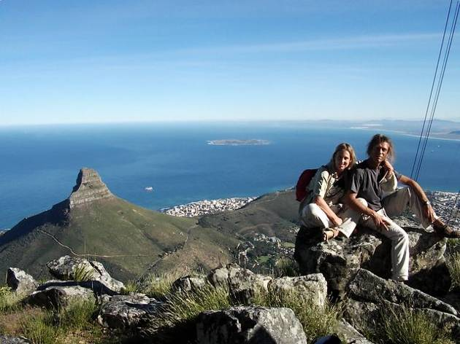Lilongwe Backpackers, Malawi
Moorings Camp Site, Zambia
Buitepos Rest Camp, Namibia
Okawango River Lodge, Maun, Botswana
Thebe River Camping, Kasane, Botswana
Aus Filling Station and Camping, Namibia
Kookfontein Center, Steinkopf, South Africa

